
The Willows Whisper Feb 2026
What Does Love Mean?
A group of professional people posed this question to a group of 4 to 8-year-olds:
"What does love mean?"

The answers they got were deeper than anyone could have imagined. See what you think...

Freddie – Age 9
"When my grandmother got arthritis, she couldn't bend over and paint her toenails anymore. So, my grandfather does it for her all the time, even when his hands got arthritis too. That's love."

Rebecca - age 8
"Love is when my mommy makes coffee for my daddy and she takes a sip before giving it to him, to make sure the taste is OK."


Emily - age 8
"Love is like a little old woman and a little old man who are still friends even after they know each other so well."

Tommy - age 6
"Love is when Mommy gives Daddy the best piece of chicken."

Chris - age 7
"Love is when your puppy licks your face even after you left him alone all day."

Mary Ann - age 4
"I know my older sister loves me because she gives me all her old clothes and has to go out and buy new ones." (Now THIS is love!)


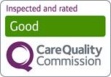



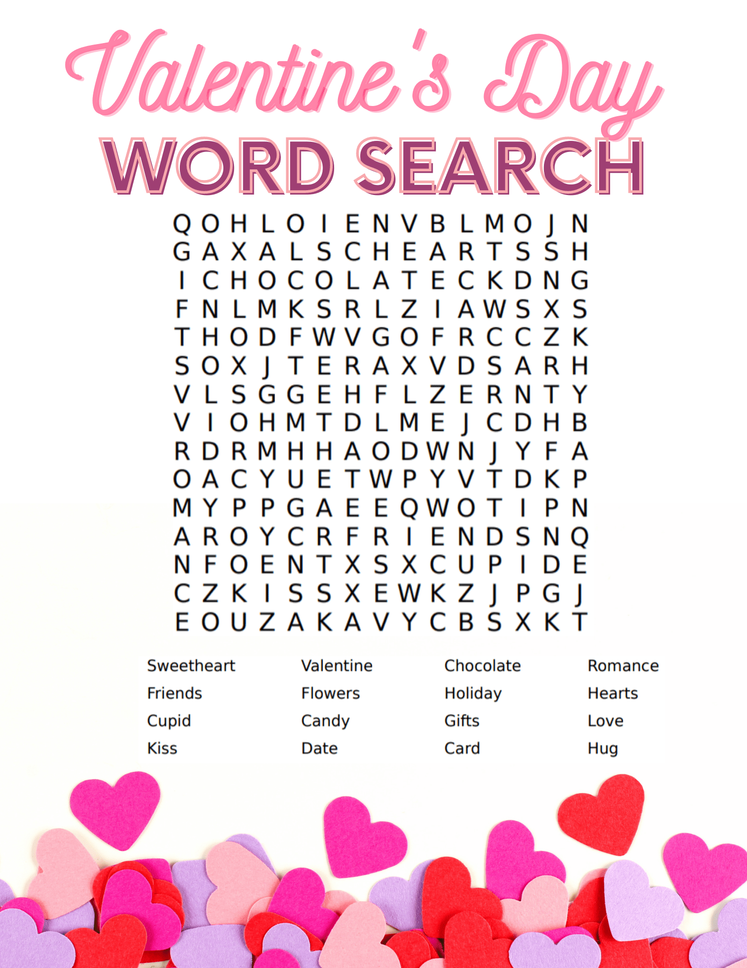Pancake Day 2026

This year Pancake Day will be celebrated on Tuesday 17th February. It changes every year as it is always forty-seven days before Easter Sunday.

At the Willows we have occasional pancakes for breakfast or tea.

Many consider themselves experts of the battered snack, but how well do you really know your pancakes?

The simplicity of the pancake means that it has been tried, tested, and tried again a hundred times over, with each effort forming something slightly different to the last.

Now, thousands of years after it first made its way into our diets, you can find multiple types of pancakes around the world.
From the well-known French crêpes and Scotch pancakes to more elaborate and complicated recipes.

Our residents have their pancakes with lemon and sugar, or whatever topping they like. We call it simply a pancake bonanza and serve our pancakes with a smile!

The Willows Pancake Recipe
Ingredients:
100g plain flour
2 large eggs
300ml milk
1 tbsp sunflower or vegetable oil, plus a little extra for frying
lemon wedges and caster sugar to serve.

Method
STEP 1
Put 100g plain flour, 2 large eggs, 300ml milk, 1 tbsp sunflower or vegetable oil and a pinch of salt into a bowl or large jug, then whisk to a smooth batter.
STEP 2
Set aside for 30 mins to rest if you have time or start cooking straight away.
STEP 3

Set a medium frying pan or crêpe pan over a medium heat and carefully wipe it with some oiled kitchen paper.
STEP 4
When hot, cook your pancakes for 1 min on each side until golden, keeping them warm in a low oven as you go.
STEP 5
Serve with lemon wedges and caster sugar, or your favorite filling

The ‘little things’ that matter…
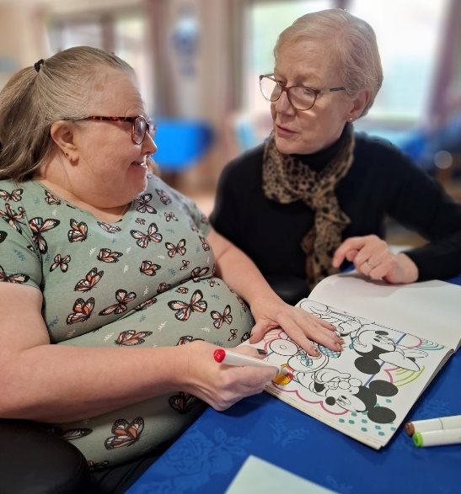
Meaningful activity in our home, involves everybody; from office staff to kitchen staff to the people delivering personal care. It’s about doing it ‘with’ the residents, and not doing it ‘for’, our aim is to create moments of connection, comfort and joy. Across all our departments, our staff members are very committed and dedicated to our residents, often going above and beyond to make a difference. This is what makes our Home so special.
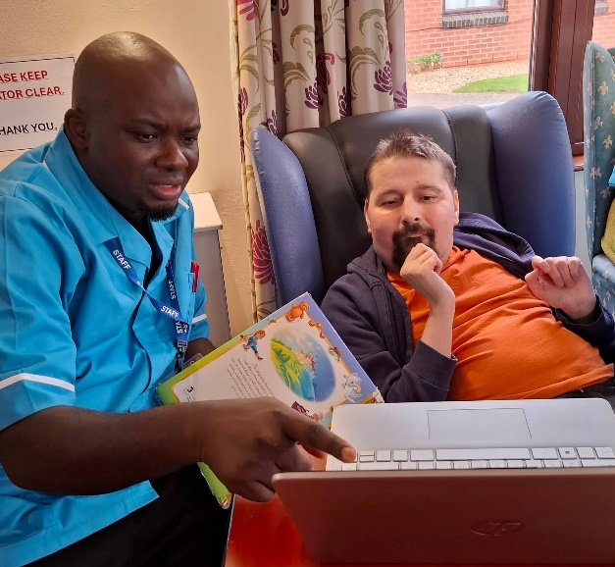
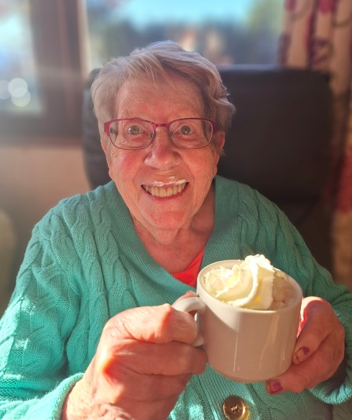

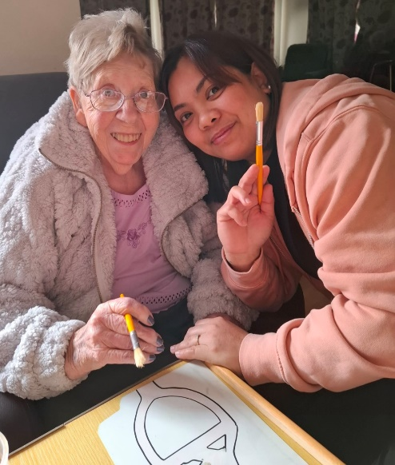
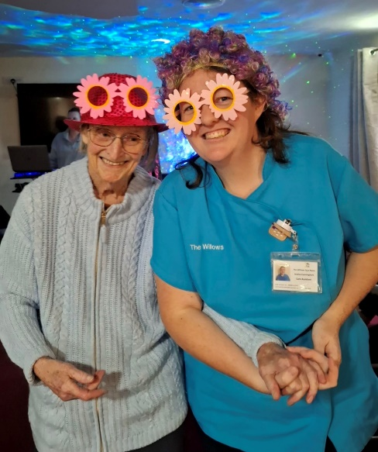

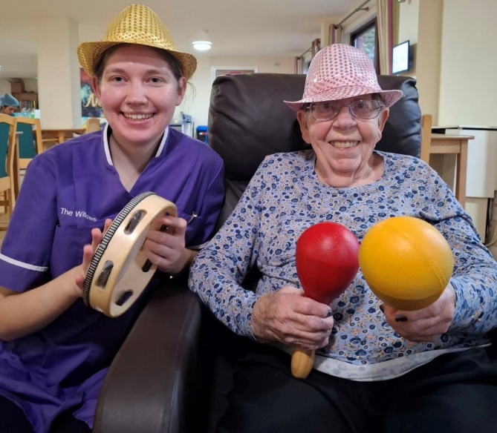

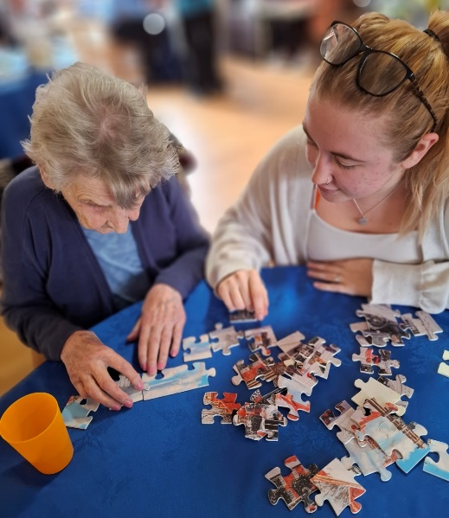
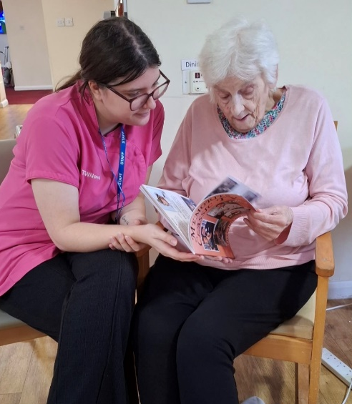
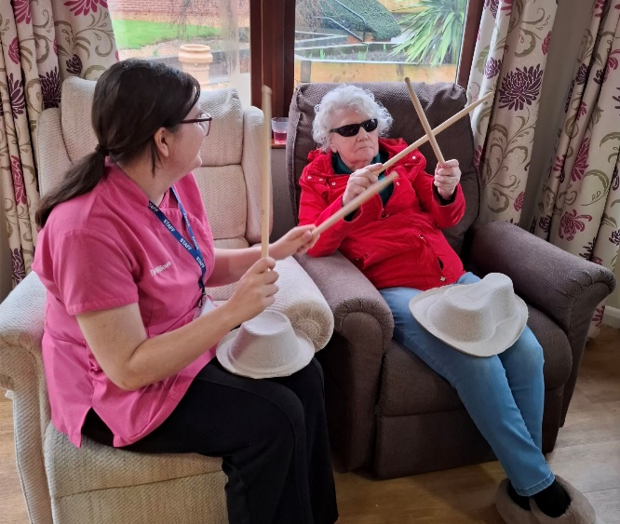



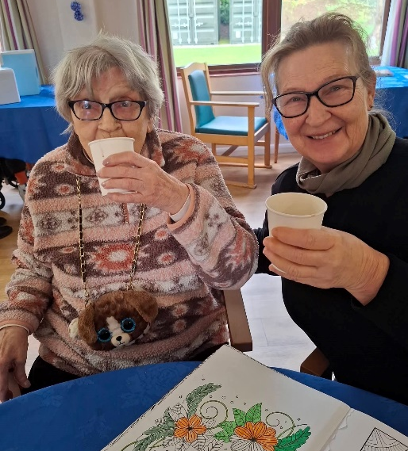
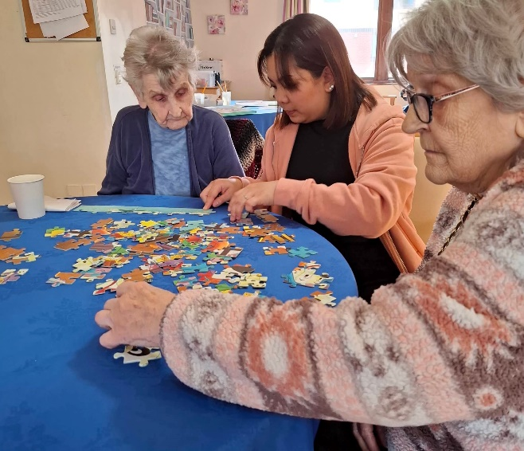
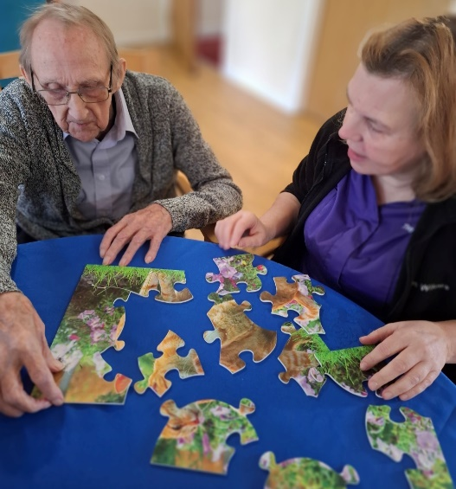

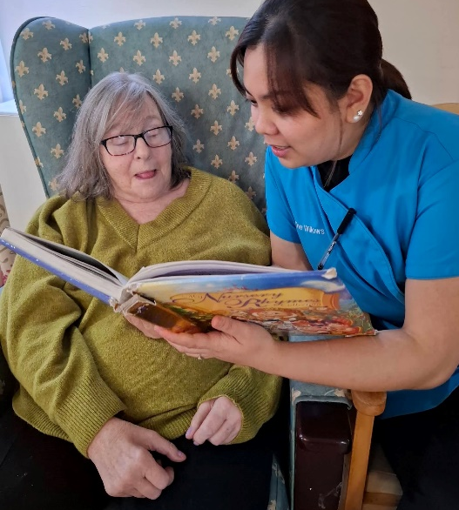
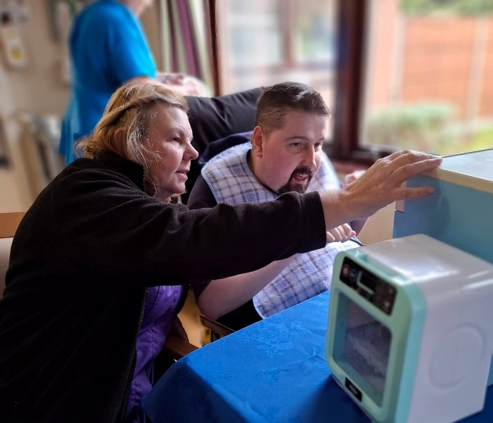
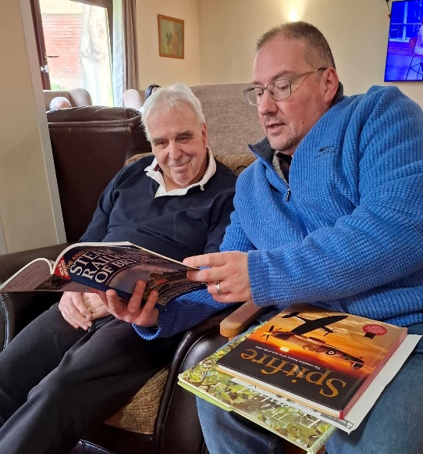

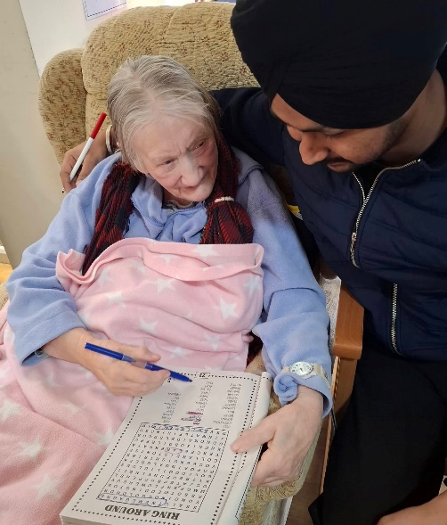
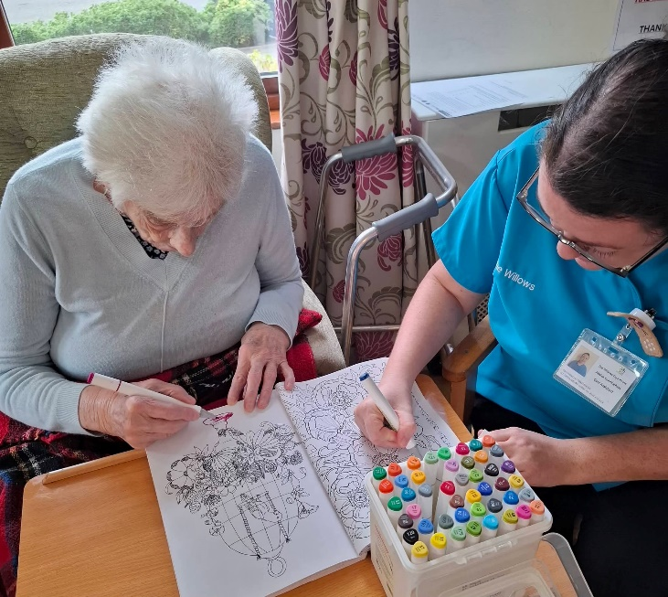
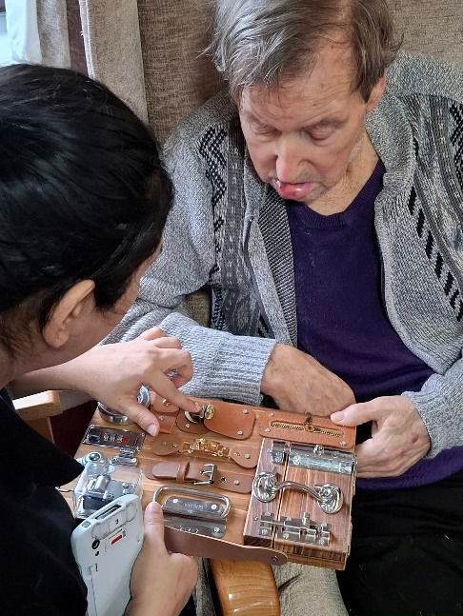

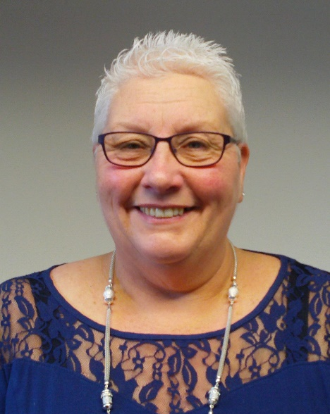
Meet with the Manager
Yvonne and Cleo will be hosting a tea time Resident meeting from 4:00pm – 5:00pm on Thursday 19th February 2026.

Topics of discussion will include:

- GSF (Gold Standards Framework)
- Upcoming activities
- New staff

We look forward to seeing you there!

What have we got planned in the month of February…….
4th February 2026 - Boogie Beats – with Hannah!
7th February 2026 – Movie night
9th February 2026 - Chocolate Day/Roy live entertainment
10th February 2026 - Penny from Art Sparks – Valentines Special
12th February 2026 – ‘Magic’ Thursday – with Dave
12th February 2026 - Fat Thursday (Polish donut day)
14th February 2026 – The Willows Valentines Day Party
17th February 2026 – The one we have waited for…..Pancake day
21st February 2026 - International mother tongue language day
22nd February 2026 - Church service (All welcome)


A Century looms!
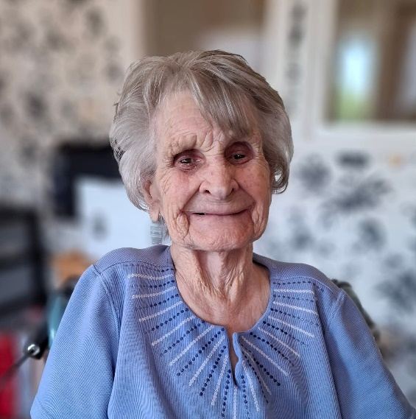
Clara is our only resident that celebrates her birthday in February. This year she will be 99! Clara has been a resident of The Willows for 5 happy years. She enjoys joining in our activities, especially the musical ones and loves a puzzle! Clara’s looks forward to her family visiting, and talks about themvery fondly to staff. We wish our Clara, a very Happy birthday from her Willows Family.
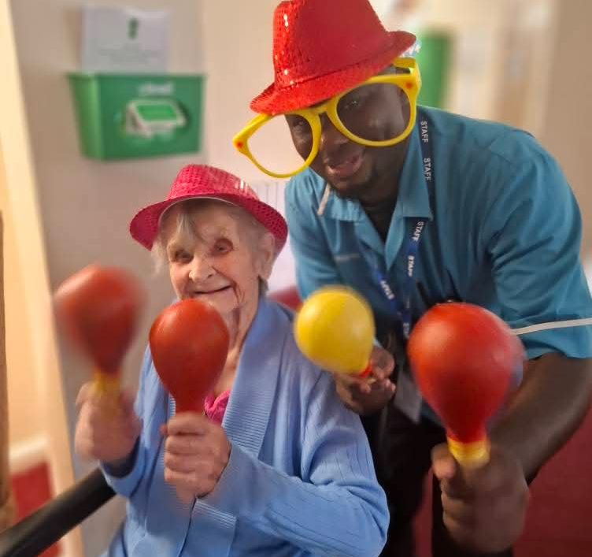
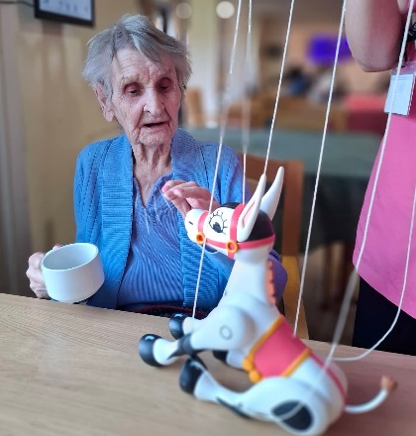
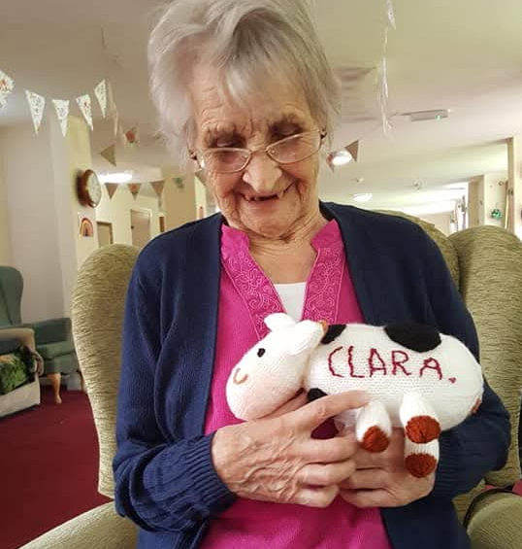

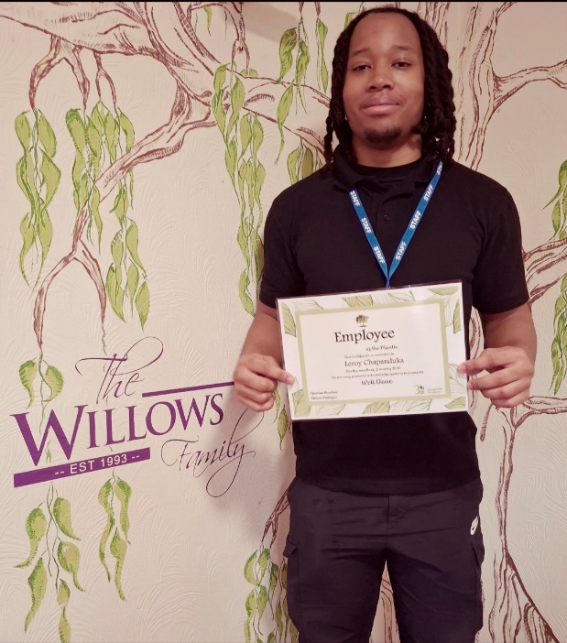
Employee of the month
Congratulations to one of our newest recruits, Leroy, who has made quite an impression on all his work colleagues.
His commitment and happy demeanour have earned him employee of the month. He has fitted in very nicely to our Kitchen Team.
Well done Leroy on your achievement!
Messages for our Staff…….


My mum was in the Willows from March 2025….
In that time me and the family were very pleased with the care she received. She was always clean she loved the food and she seemed as happy as she could be. We will always be grateful to the staff at the Willows and would recomment The Willows to anyone. (January 2026)

My mum in law was a resident at The Willows Care Home Shepshed for 5 years. In all that time, she was treated with the upmost respect, and it became her home. The staff were all very kind and attentive to her needs. It was a happy place for her, and she liked to be in the lounge with the other residents and staff. If anyone asked me to recommend a care home for their loved one, I would certainly recommend The Willows. (January 2026)



The 3ab Care Referral Program
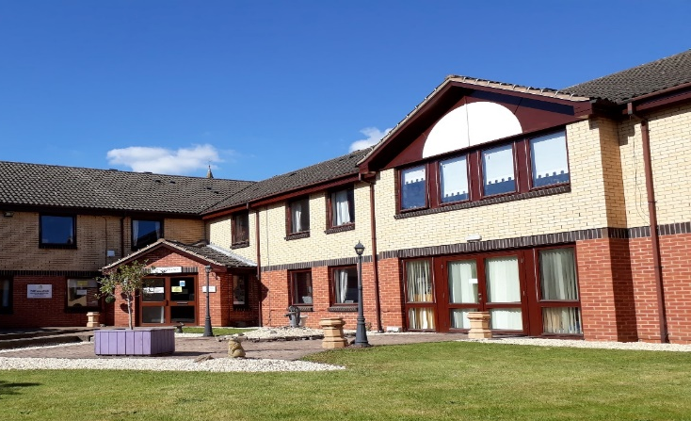
Do you know someone seeking a Care Home for a loved one?
If you refer to resident, who comes to live at The Willows, you can receive a reward!

We are offering:
£250 vouchers if the resident comes to stay with us
on a respite stay
Or
£500 vouchers if the resident you refer comes
to our Home permanently.
If you would like more information, please speak
to Priya Patel or Yvonne Manton.
Contact us on 01509 650 559
Email:
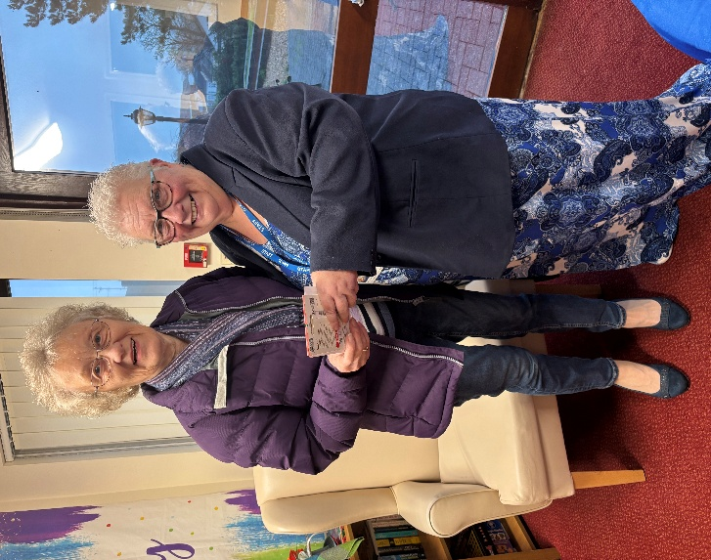
This week, we had the pleasure of awarding the lovely, Hazel Briggs, with a voucher for £250, after she recommended the Home, to a friend in the month of December.
The resident remains in our care, and we are very grateful, that just from Hazel sharing her experience of the excellent care we provide, we have had another family join The Willows.
A huge thank you to Hazel….we hope this helped you get over the January blues!
An update on our GSF Journey! 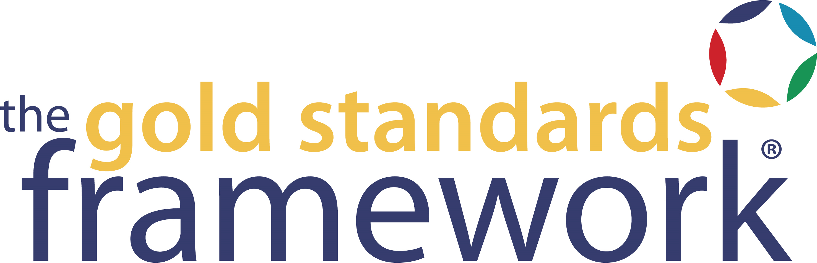

Dear All
Gold Standards Framework for Care Homes (GSFCH) Programme
This letter gives information on a national programme that The Willows are to join, the Gold Standards Framework for Care Homes Programme (GSFCH). GSFCH is recommended as an example of ‘best practice’ by many government and professional organisations including CQC. It aims to build on the good work already present in the home, to develop the very best quality of care for residents in the last years of life – aiming for a ‘gold standard’ of care.
The Gold Standards Framework was developed originally in Primary Care for GP’s and District Nursing teams and has been found to greatly benefit patients, families and staff by improving the organisation and quality of care provided. It is used by many care homes, GP practices, hospitals and other organisations across the UK.
The Willows are in the preparation stage of the GSFCH programme and are writing to let you know about this very exciting development.
The programme is explained in more detail in the attached leaflet. One of the key aspects for you may be in the proposal to have good discussions with all residents, listening to your needs, wishes and preferences ensuring better planning and communication with everyone. There will be opportunities for these Advance Care Planning discussions to be explained and discussed with the staff.
If you would like to know more about the programme, or have any issues you wish to raise, please discuss this with Yvonne, Renata Buti, Jasmine Munder or Rinku Thomas. More information on Gold Standards Framework can be found on the GSF website: www.goldstandardsframework.org.uk. and we will update you with our progress as we go through the training.
We hope that you will feel part of the programme and feedback your ideas and suggestions. You are part of making this a success, alongside the dedicated staff in the home, to ensure the very best of care at this stage of your life.

Kind regards,
Yvonne and the National GSF Team

