**OVER 10 YEARS LONG SERVICE AWARD – ANEESH & JUSTIN AND**

**CARE HOME ASSISTANT PRACTIONER (CHAPs) AWARD**

**DEENU & MANJU**

**CEREMONY HELD TUESDAY 12TH MARCH 2024**

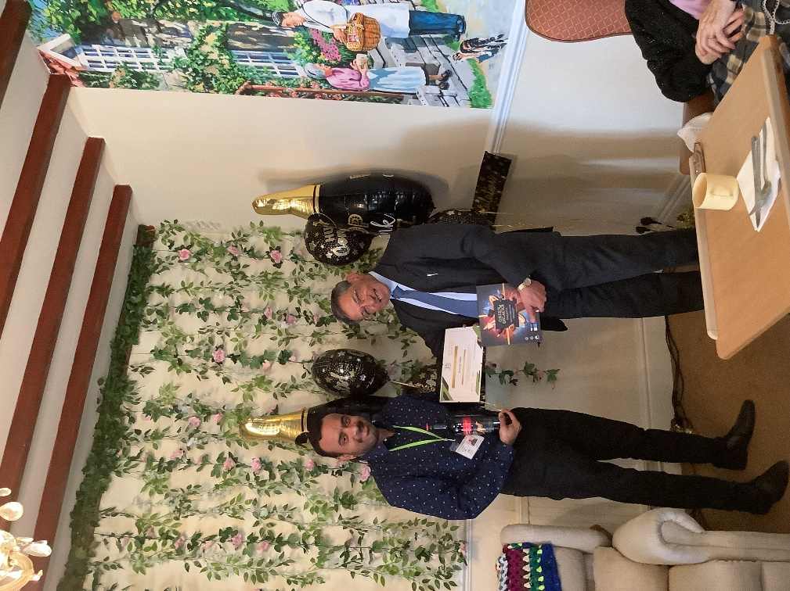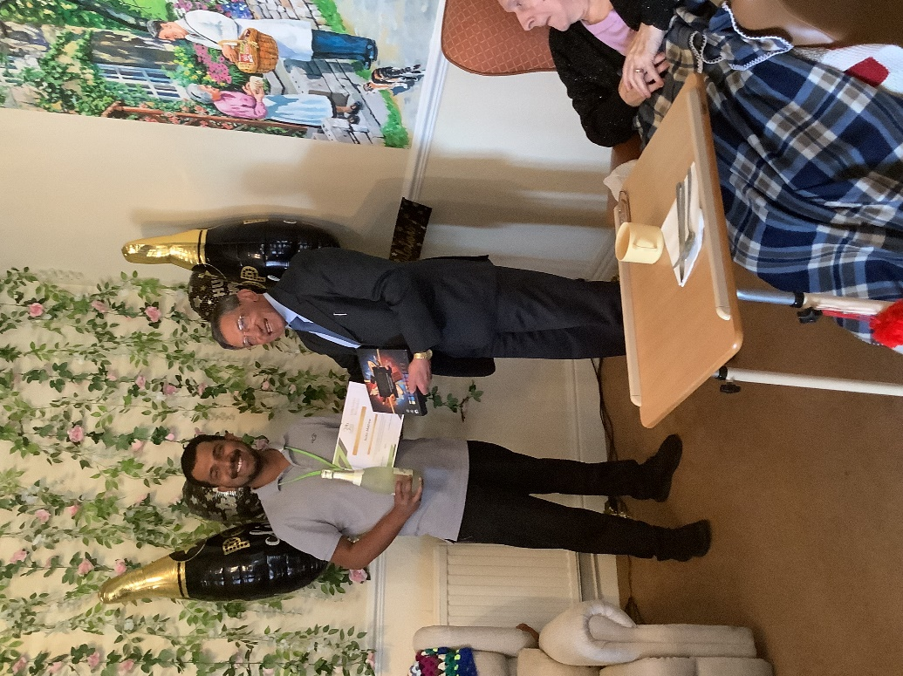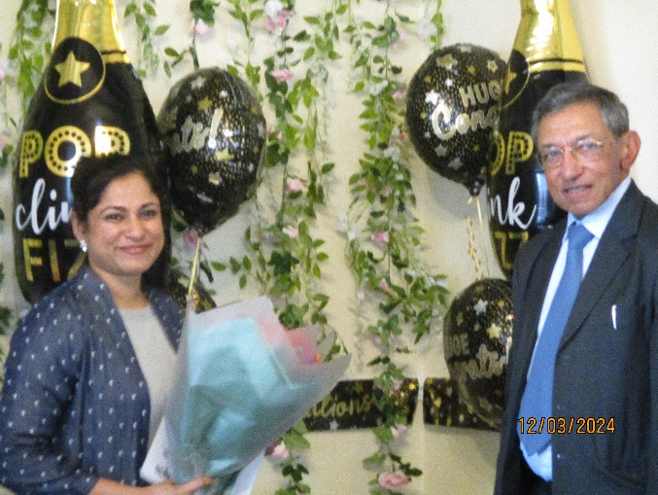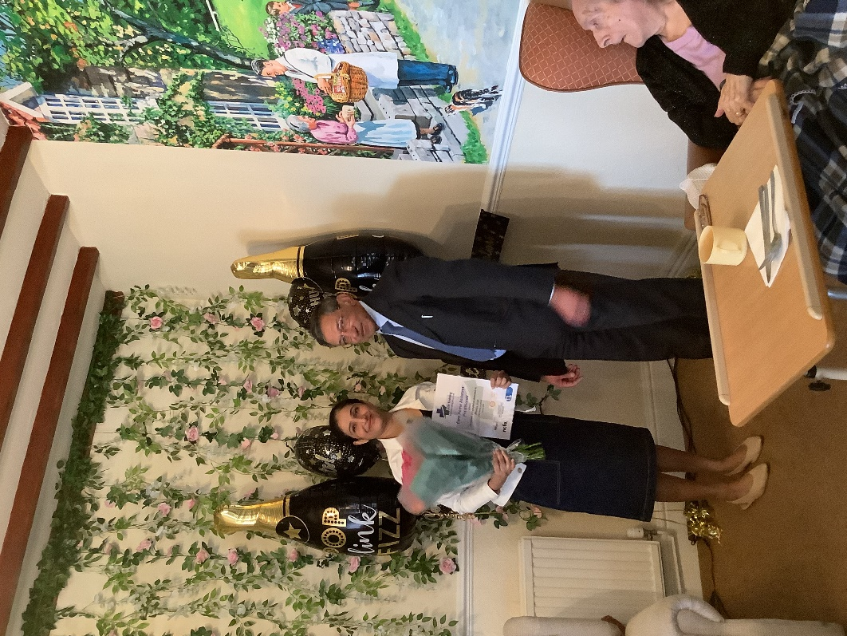

**CONGRATULATIONS TO YOU ALL.**