Saturday 11th May 2024
Today has been all about skittles!
We had a lounge full of residents and they all had a go and joined in throughout the afternoon.
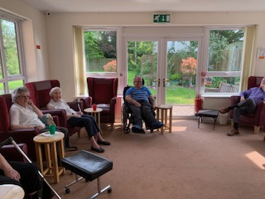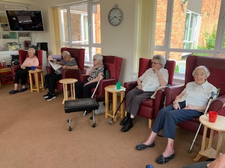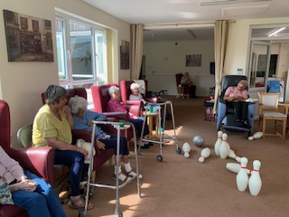
Everybody got involved with throwing or rolling the ball themselves, which was a good way to help keeping them moving and their mobility.
Heather, Cynthia, Sybil and Mary all got strikes in one of their turns, which was great and resulted in a big cheer from everyone in the room. But Kirk had an amzing strike in one go, with all skittle down in one hit…but he was slightly overshadowed by the outstanding skills of Denis who managed two full strikes in two throws!!! This resulted in a very big cheer from everbody and some slight disbelief at such skill, or was it luck???
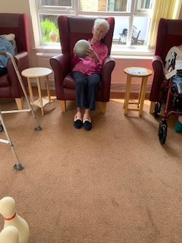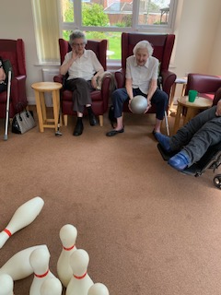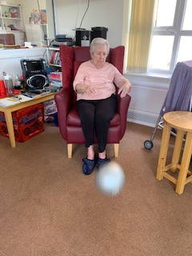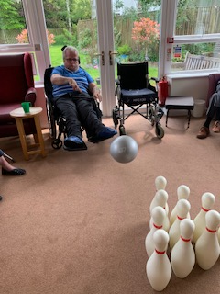
Sheila wasn’t keen to take part initially and was happy watching, but the fun must have got the better of her as she ended up having a few goes and catching up with everyone else. Well done Sheila!
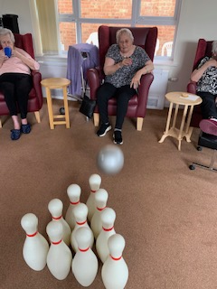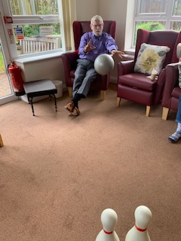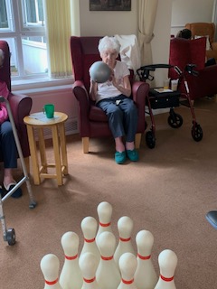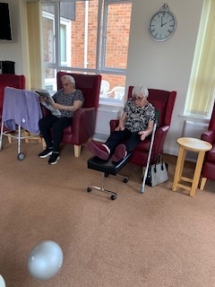
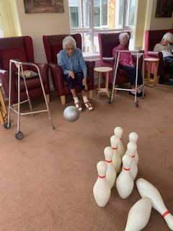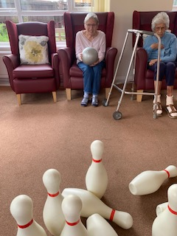
There was also lots of family and friends visiting today, with Mary, David, Brian and Alan amongst others havng family coming in and spending time with our residents.
Heather and Brian also had periods reading the newspaper and cathing up on world and at home events.
We finished the afternoon off with some tv and a David Attenbourough nature programme on the tv in the lounge.

