Sunday 12th May 2024
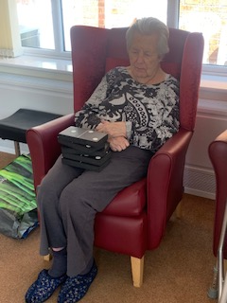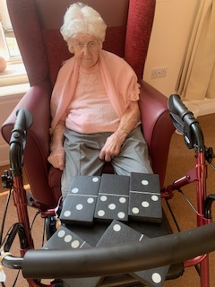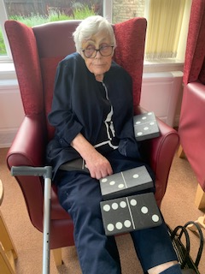
Today we have had some games of giant floor dominoes. We had a few residents join us in the lounge. Ravji joined us untilhe had family come and visit him, and then he enjoyed an hour in the garden with them.
Our dominoes went well, with Lyn winning the first game and Heather winning the second. Sheila, and Cynthia enjoyed the games and were picking the pieces to play depending on the numbers. Denis was happy to join in and was concentrating hard on which numbers he needed and so how many dots that meant his pieces should have.
Quite a few resident had family and friends come and visit today, including Mary who went and enjoyed the garden with her friend Rose. It was lovely and sunny and warm and she enjoyed having her afternoon drink out there.
Kirk had his mum come in which he always really likes, and was full of smiles recounting her visit.
Bernard also had his wife Ann come in and they both enjoyed Sunday dinner together in the dining room.

