Monday 13th May 2024
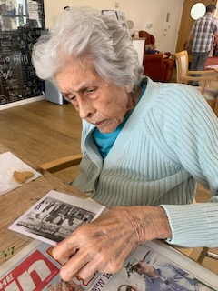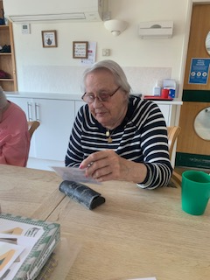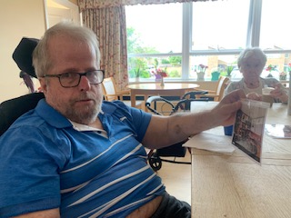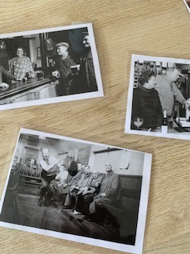
This morning we have had a session of reminiscing in the dining room. A few of the residents joined and we talked about pubs and how they have changed over the years and how they get used very differently over time too.
Dorothy was chatting about them because she remembered her father didn’t allow her to go to the pub at all, and it was only when she married that she went with her husband. Kirk and Heather were saying about going when they were younger and what drinks they would have. Kirk was recounting how he had to stop enjoying a drink due to medication he had to take and continues too.
They all talked about pubs being sociable places where it was all about meeting friends, rather than now where a lot of them are mainly eating venues, rather than pure pubs.
There was chat about the names of pubs too, with the Red Lion being a well known name used. We looked up some unusual pub names and there was one they loved called the Bucket of Blood!!
We then played a couple of old pub games – bar skittles and Shut the Box. They appeared to enjoy giving them a go, and when the scores were in for skittles Heather was our winner!
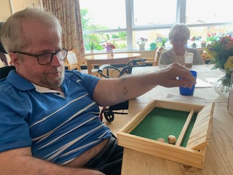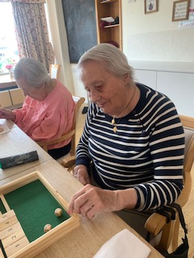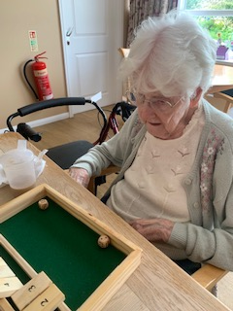
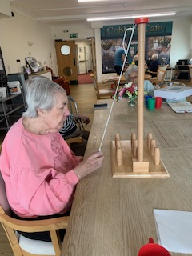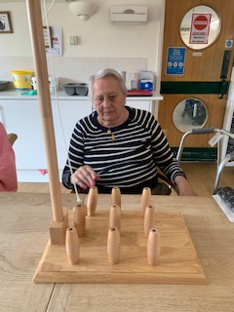
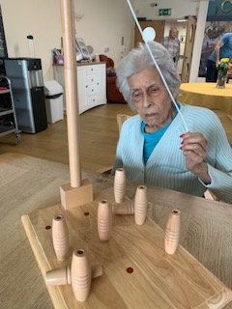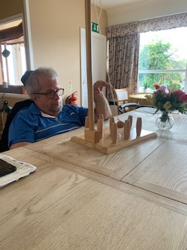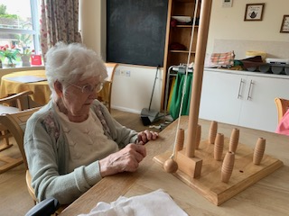
The afternoon was all about enjoying some downtime and resting in our rooms or happily reading newspapers in the lounge or dining room. This is as important as being busy and allowed residents to rest and relax in comfort.

