Tuesday 14th May 2024
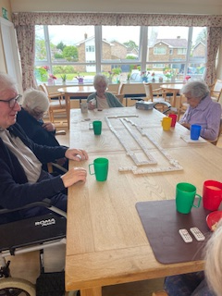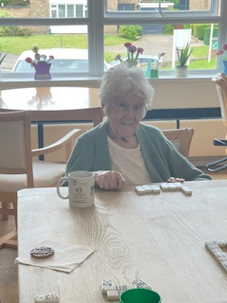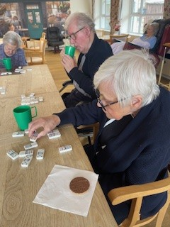
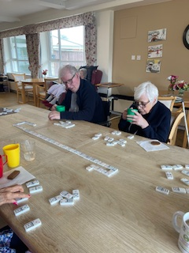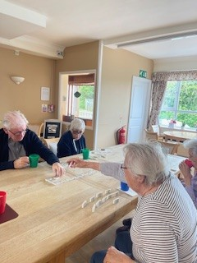
This morning the residents gathered in the dining room and had a game of super dominoes. This was good to allow residents to look at the colours and numbers on their pieces and match them up. This really helped them with counting and colour recognition.
They played a great game and were helping each other along with which pieces each needed to chose from and where possible they put their own pieces down.
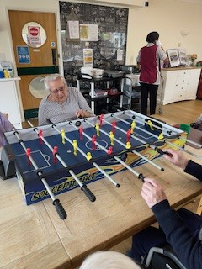
We finished off before lunch with some table football, which Heather and Brian were enjoying. Heather didn’t do well with giving away her game with an own goal to Brian!

This afternoon was a very fun time when we had some preschool children come and spent the afternoon with us. It was great fun and we all sang nursery rhymes together, then got rather messy with paints and hand prints and pictures. The residents got really involved and were interacting with the children nicely and there were some lovely big smiles. Everybody got involved with the hand prints and it was funny to see how messy everbody got.
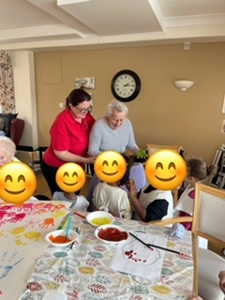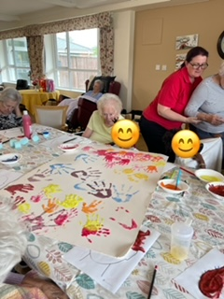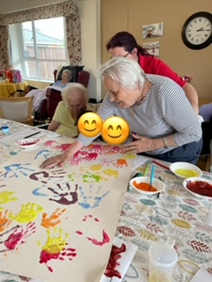

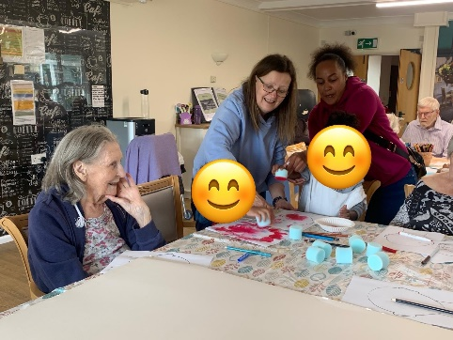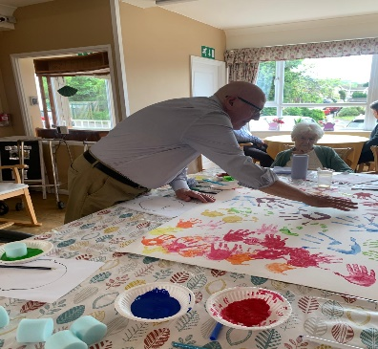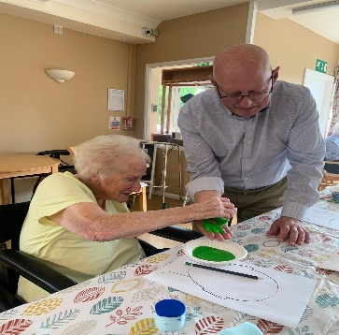
Betty had fun painting Dave’s hand with green paint so that he could add a handprint to our large picture that the children and some of the residents had been doing. A lovely and fun afternoon, but judging by the residents faces there was some slight relief when they left and peace and calm was restored to the lounge and dining room!!

