Wednesday 15th May 2024
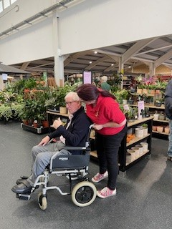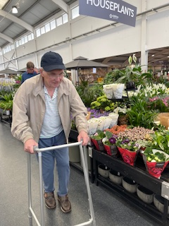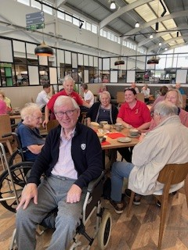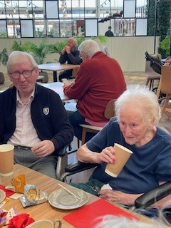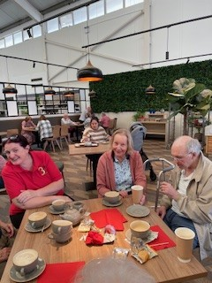
This morning we have taken a trip out in the minibus to have coffee at the garden centre. It was a lovely day and everybody was pleased to get out and enjoy some fresh air. Betty, Brian and Heather were all happy having a chat and David was pleased to be out with Astrid for the morning.
It was very pleasant and the coffee was apparently very nice, and was appreciated by all the residents.
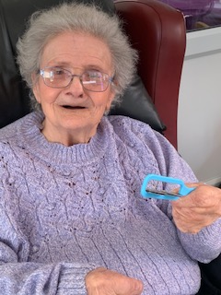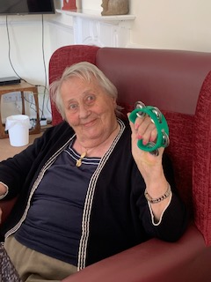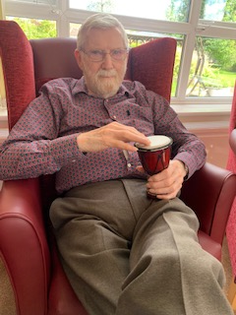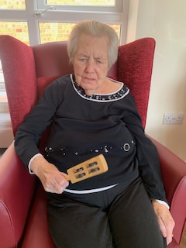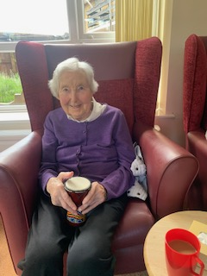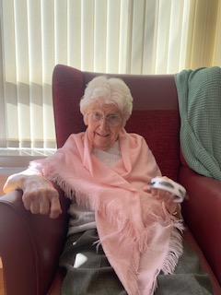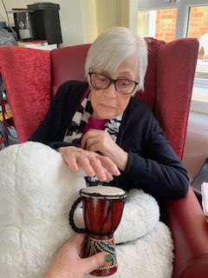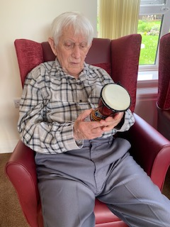
This afternoon we had Julie from steelpan come and perform for us with a great concert of music. Everybody had a great time listening to the music, and they were playing along with instruments and there was even some dancing and singing along. Sheila, Heather and Lyn all played their instruments for nearly the whole time, and Denis was very creative with his percussion playing, with arms waving and very good rhythm.
It was great to see their movements and reactions to the rhythms and tunes, and Denis got up and was thoroughly enjoying some dancing. It was almost music and movement!
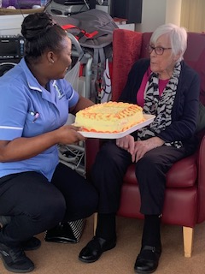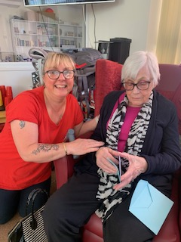
Today was also Cynthia’s birthdya and we were able to have a birthday song for her along with a lovely big cake. She has had a lovely day with lots of family and friends coming in to visit her to help celebrate.

