Saturday 18th May 2024
This morning our residents’ families have been out on a Dementia Walk to help us support dementia awareness week, the weather was great and the sun was shining, we had 2 routes to walk a more of a stroll walk, and a walk to the summit, it was a little tough but we made it, and it was great to get out in the countryside.
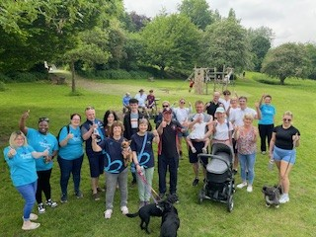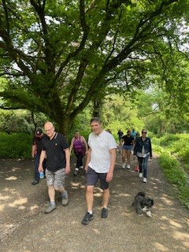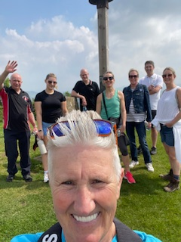
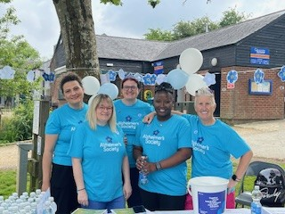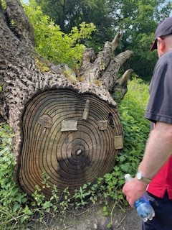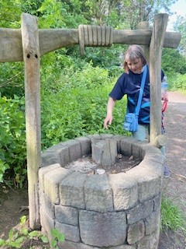
Ann had her partner Brian come for a visit and they chatted in her room whilst watching a film.
James’ sister Clare came for a visit this afternoon and they spent time in his room chatting.
Peter had a visit from his granddaughter Louise, he was very happy to see her, and was smiling.
Alan had a visit from his wife Jean today, and it was nice for them to spend time in each other’s company.
Yvonne had a visit from her family where they spent time with her in her room listening to music.

