Wednesday 1st May 2024
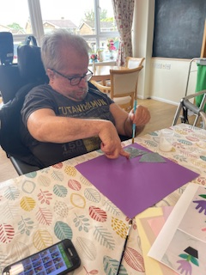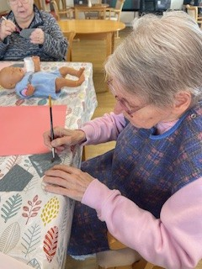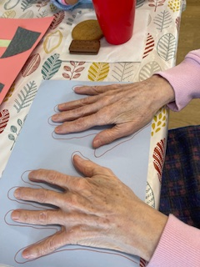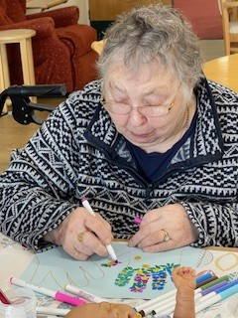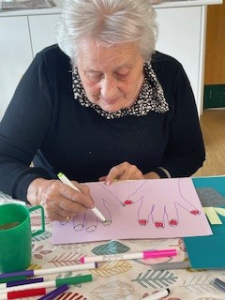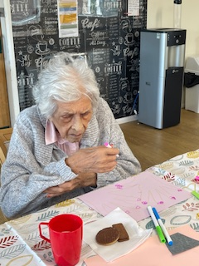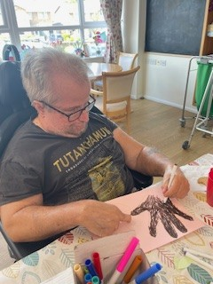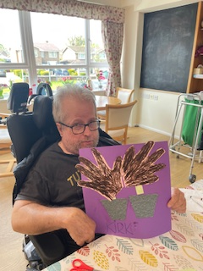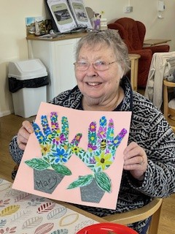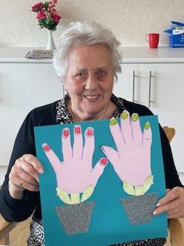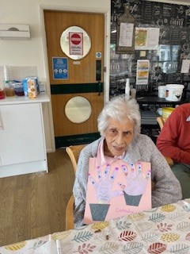
Today has been all about May Day and creating our May Day Flower pots.
Everybody drew around their hands and then had help cutting them out. There was then opportunity for the residents to get creative and decroate the hands in any way they wished. We had felt tip pens and the ideas flowed.
Kirk enjoyed coluring his hands really intensly, and Mary had some amazing colourful flowers and even a bumbl;e bee on hers.Heather was very keen to keep hers clean ad simple but wow with the nail varnish!!
Ann was visiting carol and so she was supervisded in helping Caro with the colouring in and putting on patterns. Dorothy was also very keen to get some lovely colourful patterns on hers.
They were choosing their own colours and it was interesting to see personalitlies coming through in their flowers. Big bold and colourful, or clean and subtle.
They all had really good fun and there was a lot of smiles and chatter between residents and visitors throughout which was great for their mood and engagement.

