Monday 20th May 2024
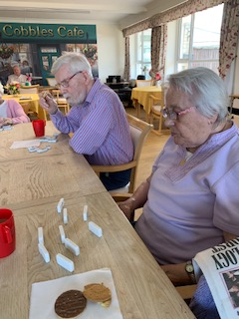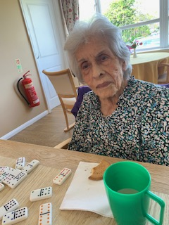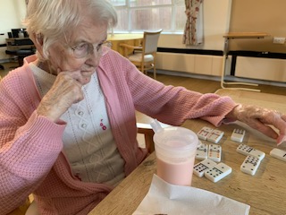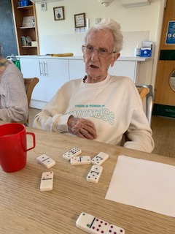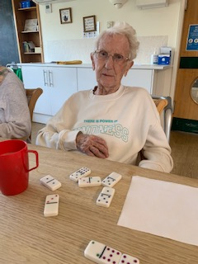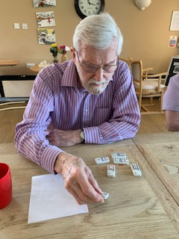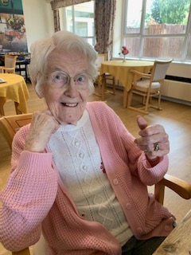
This morning we had a game of super dominoes before sending time reminiscing. The dominoes game swent for some time and everybody was able to go for a lot of the game. Eventually we had a winner and Sheila was very happy to have won. We even had a big smile and thumbs up photo to celebrate. Heather, Sheila and Denis were very good at looking at the numbers and the colours of the dots to kow which pieces to play, and Dorothy, Sybil and Carol had some help to see their dominoes, as some of the colours were similar to look at. Carols daughter joined us and helped too, which was lovely and Carol certainly had a big smile for her and was enjoyiong the connection.
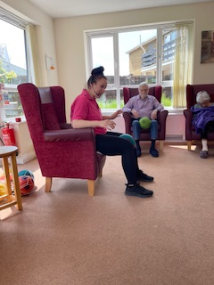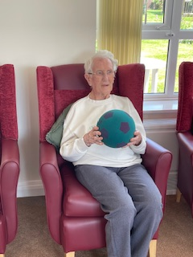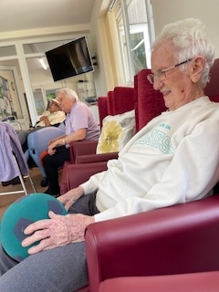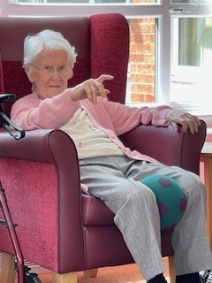
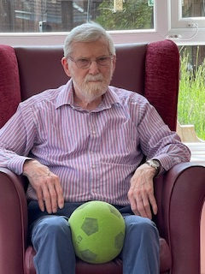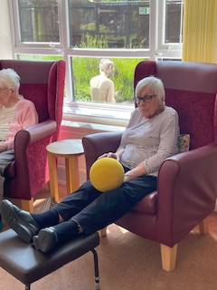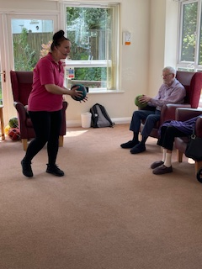
This afternoon we had Tanya from G-fitness come and do some stretches and exereises with the residents.
It is always lovely to see how engaged she gets them and how much they will take part. Denis, Sheila and Sybil all had a good go at stretching and using the balls to help with the movements. Cybil was enjoying giving it a go too, which was lovely to see. Heather was engaging too and giving all the moves a really good try.
They all felt like they had a done a great workout at the end, and this is good for their mobility and the interaction they have through the mucis Tanya uses too.

