Tuesday 21st May 2024
This morning we have been getting very creative making rainbow mosaics, Carol came to help Sheila with her rainbow and they say chatting together choosing their colour, Roy was happy sat with Carol who wanted to colour hers in as she didn’t want to get her hands messy, it took lots of concentration and is good for motor skills and keeping the mind active, Heather likes to get creative also.
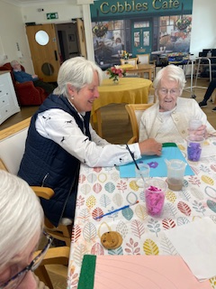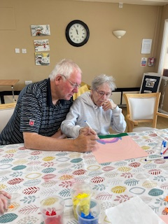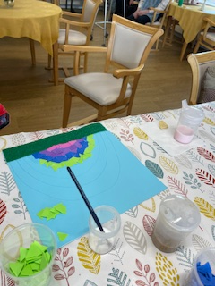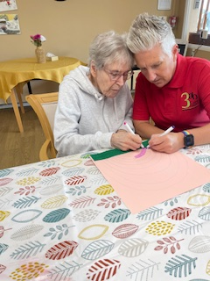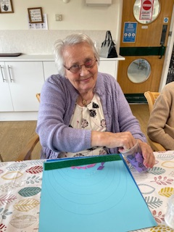
This afternoon we did some chair yoga where we did some arm and leg exercises limbering us up before playing bounce and catch we also had the little ones join in, this is great exercise and encourages eye and had coordination as well as physically throwing the ball, we also had a crossword quiz about animals as today is pet therapy day.
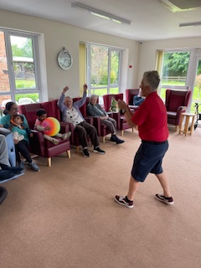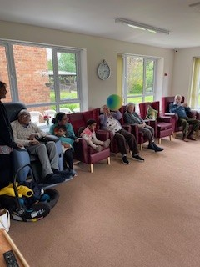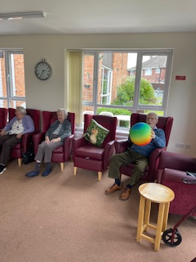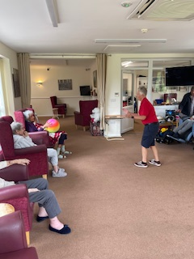

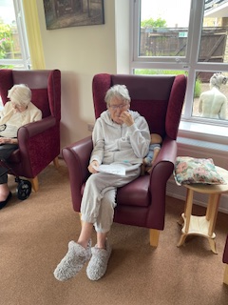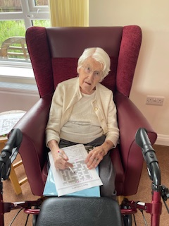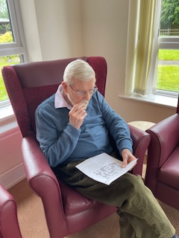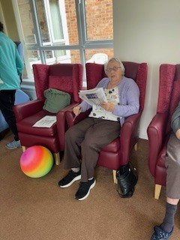
Good participation in the crossword quiz, we all went through the questions together, it was great to hear the residents shouting out the answers, some of the residents needed a little help with knowing where to write the answers, and they felt great that they had completed them.
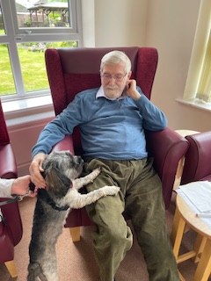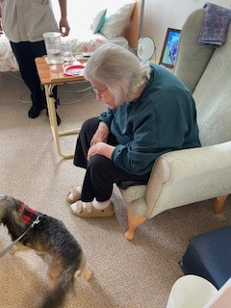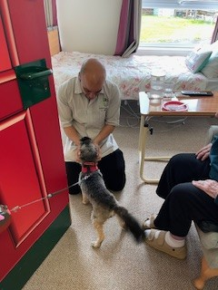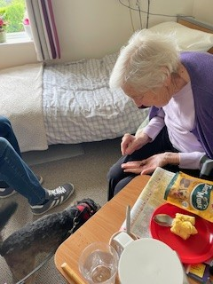

We also had a visit from Hayley and Peggy who are our regular visitors, Peggy was very excited to see everyone, and as always we had treats waiting for her.

