Wednesday 22nd May 2024
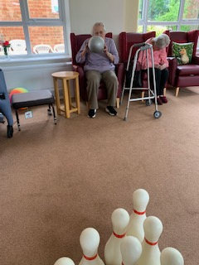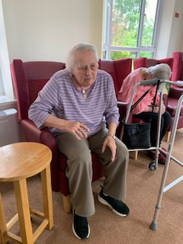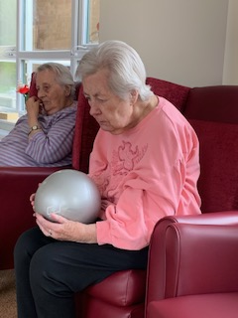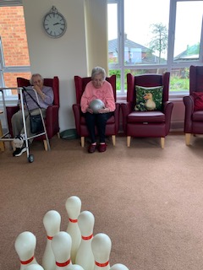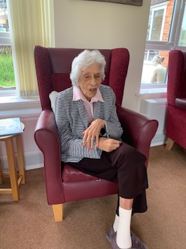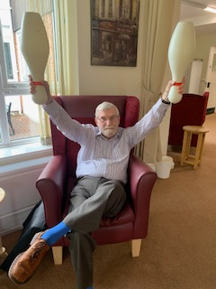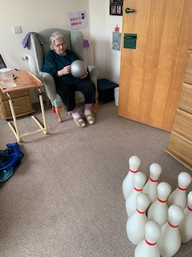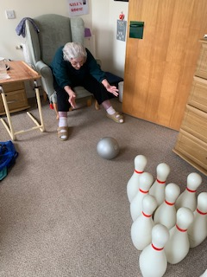
Today we have been busy with the skittles. |This is always a good way to get some phyiscal movement happening but having a good laugh and social interaction too.
Everyone was cheering when there were strikes achieved, which Denis, Heather, Lyn and Dorothy all got today, It was a really high scroing game today.
Our winner today was Denis…again…he is proving to eb a very skilled skittles player!!!
We ave also had an ABC quiz, and we had the theme of coastal seaside towns in the UK. This took some thinking by everyone but Denis, Heather and Mary were certainly gving it good go, with encouragement to get Lyn and Terry having a go too.

