Thursday 23rd May 2024
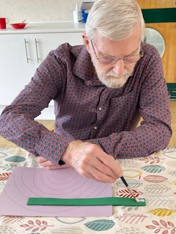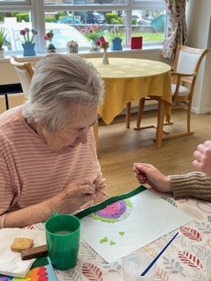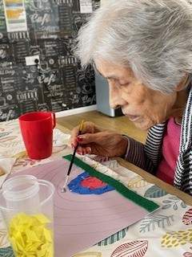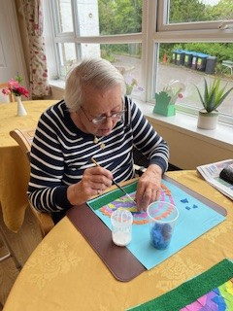
This morning we have been doing some creative art, we have been making mosaic rainbows, Dorothy chose what colours she would like to use for her rainbow and enjoyed watching it come to life, Lynn also enjoyed making her rainbow and enjoyed putting the mosaic pieces on, Denis also got involved and we talked about how rainbows are made and wouldn’t it be great if there was a pot of gold at the end of them.

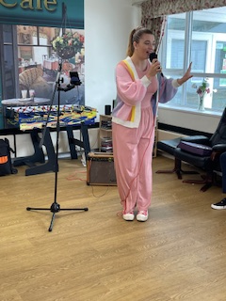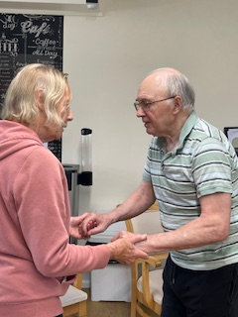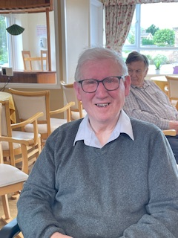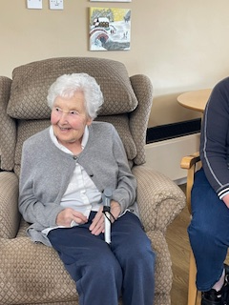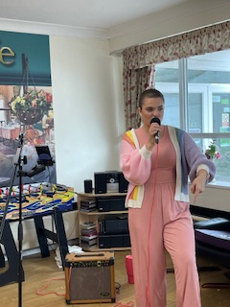
We had a visit from mini concerts today where we were transformed back to the good old days singing Abba, and some rock and roll tunes, Astrid and David got up for a dance which was great to see, Cynthia got up to dance when the rock and roll songs came on as this is what she used to do with her husband, there was lots of singing and foot tapping, and fun was had by all.

