Friday 24th May 2024
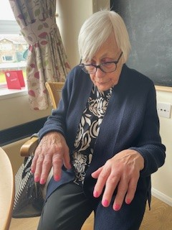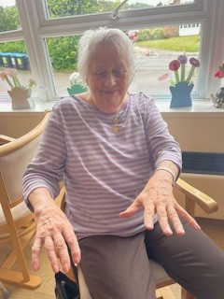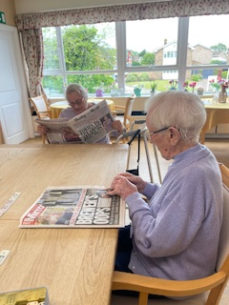
Our ladies have been having a bit of a pamper today we have been sat having a manicure, hand massage and finished off with having their nails painted, Cynthia and Heather love to have a pamper.
Heather and Sybil have also spent some time in the dining room reading the newspapers whilst waiting for the dominoes to start.
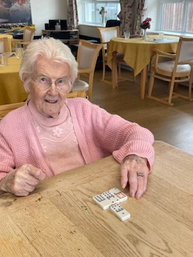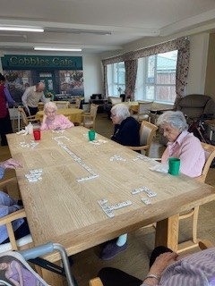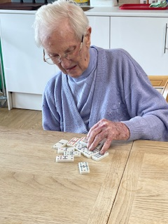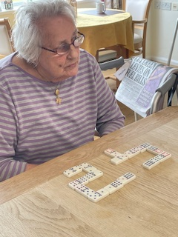
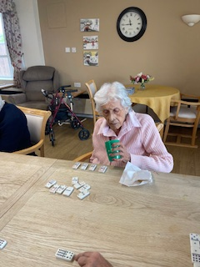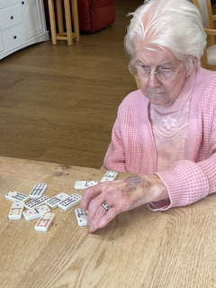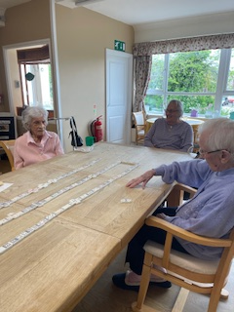
We enjoyed a game of super dominoes, the great thing about this game it can be made simple so everyone can join in, this week’s winner was Heather… well done Heather!
This afternoon we had a “60’s music Quiz”, we gave our residents and families a question sheet and we all went through the questions together, to jog everyone’s memory we played the songs from the artists and the residents were able to sing along and tap their feet.
