Sunday 26th May 2024
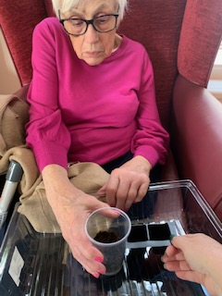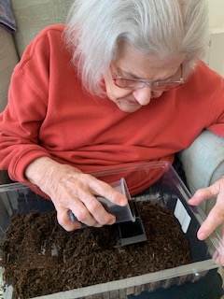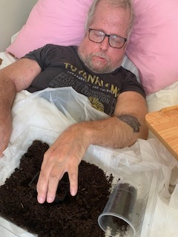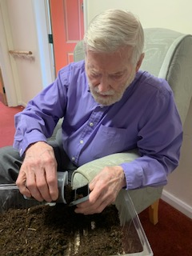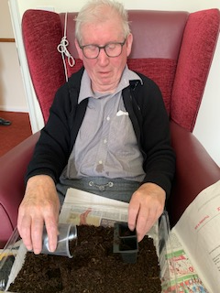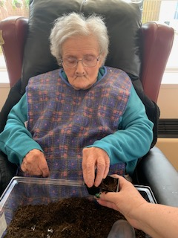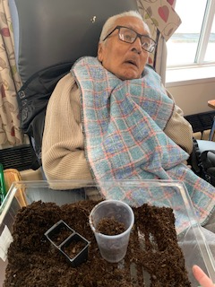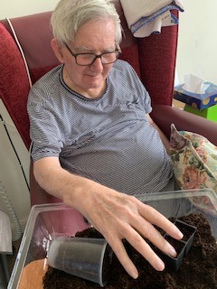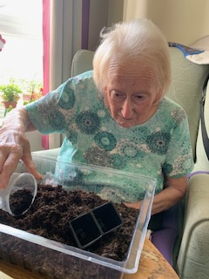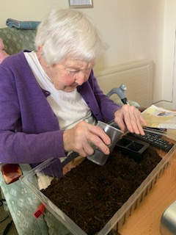
Today we have managed to do some indoor gardening!
Lots of the residents have planted some sunflower seeds to bring some sun into our days, even when it’s raining outside.
They all had a go putting the soil inot the pots, Denis, Brian, Mary all managed quite well without too much help, but Cynthia and David had a good go and needed a little encouragement and help was given where needed.
They have all got two seeds planted and now sitting in the window-ledge with water and sunshine.
We are loojking forward to seeing how much they grow, and maybe even seeing whose will grow the biggest/tallest.

