Monday 27th May 2024
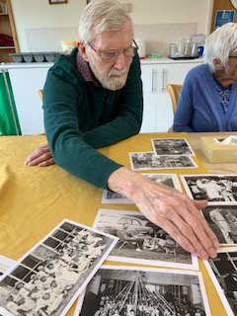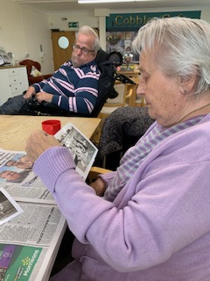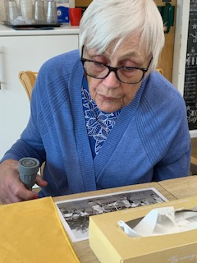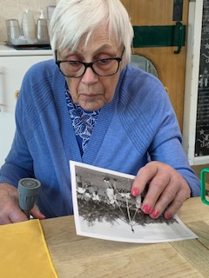
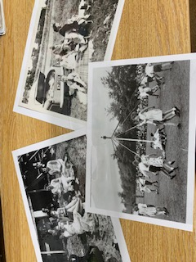
Today was a slow relaxed start to the day, as a number of our residents wanted to stay in their rooms. Each Monday morning, we always try do our reminiscing and today we looked at Bank holidays and everything to do with them.
Sheila and Denis were talking about picnics, and Kirk remembered having picnics too in Epping Forest. Cynthia also went for them but locally on Robinswood Hill. It was interesting that picnics were just on the side of roads, sat at the boot of your car.
Heather thought it was funny that as a civil servant she never worked bank holidays, however Denis’ job found him taking groups of children out for the day.
The conversation then went onto the local bank holiday Cheese Rolling event, and then other weird and strange events that happen around the country, including nettle eating and bog snorkelling!!!!
Some 1 to 1 time was spent with other residents, as they were in their rooms. This was nice to chat about things such as the music they were listening too or the tv programme they were watching.

