Tuesday 28th May 2024
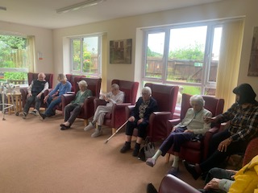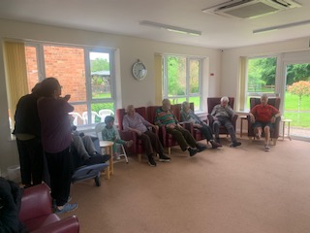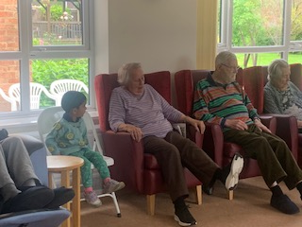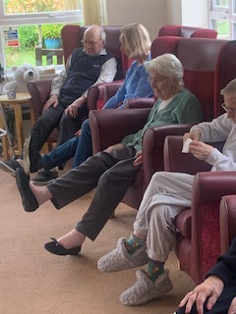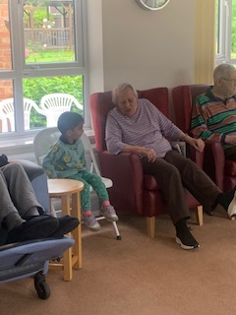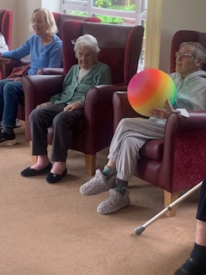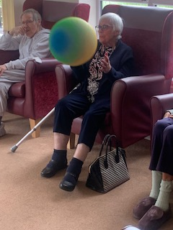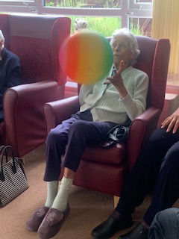
What a busy day today. We started the afternoon with lots of warming up ready to play some ball games. We had a lovely full lounge with residetns and family, and everyone joined in. There was stretching the legs and arms and then we did catch with the large beach ball. There was bouncing and catching and throwing, which was good hand eye coordination and helped strengthen upper limbs. It was also a really good laugh for everyone which is great for them to all connect and have the social contact.
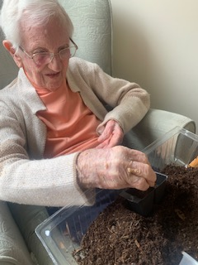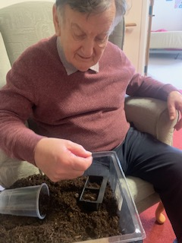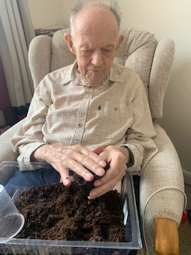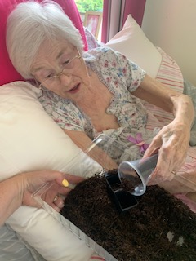
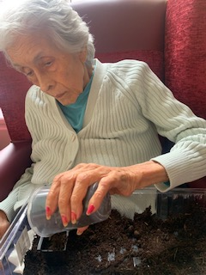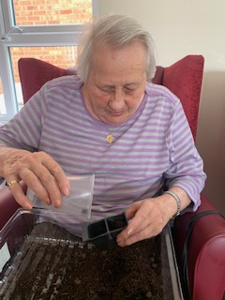
We also did some more sunflower seed planting. Heather loved getting her hands in the soil and although Dorothy did plant hers she was more cautious of gettting dirty. But chatted and enjoyed it none-the-less.
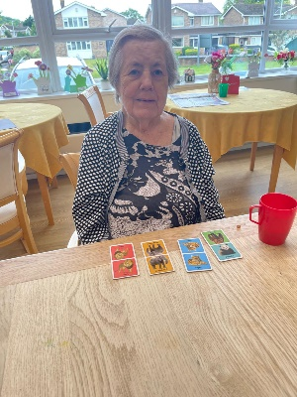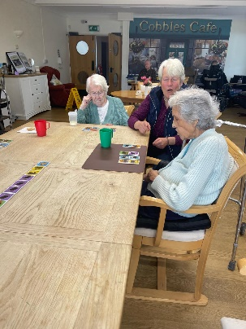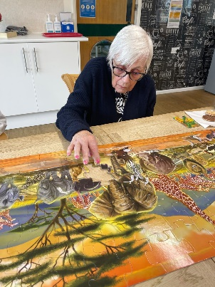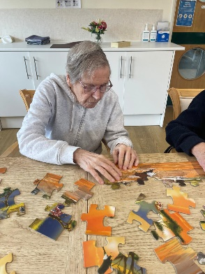
The whole day had begun with some calm and relaxing time doing some puzzles in the dining room. Cynthia did well helping Carol with the lovely safari puzzle, and Carol joined her mum Sheila helping out too.

