Wednesday 29th May 2024
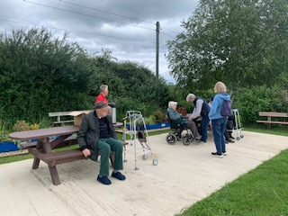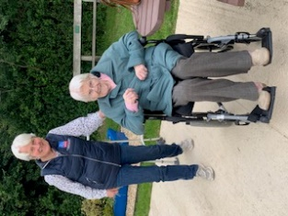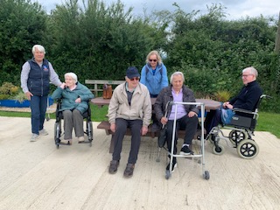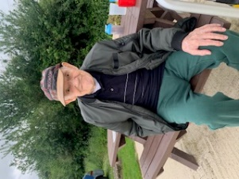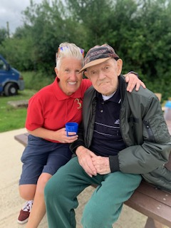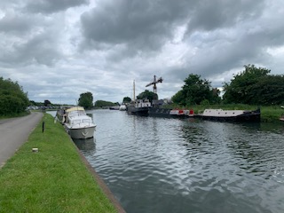
This morning began with a some of the residents going in the minibus to Saul Junction to sit by the canal and have some fresh air a coffee and to watch the boats go by. It was lovely to spend time outside and look at the plants and the activity on the canal. There was lots of banter and laughter which was great for them to all connect with each other, and also other people walking dogs along the canal too. They all enjoyed the change of scenery and having a bit more sensory stimulation from the different smells and sounds.
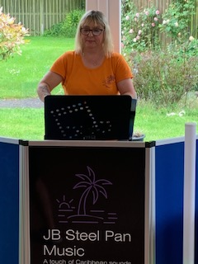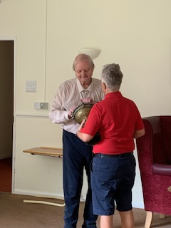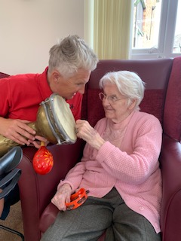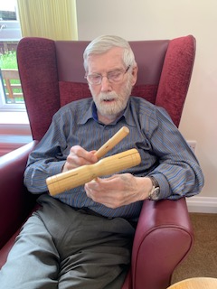
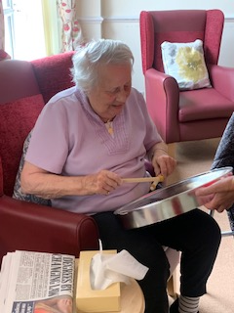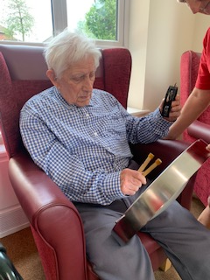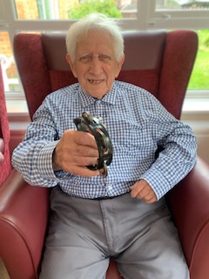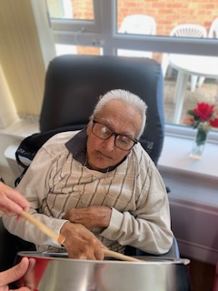
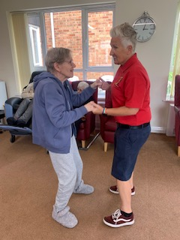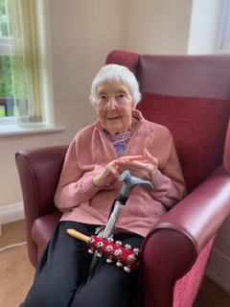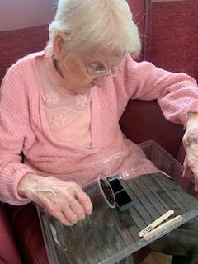
This afternoon we have had Julie entertaining us in the lounge with her steelpans and some lovely music. Everyone had a go playing the instruments and some of them also had a go on a steelpan. There was some great smiles as the music was recognised and the rhythms enjoyed with the instruments. Carol had a lovely time getting up and dancing to a number of tunes and the smile on her face showed how much she was loving the connection with Tracey. Fred was coming in and out of the lounge and was heard singing and clapping enthusiastically. He even had a go on the drums. It was nice to see Peter and Denis getting into the music too, using the instruments and along with Sheila who was tapping hers throughout the whole concert.
A very interactive afternoon for everybody, and great for getting active and for conecting with others, staff, families and other residents.

