Thursday 2nd May 2024
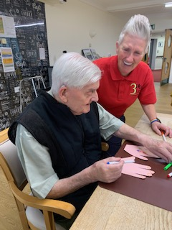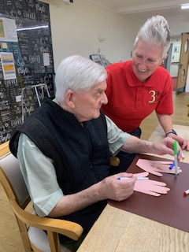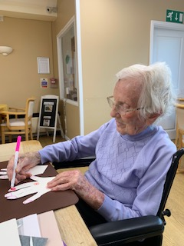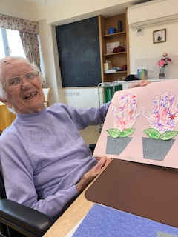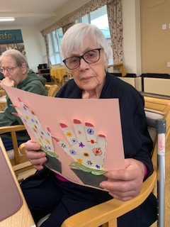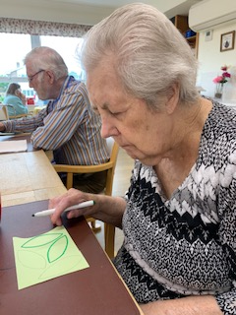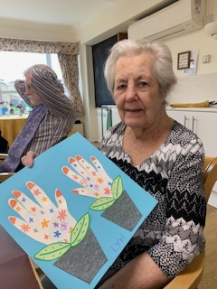
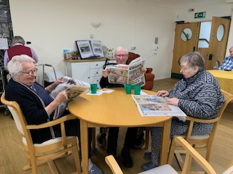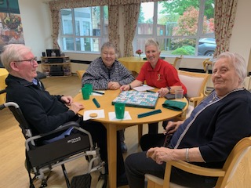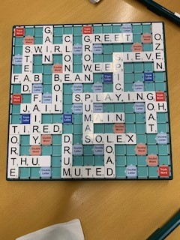
This morning we have had two activities going on in the dining room. We had some more residents taking part in the arts and crafts of making may day flowers using their hand cut outs. Sybil, Lyn, Cynthia and Reg all had a great time creating lovely hand images that were colourful. It was good to see them having a go themselves and holding the pens themselves.
On the other table we had Brian, Heather and Mary playing a game of Scrabble with Tracey. It was a really good game with some fab words played and Heather’s score was amazing, allowing her to win the game. This was really good for them to use maths skills as well as the vocabulary, so a good brain workout for them.
This carried on with them all having a read of their newspapers whilst waiting for dinner to be served.
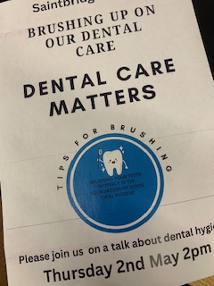
This afternoon we had a visitor come in to talk to us all, staff, residents, and families and friends, about dental care and mouth care.
This was really informative and a good opportunity for questions to be asked and care and actions to be discussed. A very vaulable opportunity for everyone who attended.

