Thursday 30th May 2024
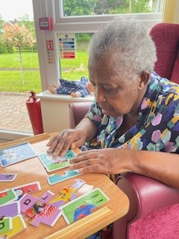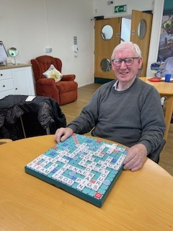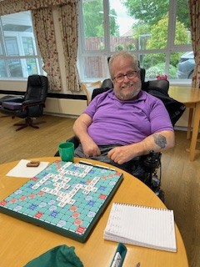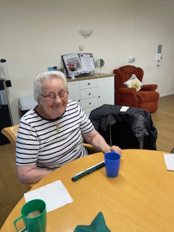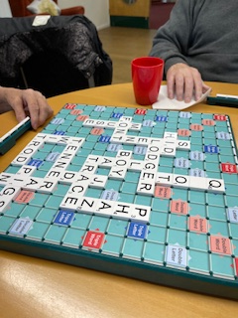
This morning, we have been playing scrabble in our scrabble club, everyone got their thinking caps on and made some good words to get the high points, Brian was on top form today and was this week’s winner, as you can see by his face, he was very happy.
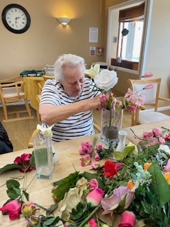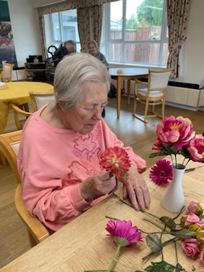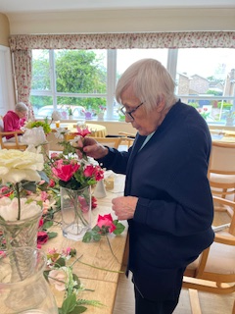
Some of our ladies have been getting creative in our flower arranging group this afternoon, they have been filling all the vases with beautiful flowers so they can be displayed around the home, Lynn went with the pink flowers for her creation, and Cynthia decided on using the tall white flowers.
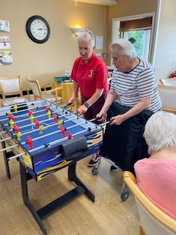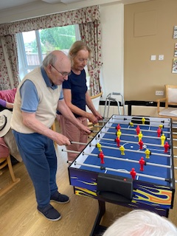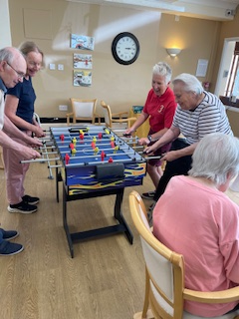
We finished off our afternoon with a shoot out on the football table this is a great exercise and is great for coordination skills whilst having lots of fun, David and Astrid played well today and won 5-4 myself and Heather are awaiting a rematch.

