Friday 31st May 2024
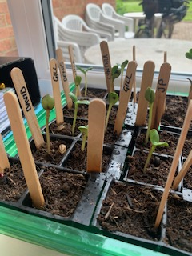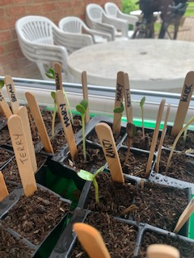
Today we have started by looking at the beginning of the sunflowers popping up through the soil of some of the residents seeds. Staff have also started planting some, so we can have a competition and see whose will grow the tallest by the summer.
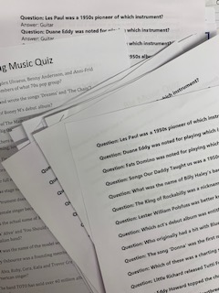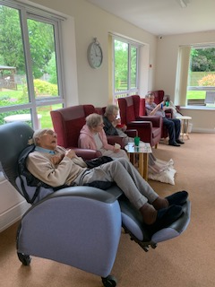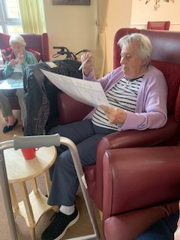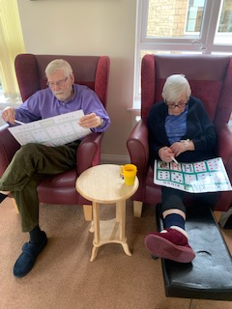
Then this afternoon we have attempted a big music quiz…sadly we just couldn’t get Alexa to work and we hadn’t got enough musical knowledge to get through!! So we resorted to a game of Bingo Bongo!
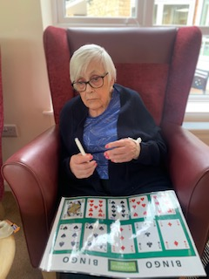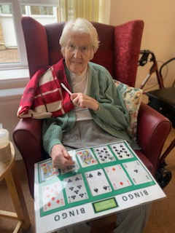

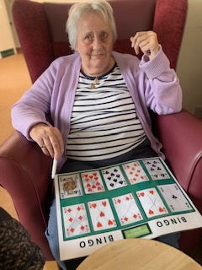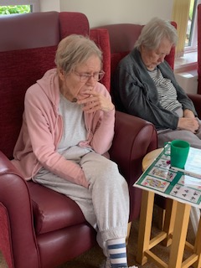
Everyone was getting involved and they concentrated well enough to recognise the numbers and the card suit. There was also good fine motor skills in using the felt pens to mark off the playing card on their bingo card.
Our winners, yes we had two today, were Mary and Denis.
Congratulations to you both!!

