Friday 3rd May 2024
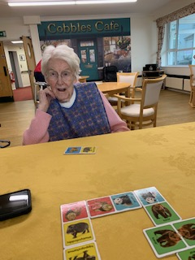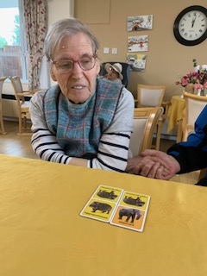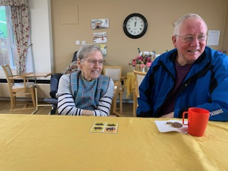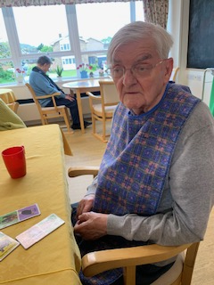
This morning we have played a great little game of animal dominoes. It was good for getting Carol, and Sheila engaged, as they were able to identify the animals and the coloured backgrounds on the domino pieces.
Carol’s husband joined in with us and was encouraging Carol too, and Reg was very chatty about his animal pieces, telling us all about them.
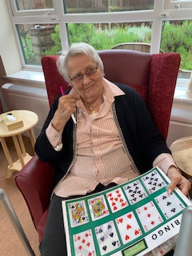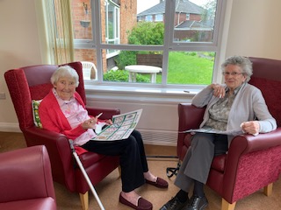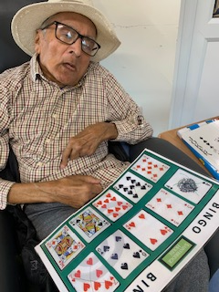
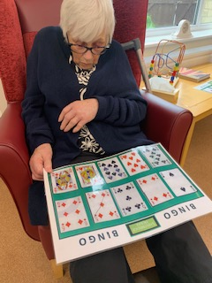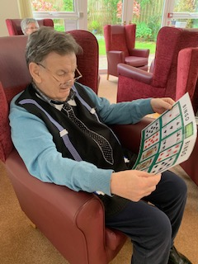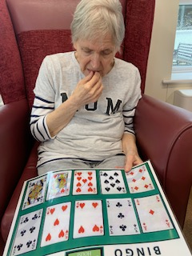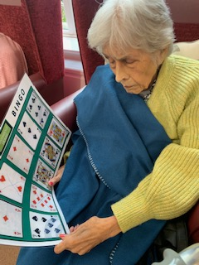
This afternoon we had a great game of Bingo bongo with lots of the residents joining us in the lounge. We also had friends joining in with us too which is always nice for the residents.
Everybody kept an eye on their playing sheets whilst the cards were called at random. It was a very close call towards the end with Sheila, and Carol and Terry being very close to getting a full house. However, Dennis was our winner getting all of the cards called on his sheet.
He was really chuffed, and he said especially as he didn’t really know the game and was learning as he went along.
Well done Dennis.
