Monday 6th May 2024
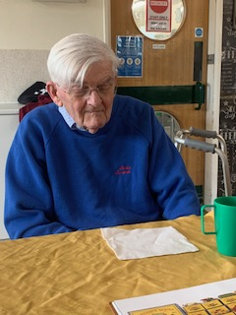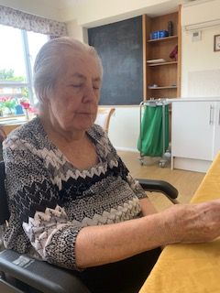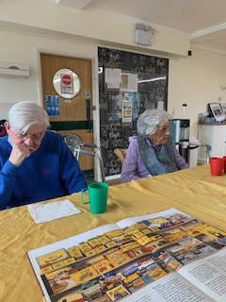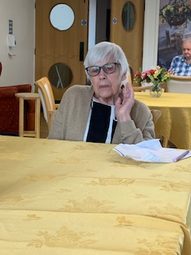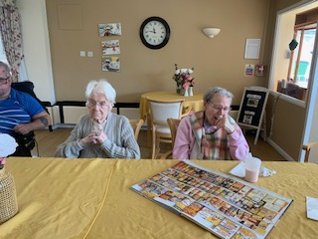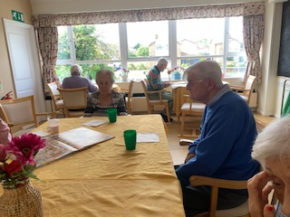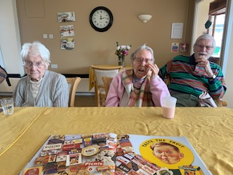
This morning we have had a time of reminiscing. The topic we started with was foods we ate growing up that we don’t see as much now, and we ended up on swets and choclates we love! The intial question posed was if anyone had ever tried eating rabbit!!
Lyn, Kirk, Dennis and Sheila were very engaged and shared lots of their favourites. Heather was encouraged to partake which she did at times, telling us about school dinners and also eating squid!
Reg, Cynthia, and Dorothy all took part, sharing meals they remember and chatting about favourite sweets and chocolates.
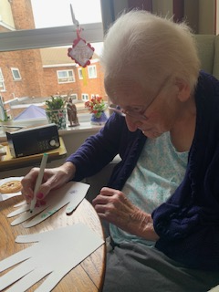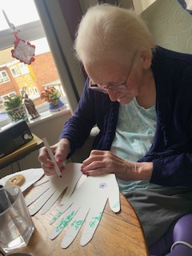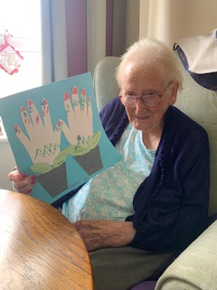
Betty had a 1-1 time in her room making her May day flower hands picture. She was guided to colour and add pattern to her cut out hands, and then she stuck them on to the picture wioth her leaves and plant pots, creating a lovely floral picture for May day. She enjoyed doing it and was able to feel proud of her finished picture.
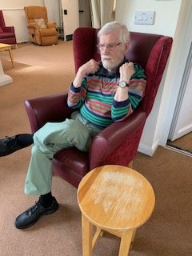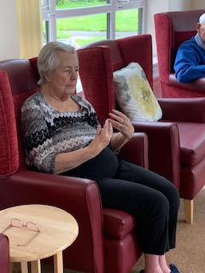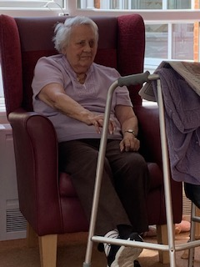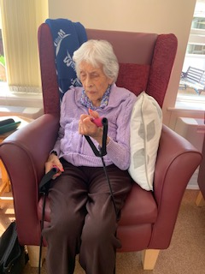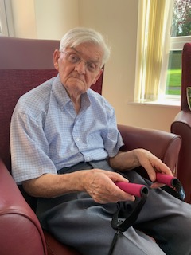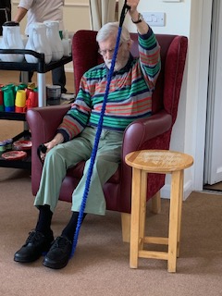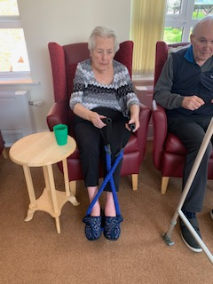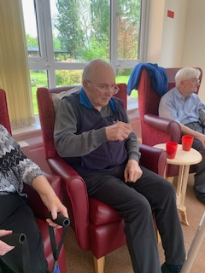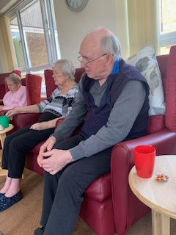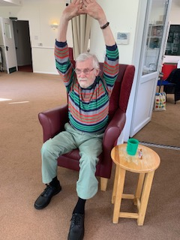
This afternoon we had Tanya from G-fitness come and do some excercise with us. It was very warm but everybody had a go and joined in as much as they were able. There was some great stretches from Dave, Dorothy and Sheila, and Dennis really showed off some phyiscal strength with everything he did. Heather managed to do lots of movement with her arms and legs, and stretched down really nicely too.
Lyn really moved a lot today, following Tanya with all the moves, and engaging really well. She was also singing along to some of the songs as well.

