Tuesday 7th May 2024
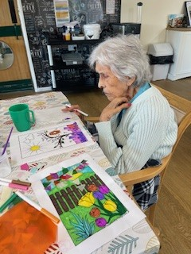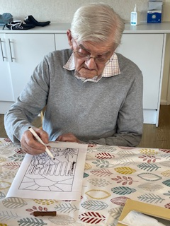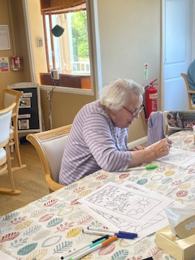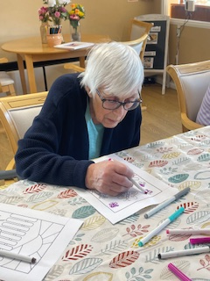
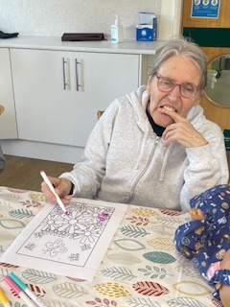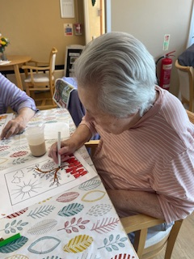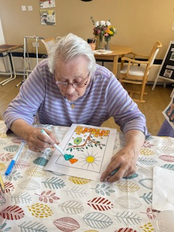
This morning we have started our stained glass window pictures for the Spring. The residents were given Spring flower pictures and started with colouring those in. We will then be adding in some tissue paper scraps to create a colourful sky that the light will shine through. It was good for the residents to concentrate and chose their own colours, and there were some lovely Spring colours on show.
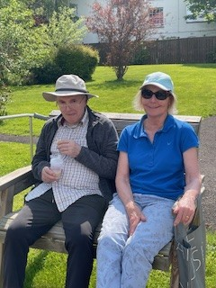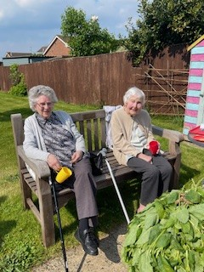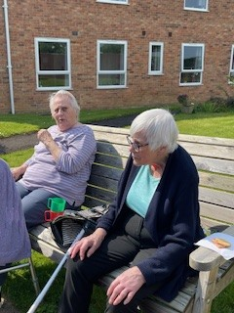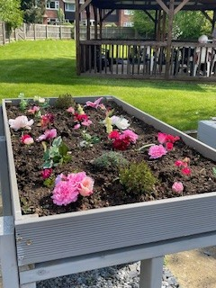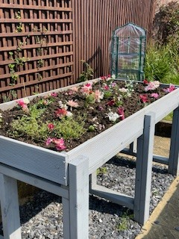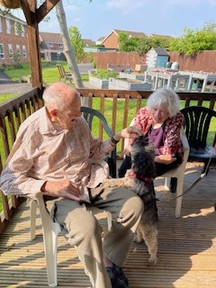
The weather this afternoon was so sunny we had to make the most of our beautiful garden. Residents and visitors were enjoying sitting out and chatting and having their cup of tea and biscuits. Ann was out with Bernard, and Maureen came out with Mary. David loves the garden and will always go out with Astrid, so he enjoyed a really relaxing time with his wife chatting and just enjoying each others company.
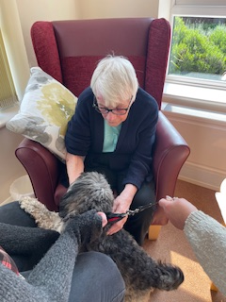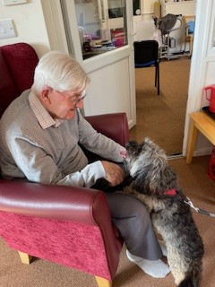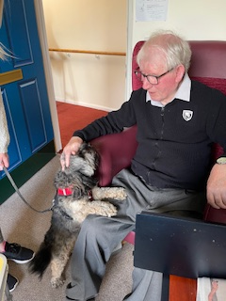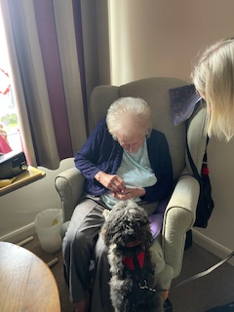
Then we also had the lovely Peggy come and visit with her owner Hayley. Peggy is always a big hit with the residents and today was no different. The smiles and lifted mood when they saw her was amazing, and of course Peggy does always enjoy their little treats. A lovely way to end the day with them all smiles and relaxed from stroking the furry visitor.

