Wednesday 8th May 2024
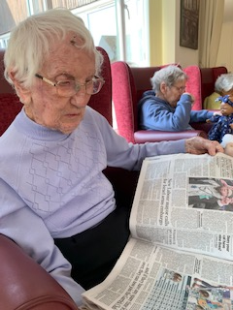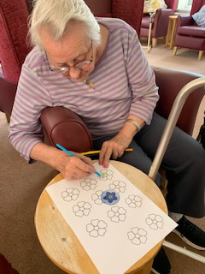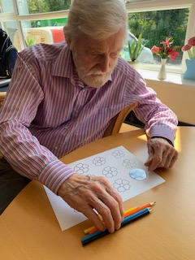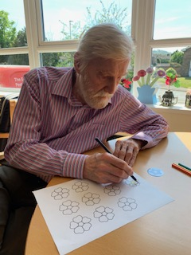
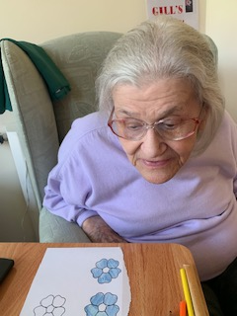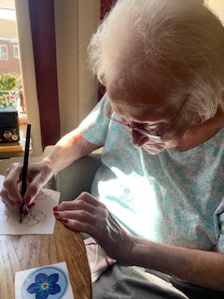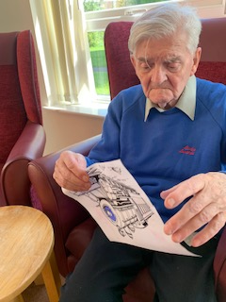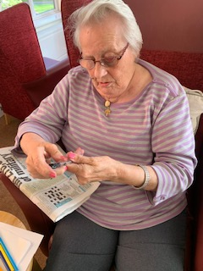
Today we have been enjoying some very warm weather which has made us all really sleepy and not very motivated to do much.
We have some pampering this morning with Dorothy and Heather having their nail varnish refreshed, which made them feel much better, nothing like a little pamper time to life the spirits.
Kirk and Reg also had a lovely hand massage which Kirk enjoyed but Reg wasn’t quite so convinced about it’s benefits, but happy for the company none the less.
This afternoon we have been colouring some forget me not flowers in preperation for your upcoming dementia awareness walk. There was some lovely colouring and chat whilst doing it, with Betty and Gill doing theirs in their bedrooms.
Sybil had a long period today reading the newspaper, and we chatted about what was in it. She was saying how it was so confusing these days and some of it made no sense to her. She did enjoy looking through it though.
Reg tried some colouring and we had conversation about trains for Train day today, which was good to help keep him interested and stimulated.

