Thursday 9th May 2024
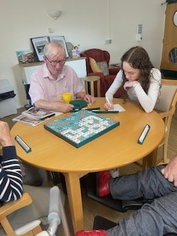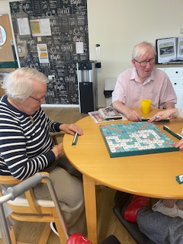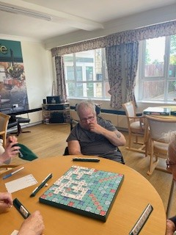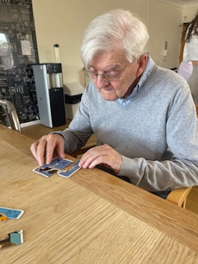
This morning we have had scrabble club and it was Kirk’s first time, he had stated that he has not played scrabble for a very long time, Brian was the lucky winner today, he has knocked Heather off the top spot, well played Brian, Reg enjoyed doing puzzles and putting pieces together.
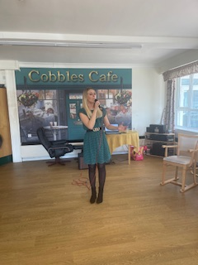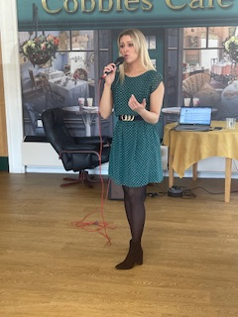
Emma from mini concerts came to sing for us today, she sang lots of Elvis and Abba, our residents loved singing along.
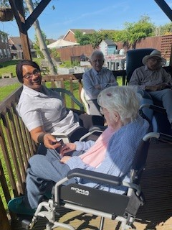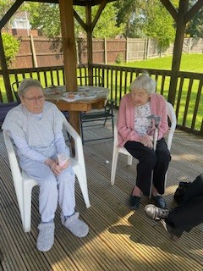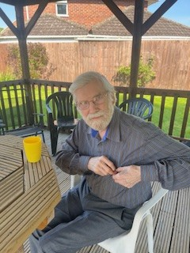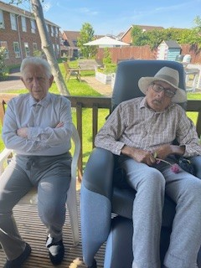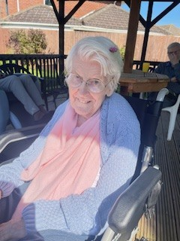
We have managed to get out in the garden this afternoon and enjoy the sunshine, we had afternoon tea and cake, our residents love being out in the garden listening to the birds, and chatting together.

