Instagram: the_heathers_home

Welcome to The Heathers Nursing home newsletter.

The aim of the newsletter is providing an informed and sometimes light hearted look at what is a very important job in looking after our residents.

In this months newsletter we will be catching up from some months we missed at the end of last year. We hope you’ve had a lovely start to your year.

please follow us on social media

Facebook: The heathers nursing home

Instagram: the_heathers_home

The Heathers Nursing Home

Monthly news letter

Visiting arrangements

Visits continue to be on an appointment basis only, to monitor how many people are at the front door and in the building at once - this is for everyone's safety.

Lateral Flow Tests are still recommended to enter the home (not mandatory)- if you need any kits, please ask a member of staff.

The use of face covering (medical mask) is still required to be worn and will be supplied at the door.

Reminder visiting times is 10.30 am - 8.00 pm, every day.

If ringing in to see how your loved one is, please ring after 11.00 am and speak to the nurse in charge on option 3.





**Catching up!**

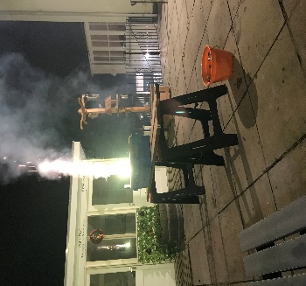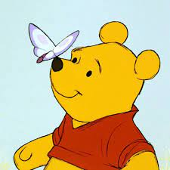

We started November off with a BANG! like most people we celebrated Bonfire Night with our very own display by our maintenance man Mark, Residents were able to enjoy it in the warmth of the home

As always we have been doing an abundance of different activities, we try to keep every day different. Here is some things we have got up to since the last newsletter in October 22'

**November Activities**

It’s been a while, but rest assured we have been having a lot of fun and celebrations here at The Heather's, From Christmas parties to Birthdays to a whole day dedicated to Winnie the Pooh himself. let’s catch up and find out what’s been going on at The Heather's

**November Tea Party**



In November we had a lovely tea party in which we had tea and cupcakes in one of our porcelain tea sets.

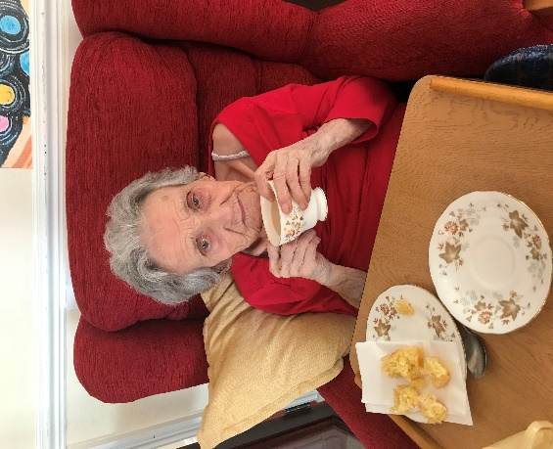

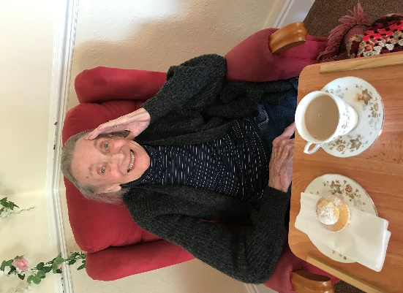



**December Activities**

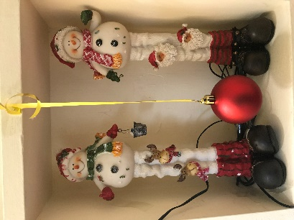

In December we filled the month with many festive activities, such as parties and day to day festive themed activities, The residents had a lovely Christmas celebrating with their families and staff member at the home.

Our staff worked together in order to decorate the home as much as we could to create an amazing festive atmosphere.

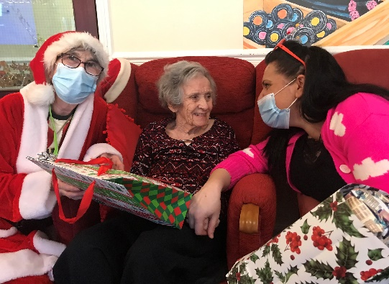



***CHRISTMAS!***

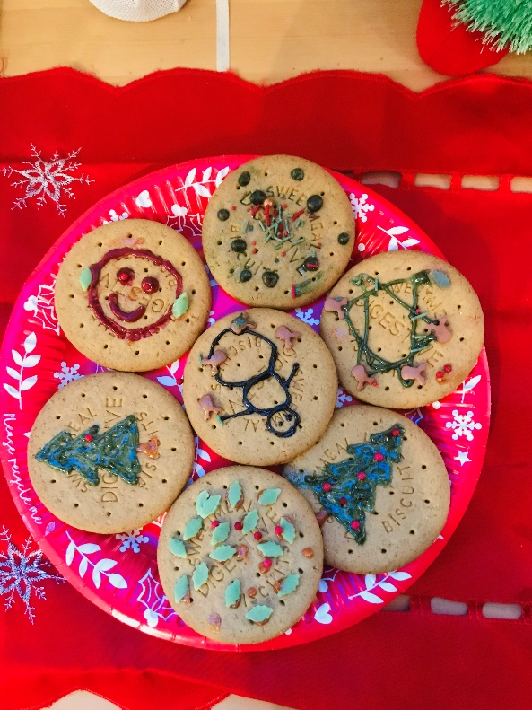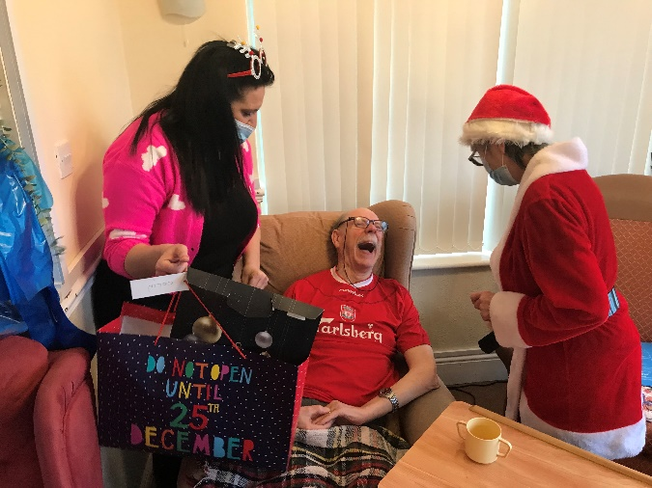

Over Christmas Day everyone came together in order to celebrate. Being festive the whole month making every second count.

We kicked off our Christmas with a party, in which we played Bingo, had lovely food and invited Shannon a great singer to come along and give us a show!

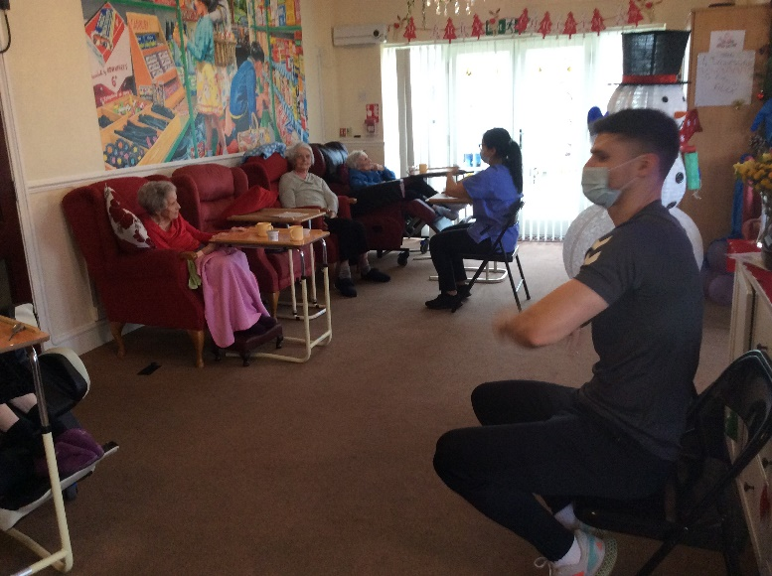

**Happy New Year!**

**January**

On January 18th we celebrated Winnie the Pooh Day, watching classic episodes and eating honey sandwiches!

**Winnie The Pooh Day**

After a lovely Christmas, We went into the new year ready for more exciting activities.

**December Activities**



21st Karaoke

22nd Quiz

23rd Biscuit Decorating

24th CHRISTMAS EVE

CHRISTMAS DAY  
26th Pamper day

27th Sensory

28th Bingo

29th Arts and Crafts

30th Games

31st NYE resident's party

11th Church on youTube (Chipping Sodbury Baptist church)

12th Christmas Arts and Crafts

13th Carol singers

14th Pamper day

15th CHRISTMAS PARTY

16TH Sensory

17th Games

18th Church on youTube (chipping Sodbury Baptist church)

19th Singer Frank at 11am

20th Movie night

1st Christmas Decorating / Tea Dance

2nd Church service at 11am

3rd Arts and Crafts

4th Games

5th Quiz

6th Pamper Day

7th Alex G fitness

8th Bingo

9th Carol Singers

10th Movie night

**January Activities**

**11th Zoo lab**

**12th Arts and Crafts**

**13th Bingo**

**14th Karaoke**

**15th Church Service**

**16th word searches**

**17th Bingo**

**18th Winnie the pooh day**

**19th Quiz**

**20th Frank the singer**

**21st Poetry**

**22nd Chinese New Year**

**1ST HAPPY NEW YEAR!**

**2ND Sensory**

**3rd Games**

**4th Alex G**

**5th National Storytelling Day**

**6th Bingo**

**7th Chair exercise**

**8th Church Service**

**9th Games**

**10th Pamper day**

**23rd Games 30th National croissant day**

**24th Arts and crafts 31st International zebra day**

**25th Burns night**

**26th Chocolate Day**

**27th Holocaust Remembrance Day**

**28th Lego day**

**29th National puzzle day**

