Brook House Newsletter
Its October, which means Halloween is officially upon us!


This month, we have lots of visitors including Boogie Beatz and Samantha the Singer to look forward to!
Sunday | Monday | Tuesday | Wednesday | Thursday | Friday | Saturday
1 | 2 | 3 | 4 | 5 | 6 | 7
8 | 9 | 10 | 11 | 12 | 13 | 14
15 | 16 | 17 | 18 | 19 | 20 | 21
22 | 23 | 24 | 25 | 26 | 27 | 28
29 | 30 | 31
October 2023

Please tear and keep this page for your monthly calendar
Reflections
September has been a cheerful month where we enjoyed lots of lovely coffee mornings!


One highlight of the month would be our advertising trip out to Rugby, where we spread awareness of our lovely home!

Baking
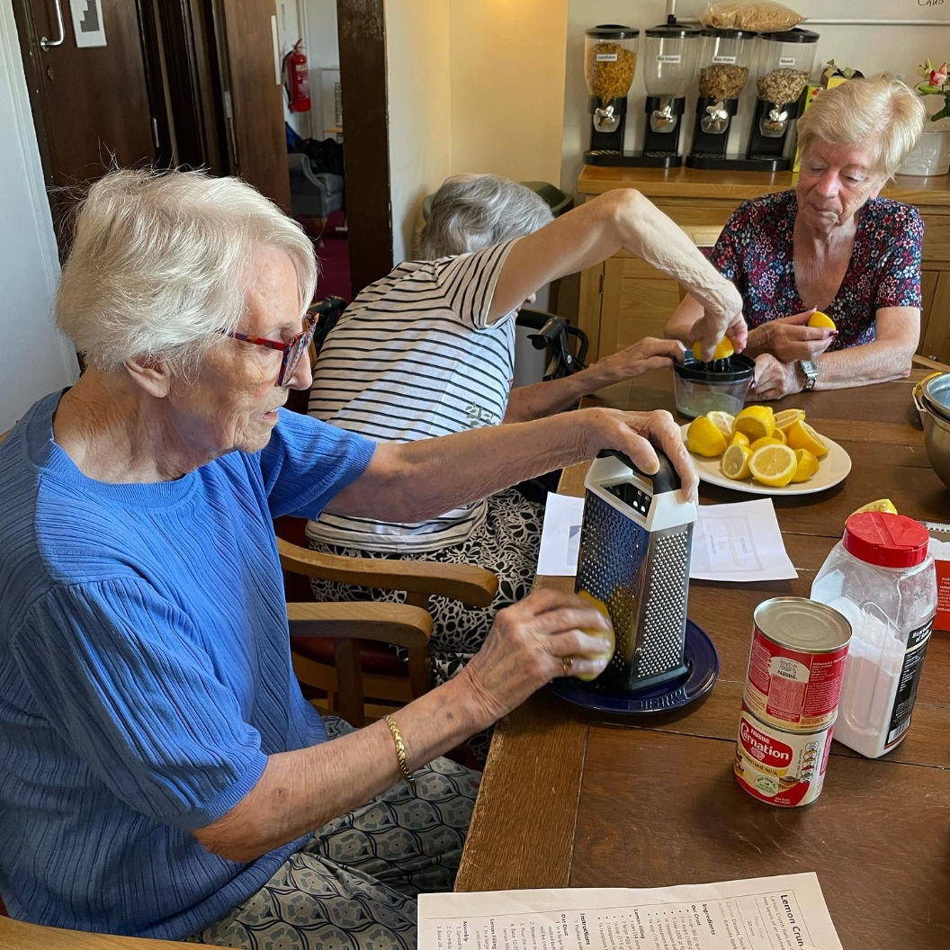
We have been loving getting hands on when baking after lunchtime. We have been experimenting with some different treats and so far, we think our layered brownies have been the favourite!!







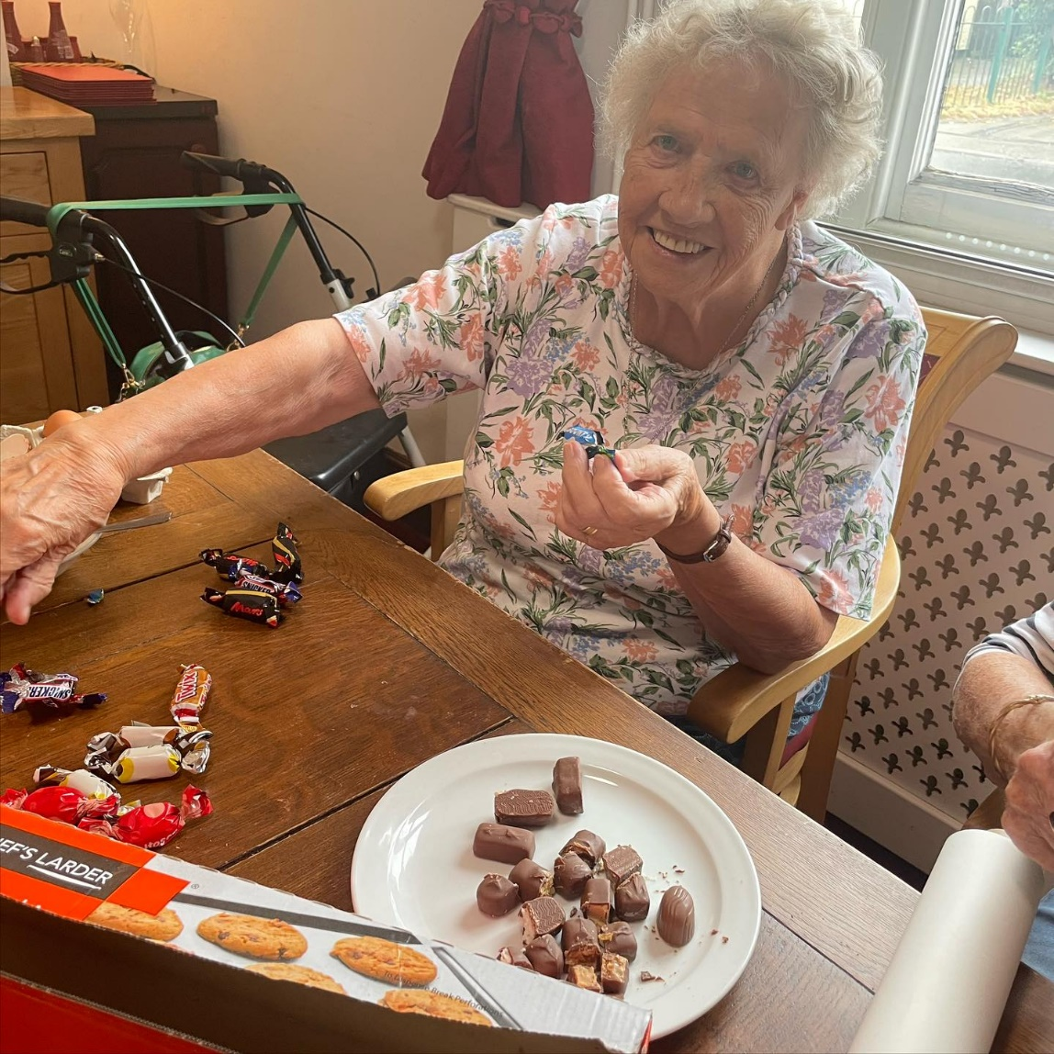
September has been full of delicious food from our Baking Bandits! …





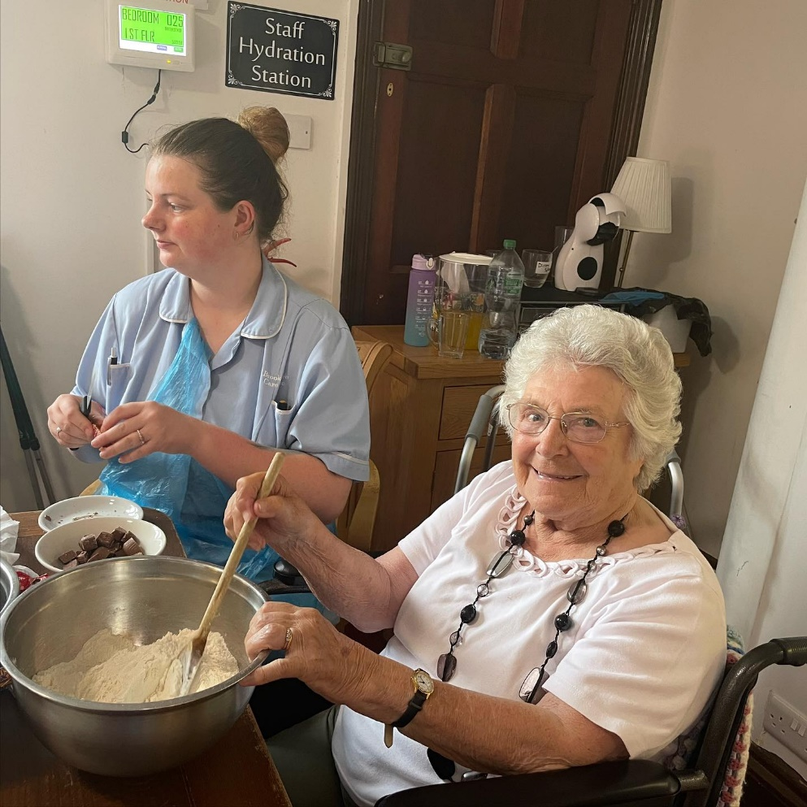

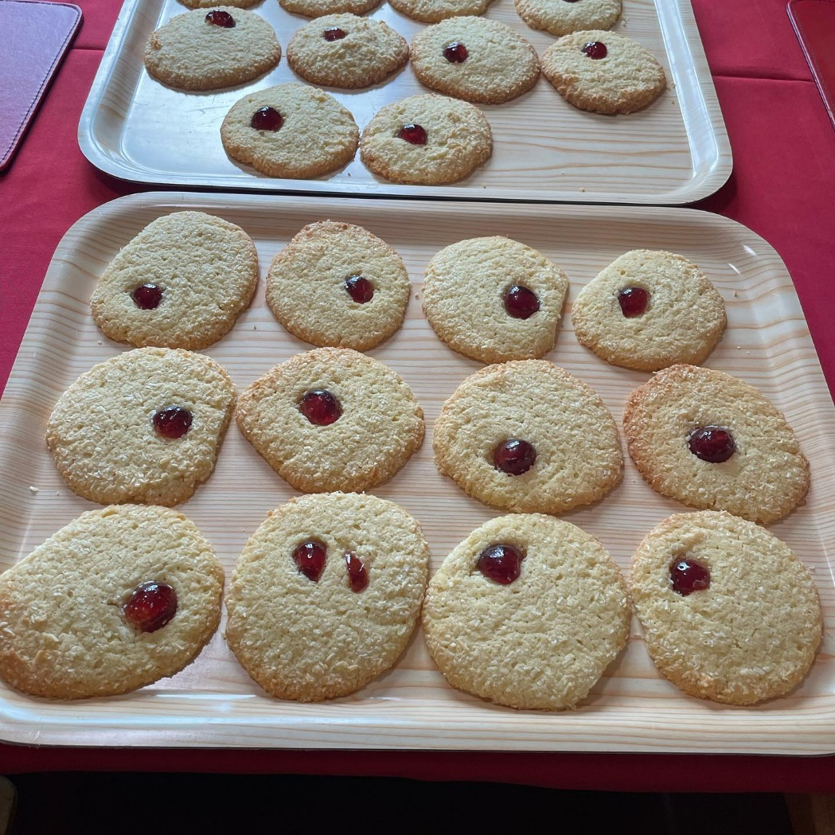

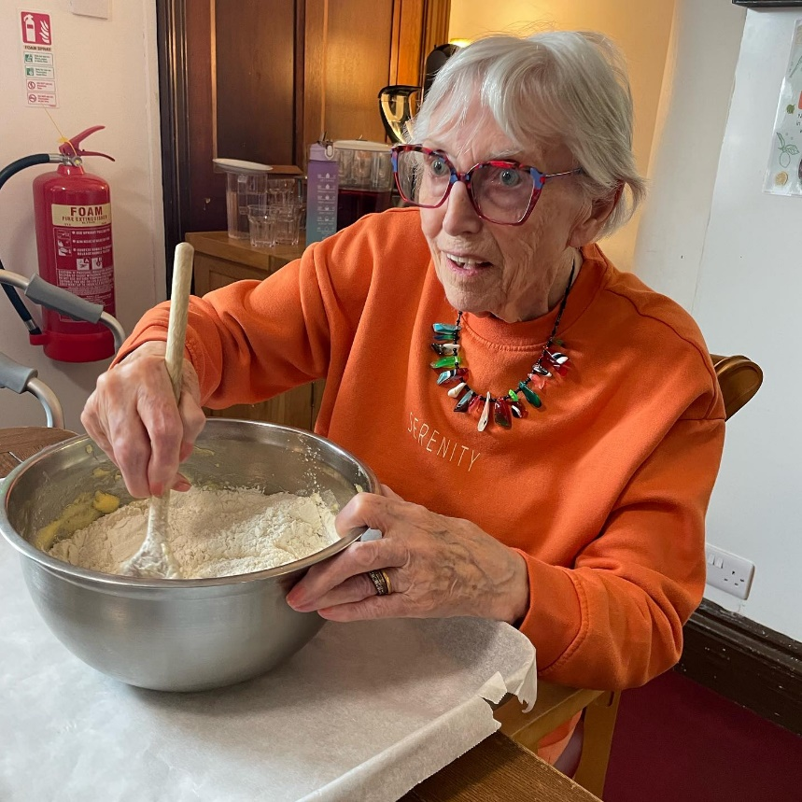





Mini Bus trips!
The residents love our little trips out to various places! Recently we have visited Cherry Tree Garden Centre and much more!


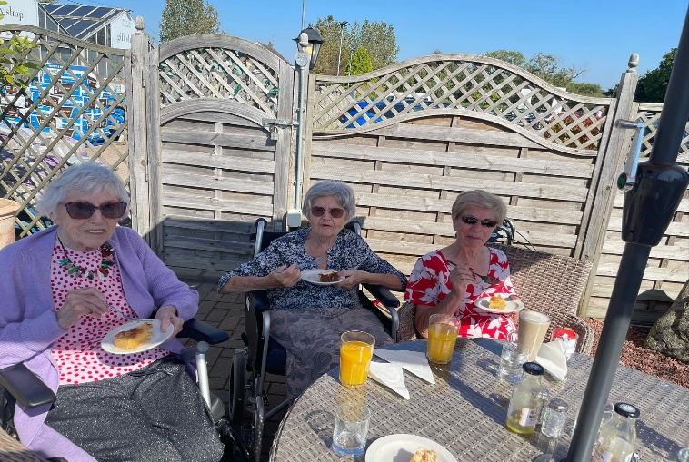


Our lovely Coffee Morning…
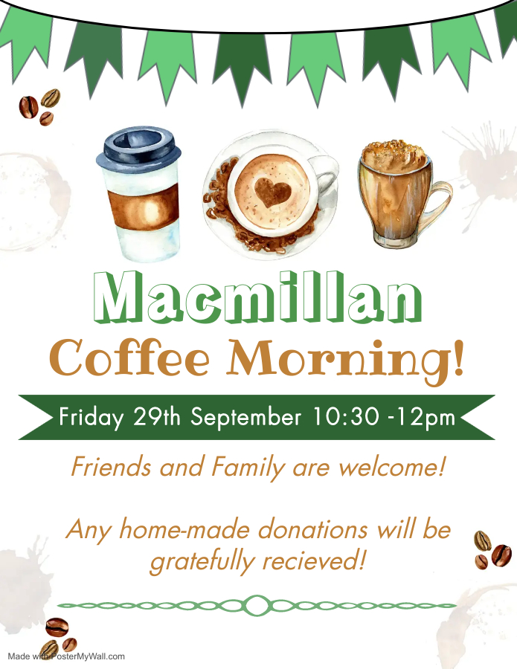

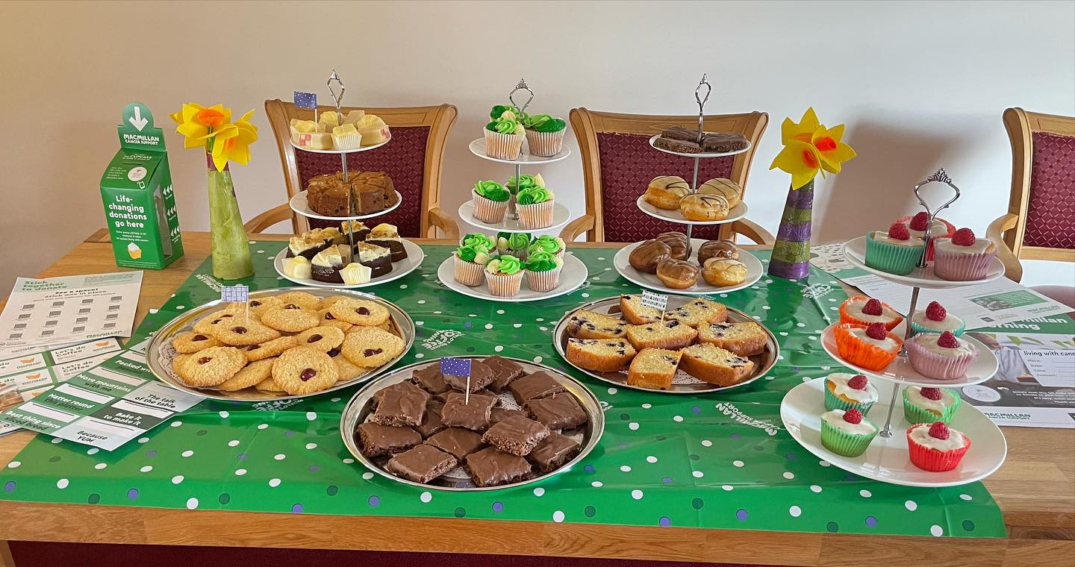

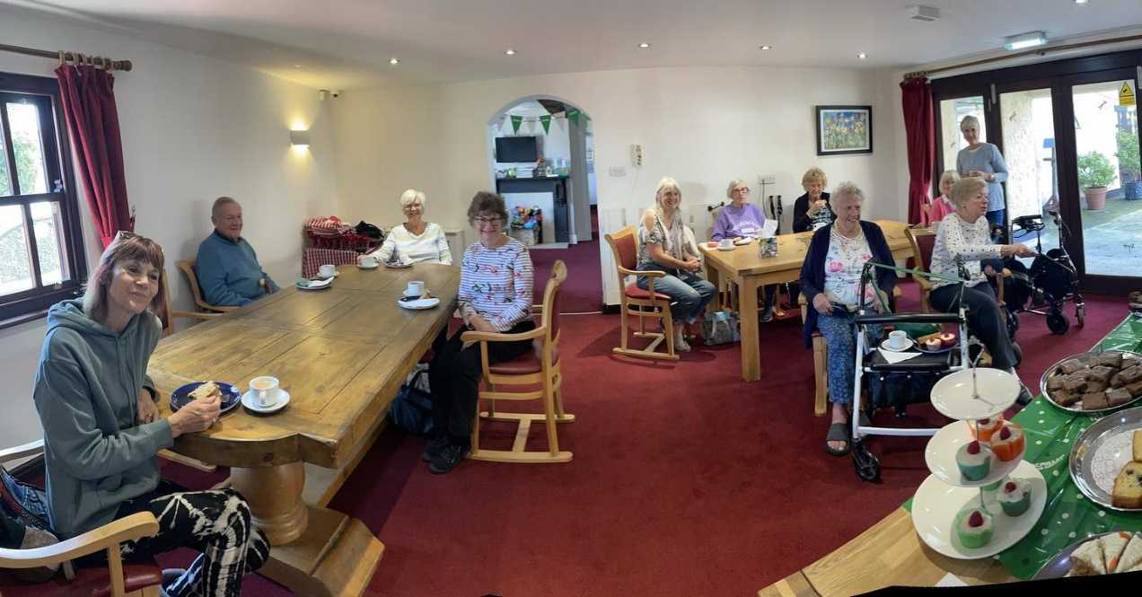

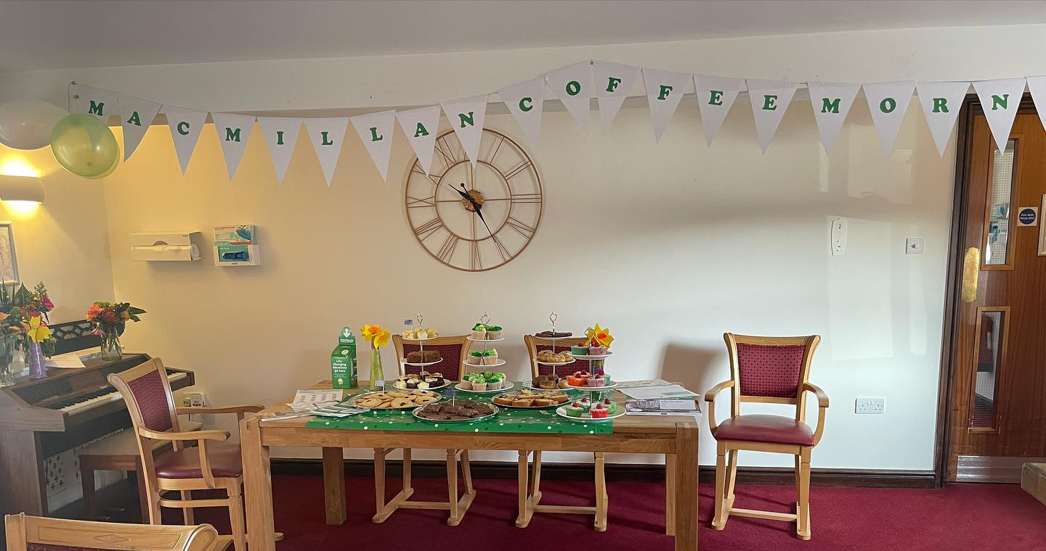

Coming up this month…

Boogie Beatz – October 3rd

Holy Communion – October 4th

Carl the Singer – October 6th

Wear Pink Day – October 20th

^{Halloween! – October 31st}



Rugby Central Advertising Day!
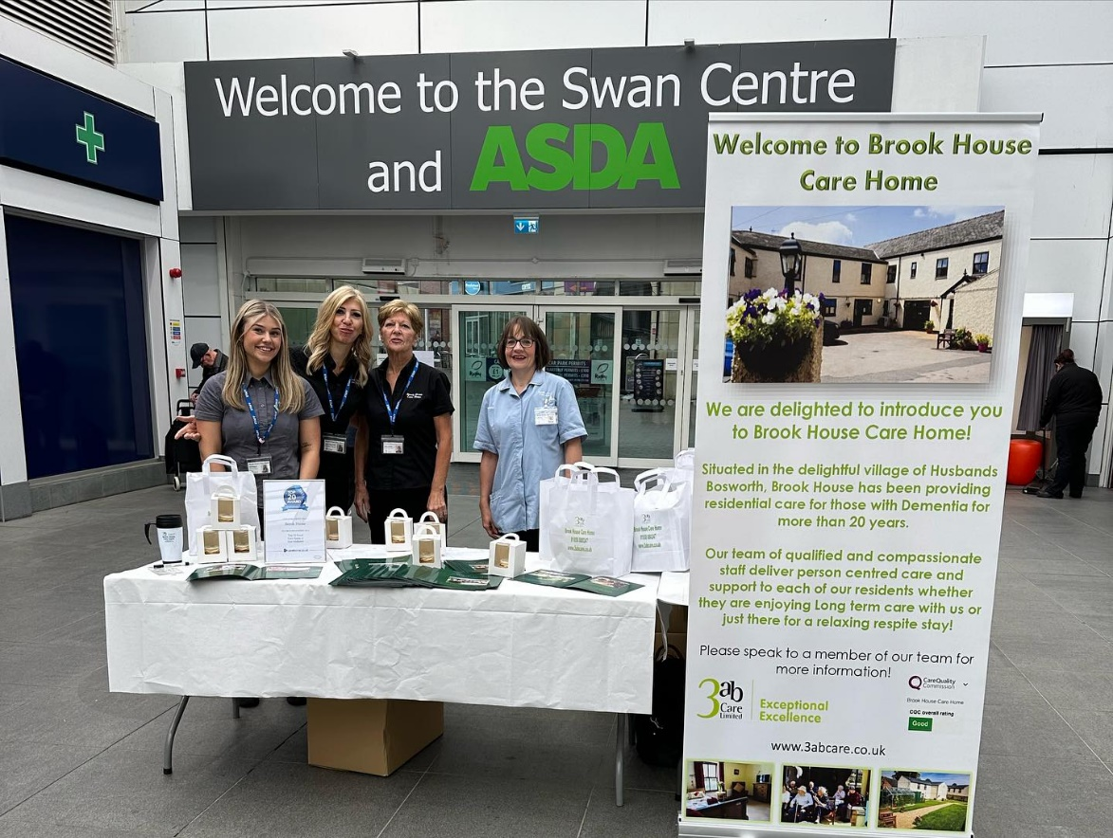
This month we took our minibus trip to rugby, where some of our staff members were set up with a stall to raise awareness of our lovely care home…

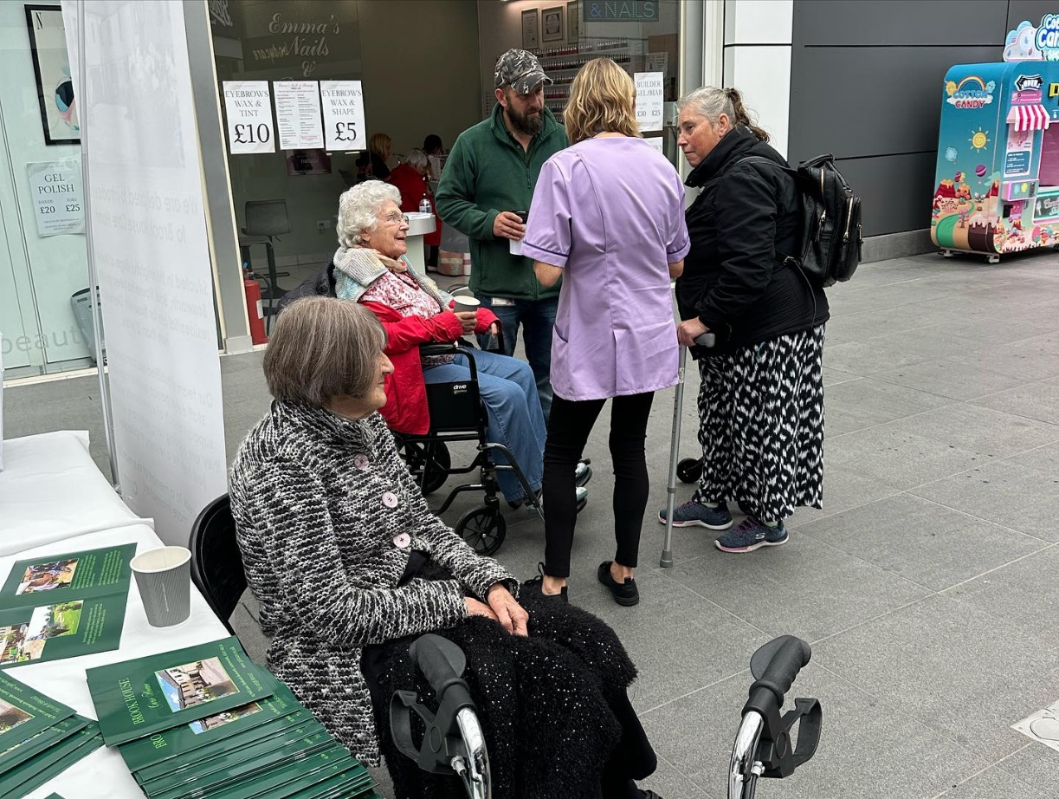

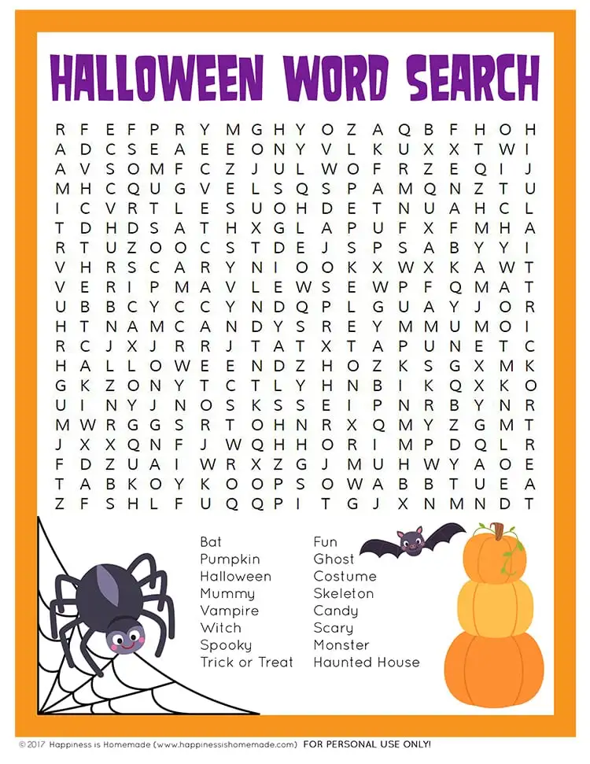
Brain Puzzle time…


Colour me In…..





Ann Johnson – 3rd October
John Hunt – 6th October
Kate Jameson – 19th October

Horoscopes
Spooky season is coming, so get ready to lean into your most intense and honest incarnation of yourself. Embrace October’s predictably enticing blend of glamor and mystery, propelling us toward transformation, and perhaps even makeovers.

