Saintbridge House
Impact Stories
Navratri Festival Celebrations
It is very important to Ravji that he has his family and friends together for Hindu celebrations, unfortunately back in 1977 there were not many places to celebrate in Gloucester. This inspired Ravji to set up his own gathering, which he did, the first celebration was held at Hatherley Road School, but now are held in different venues all over Gloucester. Family and friends travel from all over to be part of these celebrations.
Ravji has not missed a festival, although his health has deteriorated and has affected his mobility, he wanted to go and be very much a part of the celebration. We were delighted to help make this happen and supported him to attend.
Everyone was delighted to see Ravji and made him feel very special, it was a very emotional experience as some of his family and friends had not seen him in a very long time. Ravji thoroughly enjoyed being part of the celebrations and spending time with his family and friends.
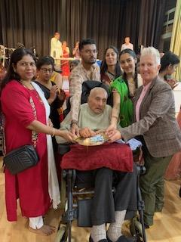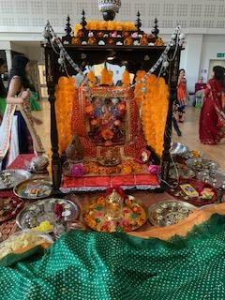
Ravji joined in with the Dandiya (stick) dance, watching everyone, as they danced around the room.
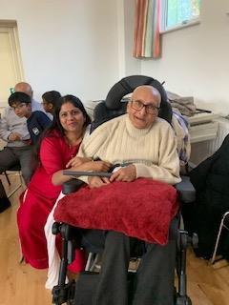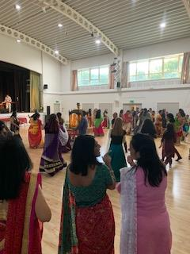
Ravji’s family were with him for the offering to the goddess, and once finished was served a feast,
We at Saintbridge House encourage our residents to continue with the things that are important to them, and we support them wherever possible.
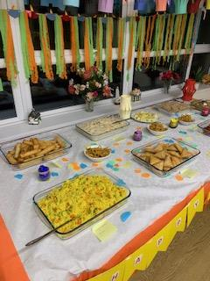 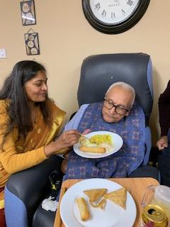Diwali Celebrations
We were also delighted to hold our very own Diwali festival at Saintbridge House, making decorations, listening to music, and dancing.
We also had an Indian feast which was prepared by our very own staff. Ravji’s family also came along to celebrate with him, it is very important to us that we embrace other cultures, and that our residents are always included and feel valued.

