Saintbridge House
Welcome to our July newsletter!

Fun Facts about July

- The July gemstone is the ruby
- The July flower is the waterlily, but also larkspur
- July was named after Julius Caesar in 44 BCE. Its original name was Quintilis, Latin for the “fifth month,” indicating its position in the early Roman calendar.
- On average it’s the warmest month in the UK.
- July is known as both Picnic Month and Ice Cream Month!
- Sometimes the hot, long days of July are called the "dog days of summer"
- Diana, Princess of Wales was born 21st July 1961

Let’s look at what we have been up to in June
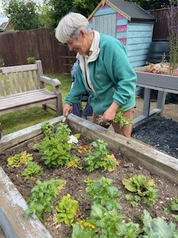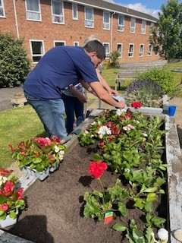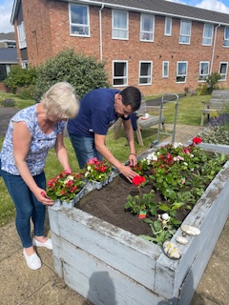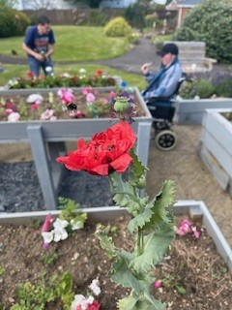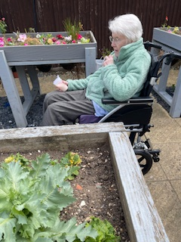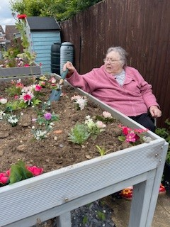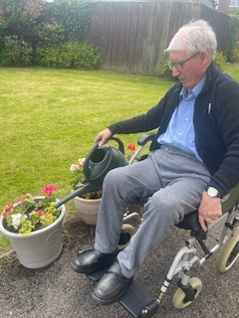
The garden is a lovely space to spend a sunny afternoon, however it is going to look even better after the big garden project in July.
The residents love going and spending time with family and friends out there, and very often having their afternoon drink and snack out there too. There have been a few less rain showers restricting us in June too.
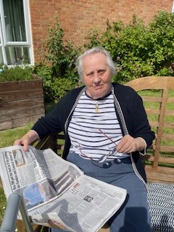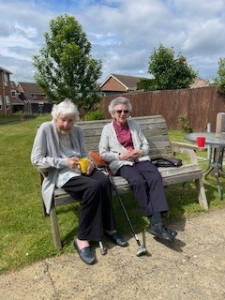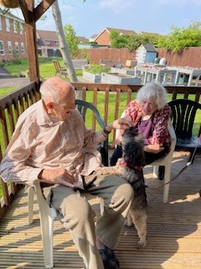

Reminiscence Group
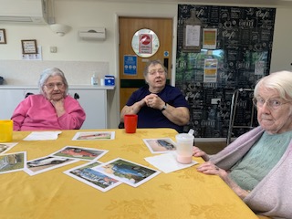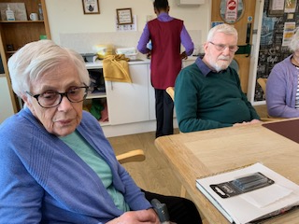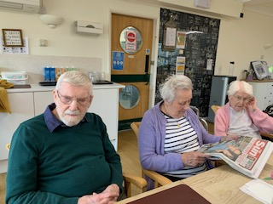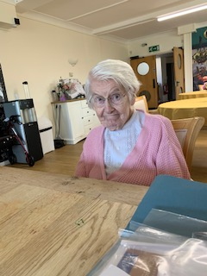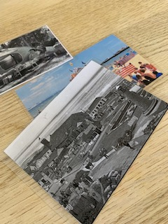
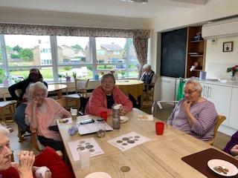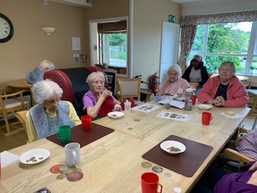
Our remisiscing mornings have continued during June and we have talked about a real mix of topics.
We had a morning chatting about cars, and what cars we could remember driving. When we passed our tests and how many times we took it. It was very interesting to hear about the differences in the driving tests and who passed first time.
For another reminiscence morning we talked about learning to write. It was very different for everyone and in particular Mary was telling us that due to be it being after the war, she learned to write using crayons, as pencils were not readily available to them.
Another topic in June was holidays. Not everyone could remember them very well, but it was nice to chat about places they might have wanted to go, and Doreen was very happy telling us she would have liked to have gone to Canada or Australia.
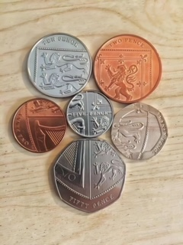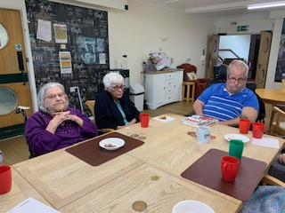
Another topic we have discussed was money and everything about it. Kirk remembered quite clearly how he was only 9 when decimilastion happened and he had to learn both types of money at school. Everyone remembered the old money very well and we had a quiz about the values and names of some of the old coins, such as the florin or the bob. We also spent some time using current coins and doing some comparisons of size and value, and then a bit of maths using coins and shopping for items.
Gill, Ann, Heather and Cynthia were all quite amazed at the cost of things today in the supermarket. Which led us on to talking about where you would buy things such as bread. Nora and Sheila said about going to the local baker rather than big stores as we do now.

Creative Art group
There has been lots of creativity during June again.
A couple of the ladies continued with the mosaic rainbow pictures. Heather and Mary had a lovely afternoon getting theirs made and they looked very colourful.
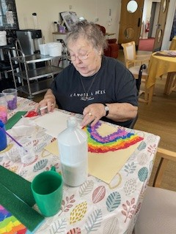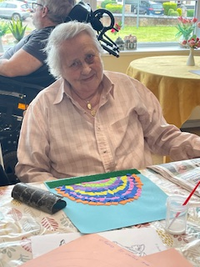
Then we have got the paper plates out and got inventive with them, making some colourful parrots for World Rainforest Day. This was really good fun and made all the more fun by chatting about the colours that everyone chose, and making sure we stuck the eyes in the right place! Heather was very creative with her feather positions and Mary chose some really great colours. In fact so many colours, hers took a long time to dry!! We also had some little people visiting who really enjoyed joining in with us too.
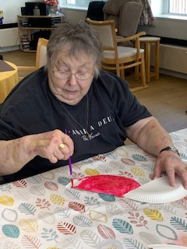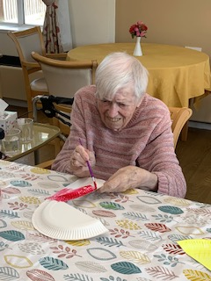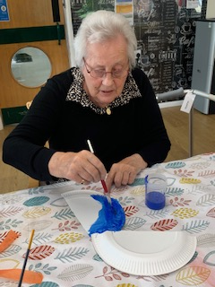
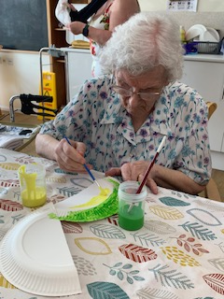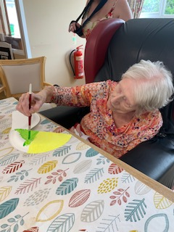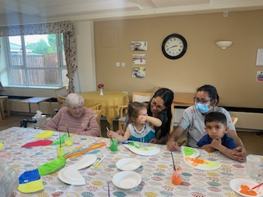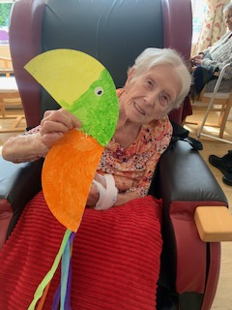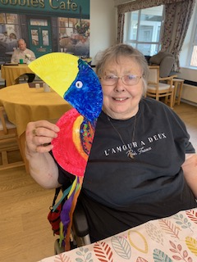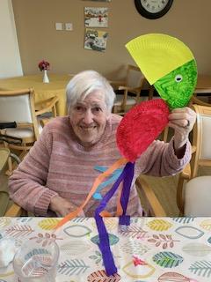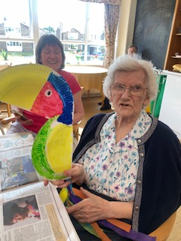
Then the paper plates got pulled out again to make our very own goldfish bowls! Again lots of creativity and imagination here, with Sheila and Mary having starfish and all sorts in their bowls. It was great to see the ideas they had and then putting them together cutting out shapes and sticking them on.
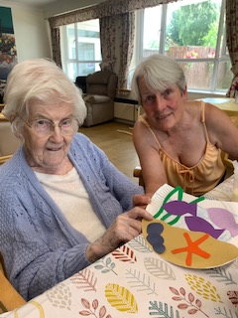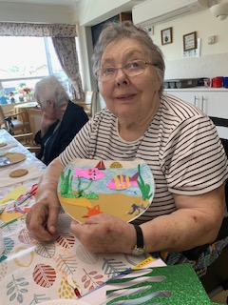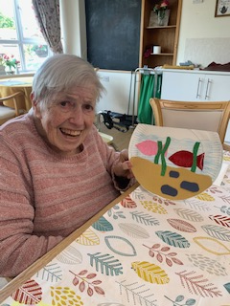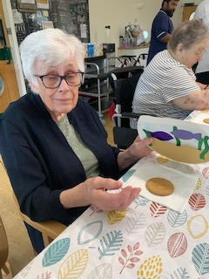
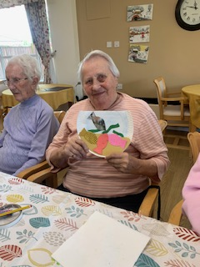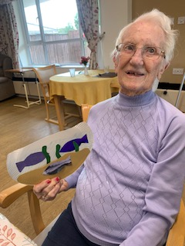
Mini Concerts Came to visit!!!...
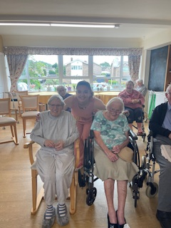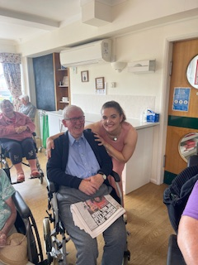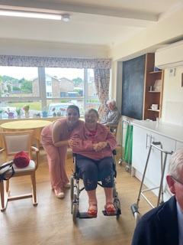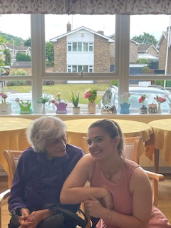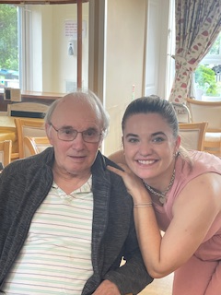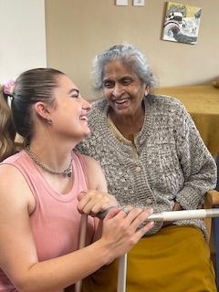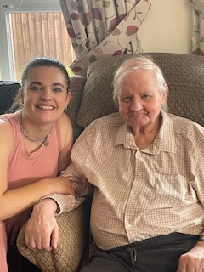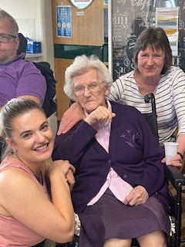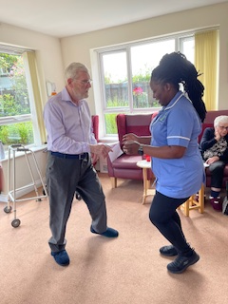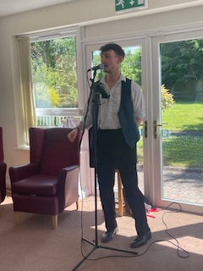
We have amazing afternoons of singing from the mini concerts. This month we had Issy and Nick singing to us.
Nick sang songs from Oklahoma the musical, and Les Miserable’ as well as some songs from Elvis Presley and Frank Sinatra. Our residents sat tapping their feet and singing along to the tunes they could remember, Nick finished his set with a rendition of “sweet Caroline”.
Issy certainly caught there attention with her familiar favourites and go everybody singing along.
Steelpan Music
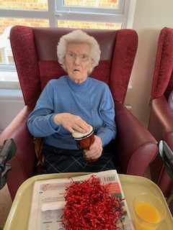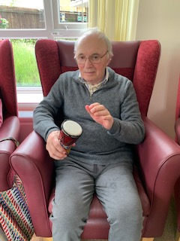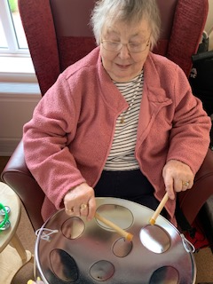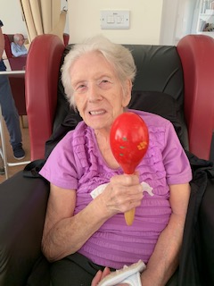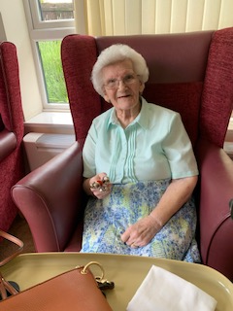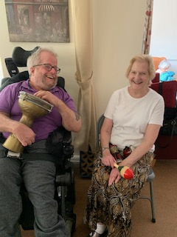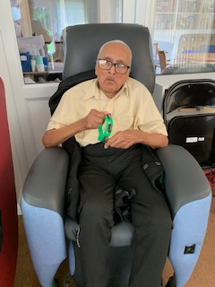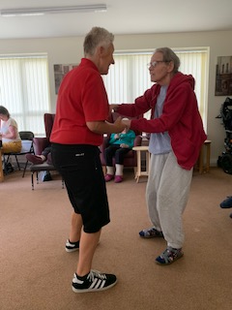
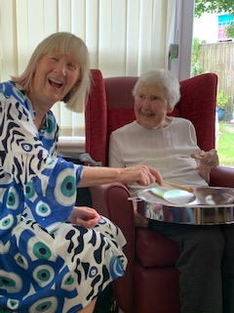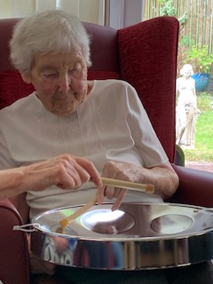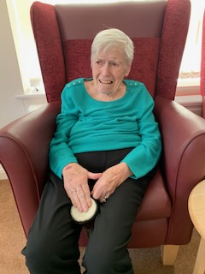
We had Julie with her steelpans join us again for this months concerts. Residents enjoyed dancing, clapping and playing instruments along with the music. Everyone really enjoys it and there are always smiles all round…and it’s always nice to see different faces interacting and moving with the music.
This was Ann’s first experience with the steelpan concert and she was a bit bewildered by it initially! As you can see by her face…
Even family and friends enjoy joining in when they are with us.

Hairdressing Salon
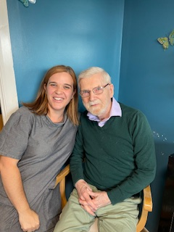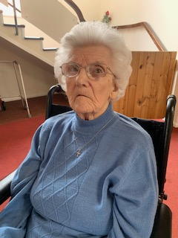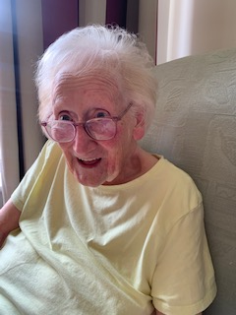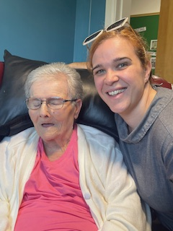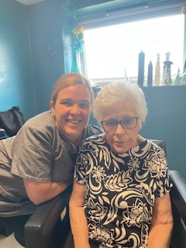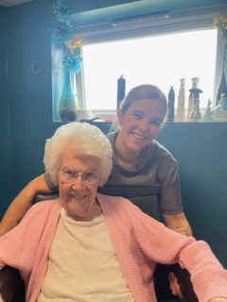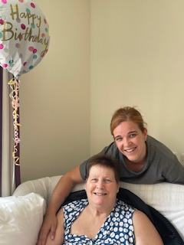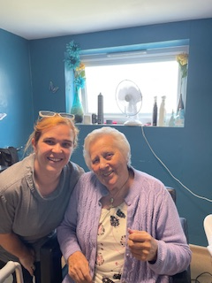
Our amazing haridressers have being doing a great job during June again. They do put some lovely smiles on our residents faces each time they visit and do their magic!
The residents always look so happy after time with her and they really appreciate the 1 to 1 attention it allows them.
Being pampered and spoiled is great for their self esteem and shows them some individual love. The big smiles show how much they love the results.
Pet Therapy
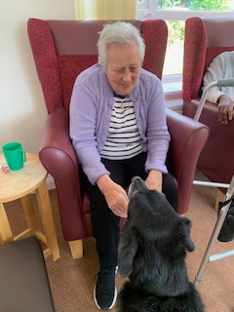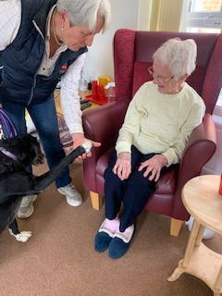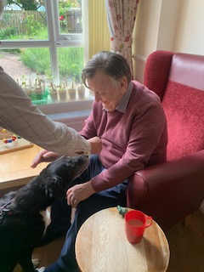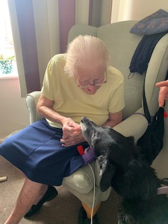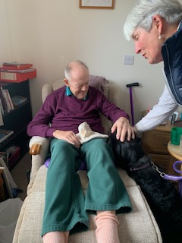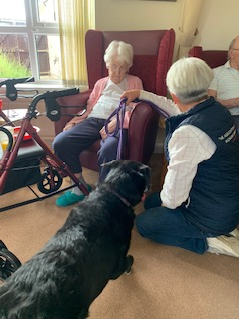
Pet therapy is always a highlight of the day, and this months visits were no different. We had Sky come and visit the residents and she brought along Carol!! There were lots of treats and Bernard and Mary have treats already in their rooms waiting for the visits.
Peggy also visits but we don’t always catch her on camera, but the residents do talk about the visits after they have gone and how much they like seeing her.

Trips out for coffee
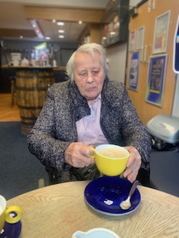
We went across the road one morning with Brian and Heather for a coffee and bacon sandwhich. It was nice to have some more one to one time to chat and get to know each other a bit better. The bacon roll certainly helped to keep up spirits, as they were very nice.
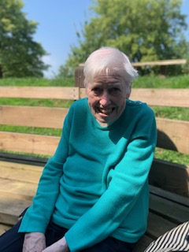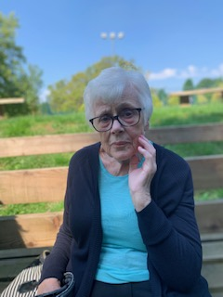
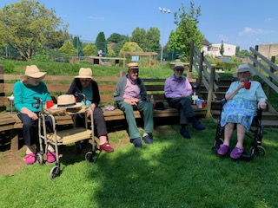
A lovely sunny day took us out to Stratford Park for coffee and to sit and take in the lovely scenery and listen to the birds. Ann and Kitty joined for their first trip out on our minibus and they both said they thoroughly enjoyed it and Denis certainly enjoyed soaking up the sunshine too!
Exercise and Movement
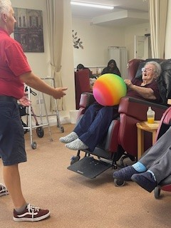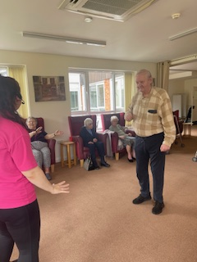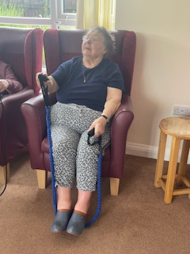
Getting involved in exercise and movement is a big part of activity programme as it has so many benefits, both physically and mentally. We have had Tanya from G-fitness coming in again during June, but we also do a lot of other activities.
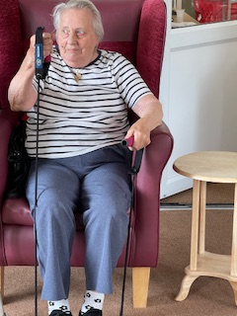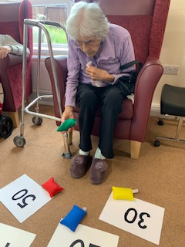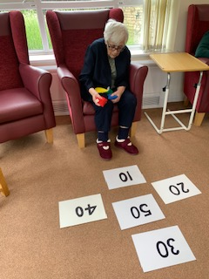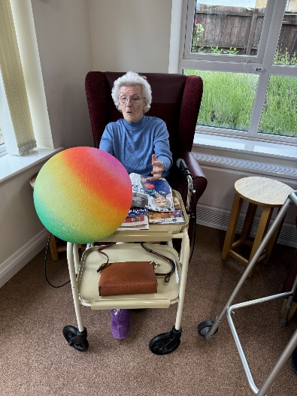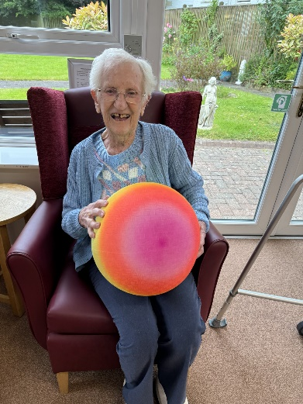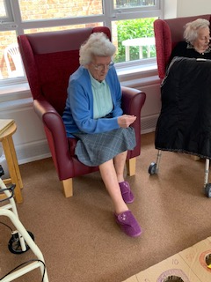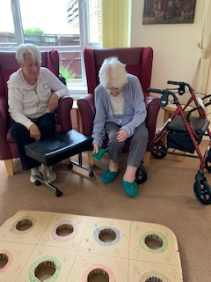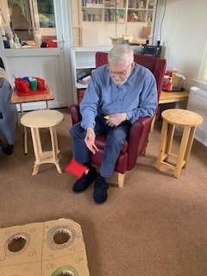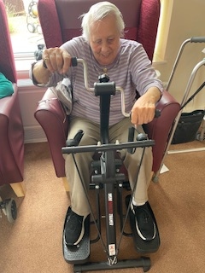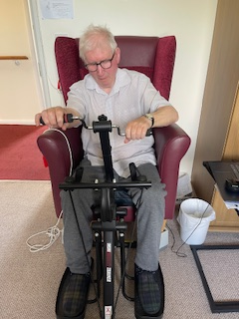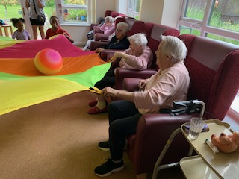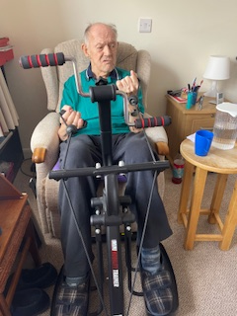
During June we have had the beach ball out, we have had bean bags being tossed, we have had the skittle being knocked down, and we have even had the parachute out with the children.
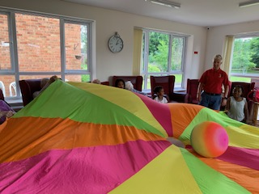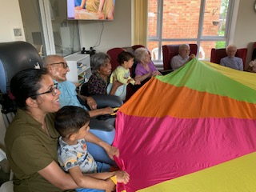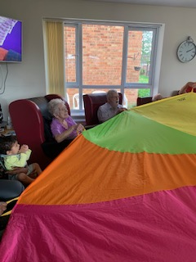
And that’s not including the fantastic bargain bit of kit that Tracey picked up at a car boot sale!!!
In addition we have had lots of ball games and some chair yoga sessions. This really helps to keep our residents moving and aid maintaining their individual mobility. It also really helps with their mental health as you can see their faces light up once we get having some fun.
When I’m Cleaning Windows Show
Jack and Harry came to perform for us from Northeast productions, and the theme was “When I’m cleaning windows”. Jack and Harry told the story of what it was like to be a window cleaner in the olden days, and the sights they saw. They talked about falling in love, and sang songs that most of our residents knew and they were able to sing along. There was lots of comedy in the show and fun was had by all.
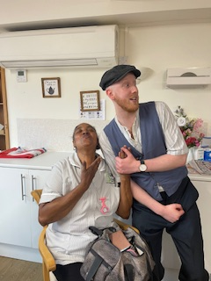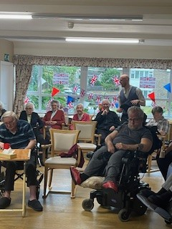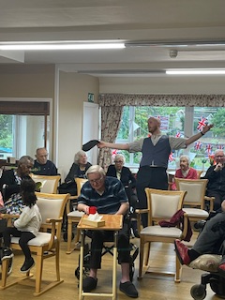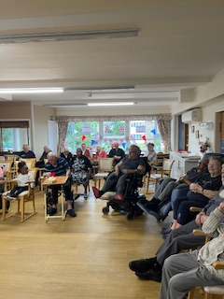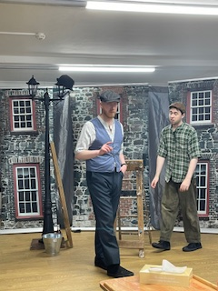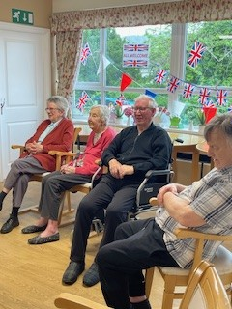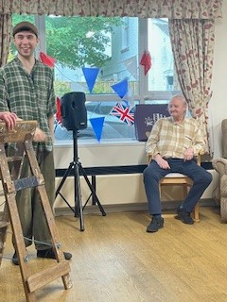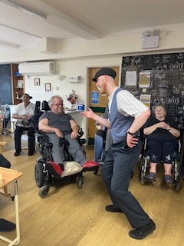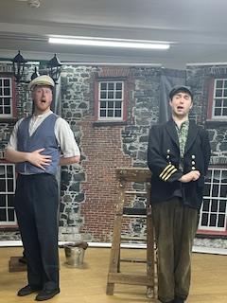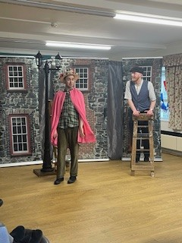

Messy play with pre-school visitors
We had a visit from some children from the local pre-school again during June and it was great fun to see them and the residents engaging together.
We were playing lots of games this visit including the bean bag tossing game, skittles and then the giant parachute. It was amazing to see the smiles on faces, and how much the residents enjoyed the parchute game.
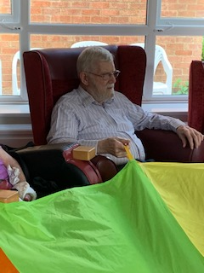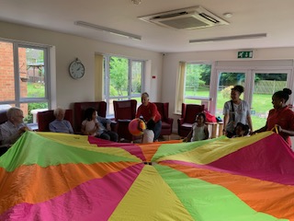
We finished off the afternoon fun with games of musical statues and musical bumps, and the children loved it, and some of the residents even joined in the musical statues dancing in their seats!
D-Day Dollies Concert
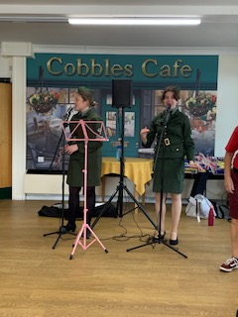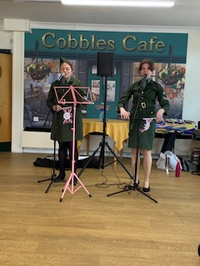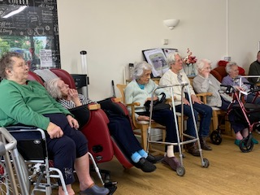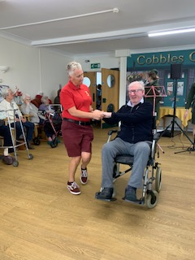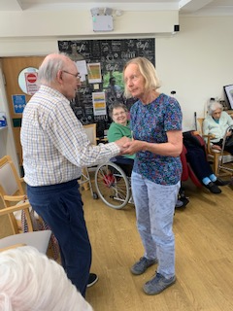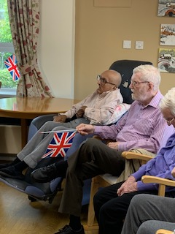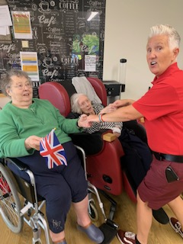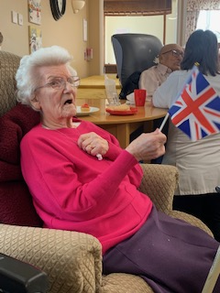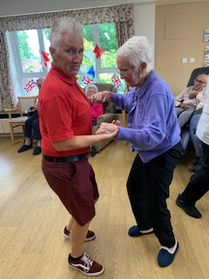
What an amazing day we had for D-Day. It was all about the 80th anniversary of the D Day landings.
There were lots of residents who had memories of that time, in particular Bernard who as a young boy saw hundreds of boats out from the coast where he was growing up.
Everybody really enjoyed the D-Day dollies cncert and there was dancing from Brian, and Sybil and David with Astrid, and Betty and Mary too.
Everybody was waving their flags and singing along to some real old favourites of that era, and there was even some marching and some trains with the Chatanooga Choo Choo!!!
It was also quite emotional for a lot of them, as it must have taken them back to times and places long forgotten and even to remember people from their lives, now long gone.

Day Trip to Burnham-on-Sea
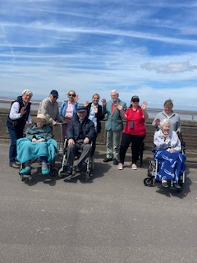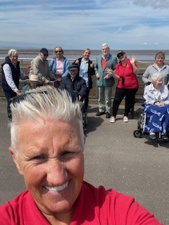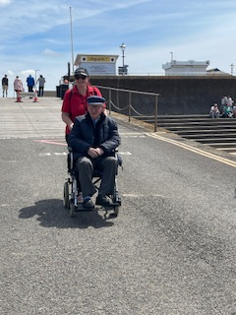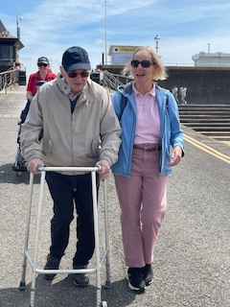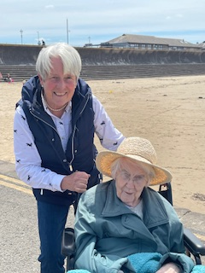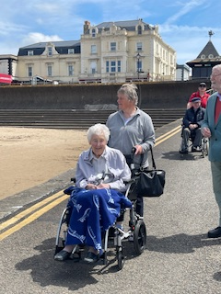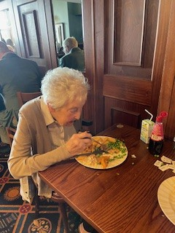
This month we have had a fabulour day trip out to the seaside. We have taken a minibus full of residents, staff, friends and family to Burnham-on-sea.
The weather was beautiful and it was great to put smiles on residents faces as they enjoyed the fresh sea air and time to walk out and about on the sea front. We chatted and laughed and had really good banter, with lots of friendly bickering and mickey taking. Brian certainly likes the banter and interaction with others and is the first to liven up the conversations.
After time on the front we then had fish and chips in a local seafront bar, which everybody loved.
Denis was really soaking up the sunshine and appeared really content and enjoyuing the feeling of the space and the time to ponder.
Sheila had her daughter Carol with her and they were able to have some quality time chatting and sharing the day together. Carol even enjoyed an ice cream, but Sheila declined.
Mary had time with her friend Rose. They had the opportunity to chat and share the days experience together, which they can look back on fondly.
David loved the walk along the front with his wife Astrid and was very keen for his ice cream after lunch. He and Astrid enjoyed their day together, having lunch and remebering past holidays with family over the years.
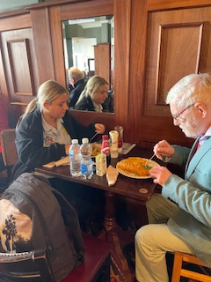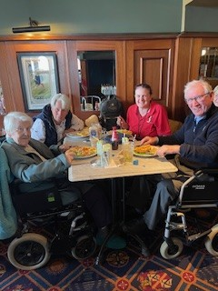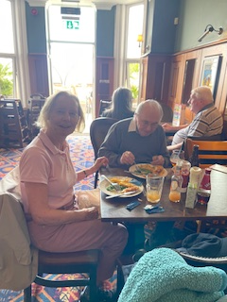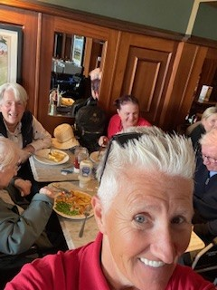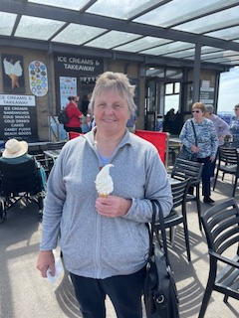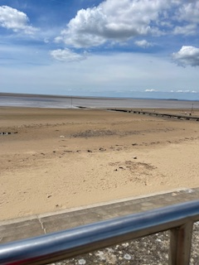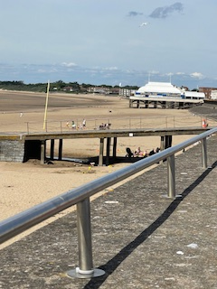
It was a lovely day for everyone, and we can’t wait to get out somewhere in the minibus again soon.
Who knows where the next adventure will take us.

Birthday Celebrations
This month we have had a big birthday celebration, as Sybil was 101 in June.
This is an amazing achievement and we had to celebrate such a big milestone with her.
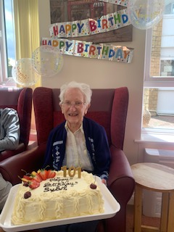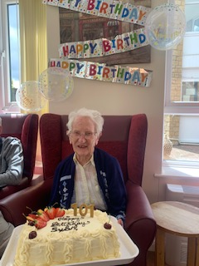
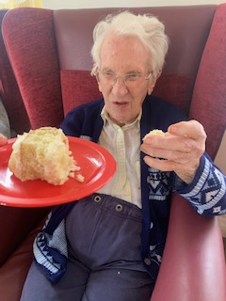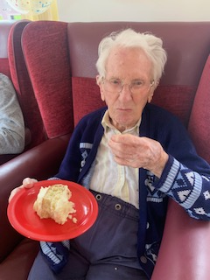
There was a beautiful cake made for her and after we had all sang happy birthday to her, she tucked into her piece and by the looks onher face, she thoroughly enjoyed it.
Everybody was offered a piece and they all celebrated with her in the lounge.

We could tell you about so much more!!!
- Crosswords and ABC quizes
- Gaint snakes and ladders, Big music quizes
- Indoor skittles and bingo bongo
- Giant floor dominoes and super dominoes
- Scrabble club
- Church services
- Hair and beauty

Employee of the month for June
Each month we celebrate our employees, and for June we have Henerita Rayner, one of our carers. Well done Henerita, keep up the good work…
Who will it be next month?? Watch this space…

Welcome to new staff member, Mark. Who is joining us on the activities team.

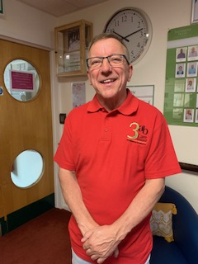

Upcoming events in July:
Mini concerts are coming to sing golden oldies on 4th and 18th July
Julie from steelpan will be coming to play some Caribbean music on the 10th and 31st July
Hayley and Peggy will be visiting us for more pet therapy, also there will be days when Carol and Jean will bring in Sky and Cali
Our church service will be Friday 19th at 11:15
We always welcome family and friends to join in our activities as we always try to make them fun, so come along…you know you want…

Upcoming birthdays this month
Rebecca J,
A Happy Birthday to you all!!!!

Additional Events in July
Resident and Family Meeting
6pm Tuesday 8th July
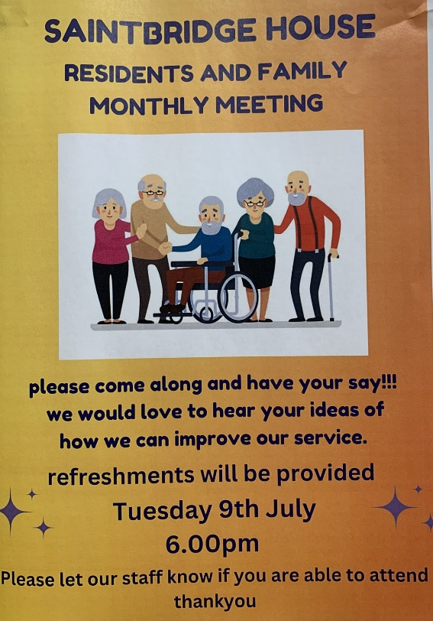
Garden Project
Saturday 20th July
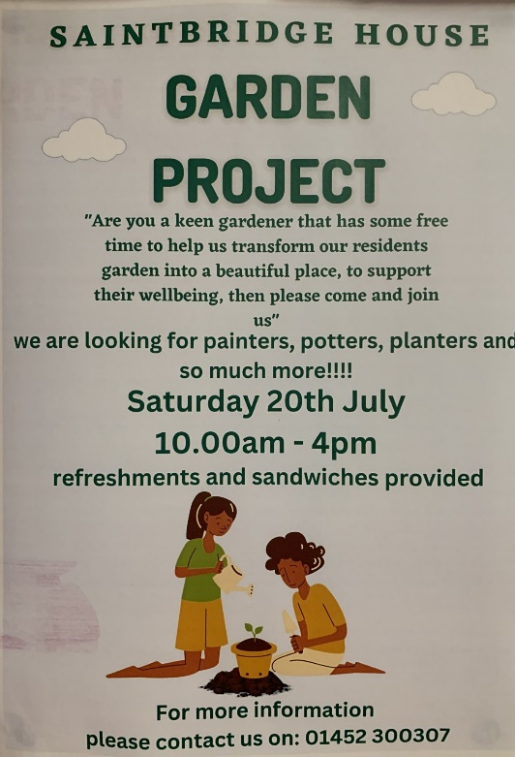
Teddy Bears picnic
Sunday 28th July
Saintbridge Garden 2:30
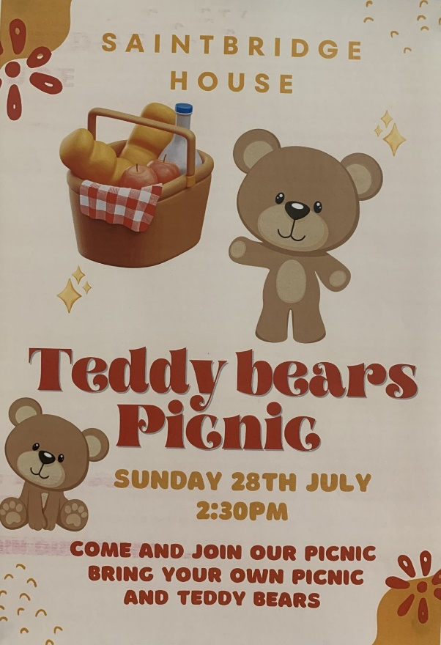

Outing To Croft Farm for Picnic
Wednesday 24th July
10:30 – 3:30

July programme of activities
Mon 1st reminiscing life stories / jigsaws / g-fitness
Tues 2nd creative art / gardening
Wed 3rd mind song music session / flower arranging / ABC quiz
Thurs 4th scrabble club / puzzles / min concerts
Fri 5th hairdresser / bingo bongo / Big quiz
Sat 6th relaxation / pottery / storytelling
Sun 7th Morning prayer (Bible Reading) / pamper sessions / film afternoon
Mon 8th reminiscing life stories / poetry reading / movement to music
Tues 9th creative art / table football or pool / chair yoga / pet therapy / 6pm resident and family meeting
Wed 10th out for coffee / ABC quiz / 3pm steelpan concert
Thurs 11th scrabble club / puzzles / giant snakes and ladders / quiz
Fri 12th awaken the senses / skittle / karaoke
Sat 13th relaxation / bean bag target toss game / water colouring
Sun 14th morning prayer (YouTube) / floor dominoes / DVD about sharks
Mon 15th reminiscing life stories / jigsaw puzzles / 2pm G-fitness / film afternoon
Tues 16th creative art / table football or pool / gardening club
Wed 17th Mindsong music session / 2pm Wellness Wednesday / Flower arranging / ABC quiz
Thurs 18th scrabble club / puzzles / 2pm mini concert
Fri 19th hairdresser / 11:15 church service / parachute game / Big Music quiz
Sat 20th relaxation / GARDEN PROJECT / film afternoon
Sun 21st morning prayer (Bible Reading) / crosswords / quiz
Mon 22nd reminiscing life stories / table tennis cub / music and movement
Tues 23rd creative art / table football or pool / chair yoga / pet therapy
Wed 24th outing to Croft Farm for picnic
Thurs 25th scrabble club / puzzles / ball games / balloon tennis
Fri 26th Saintbridge Houe Olympics / sports quiz
Sat 27th relaxation / super dominoes / film afternoon
Sun 28th morning prayer (YouTube) / 2:30 TEDDY BEARS PICNIC
Mon 29th reminiscing life stories / jigsaw puzzles / 2pm G-fitness
Tues 30th creative art / Table football or pool / gardening club
Wed 31st out for coffee / 2pm steelpan concert / ABC quiz

