Saintbridge House
Welcome to our September newsletter!



Fun Facts about September

- The birthstone for September is the sapphire which is said to reduce inflammation, treat fever and act as a lucky charm for the person wearing it. It symbolizes intuition, clarity of thought, peacefulness, as well as loyalty and trust.
- The name “September” comes from an old Roman word, “septem,” which actually means 7. That’s right – September was the seventh month of the year on the Roman calendar – It did not become the ninth month until the advent of the Gregorian calendar.
- The September birth flowers are aster and morning glory. Considered the 'star' of the show, aster flowers were named after the Greek word for 'star' because of their shape. Asters are beautiful, dainty blooms that come in many colours but mainly pink, white, red or lilac.
- Out of all 12 months of the year, September is spelled with the most letters. It contains nine letters, and it happens to be the ninth month of the year. No other months have the same amount of letters as their number in the calendar year.
Let’s look at what we have been up to in August
We have had a great month of August, with so many activities and events happening. The garden has featured a lot again this month, including for our Summer fun day.
Families and friends have joined us, with activities and events, but also just enjoying the company and interaction with their loved ones.
The residents have been very busy, with gardening, creating, getting phyiscally active with games and music and movement, enjoying the outdoors and the sunshine and sometimes simply sitting and chatting and recalling memories.

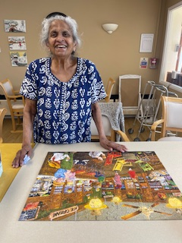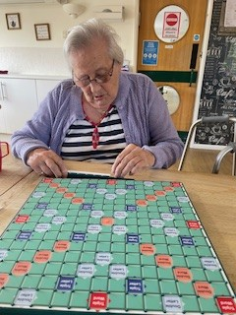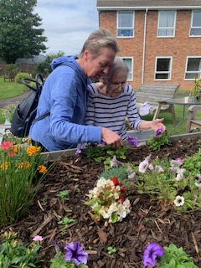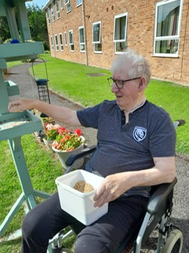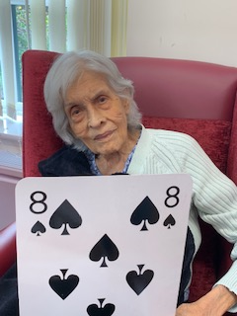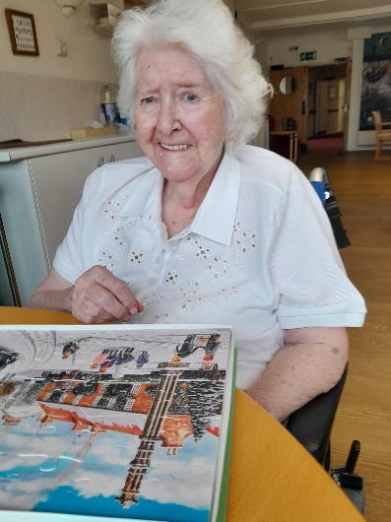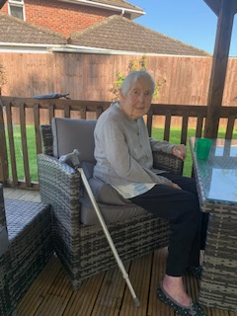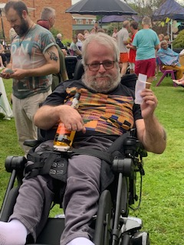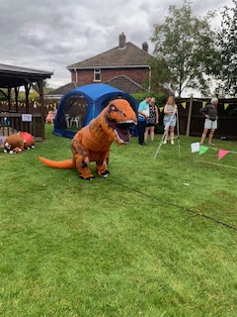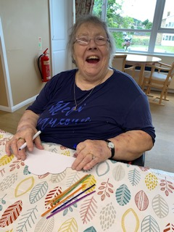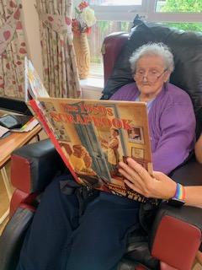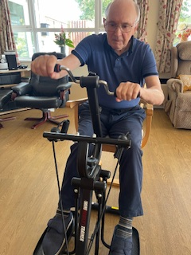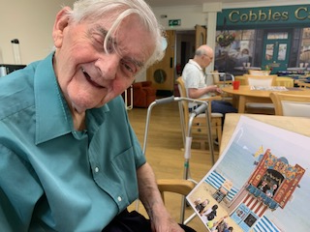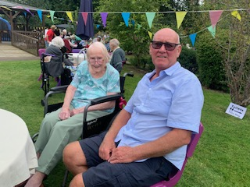

Reminiscence Group
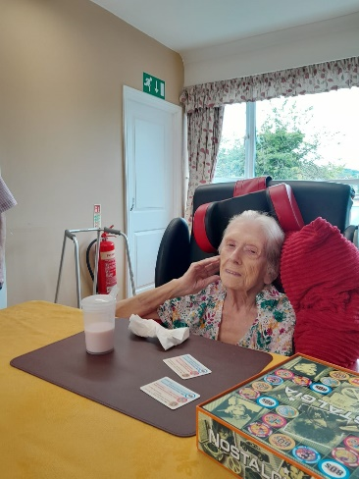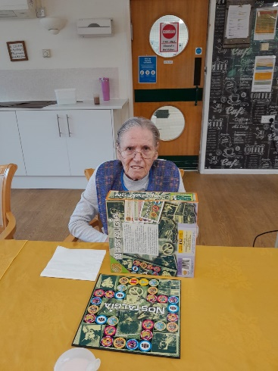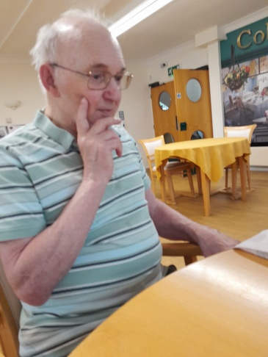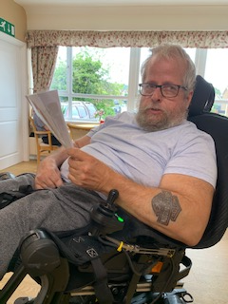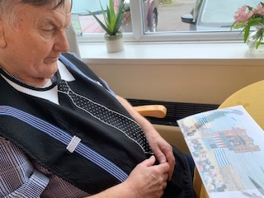
This month we have a had our Monday morning reminiscence time. We tried a new game called Nostalgia which was great for triggering memories and instigating chat about the topics or themes that came up on the cards. We adapted the game to be more suitable for us, and it proved to be a great way to dig out some long forgotten memories.
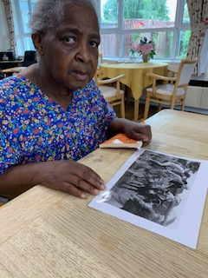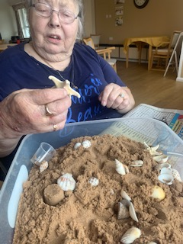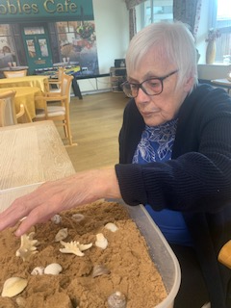
The discussions on other days ended up being all about holidays and the seaside. We chatted about donkey rides on the beach, and this led Margaret to recall a donkey ride her daughter certainly won’t forget in a hurry.
There was also chat about which beaches they remember visiting as children or with their own children and this led onto discusions about building sandcastles.
We had memories of big castles and castles with sea moats, and those that were trying to keep the sea in and those trying to keep the sea out!!!
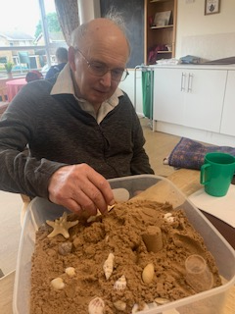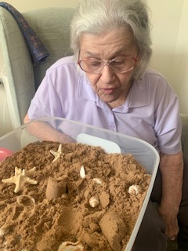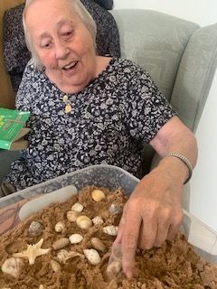
We were then able to bring in some sand and shells and they could feel it and mess about with it. It was interesting that not many wanted to touch it and Gill recalled that she never took her shoes and socks off on the beach as she didn’t kinow what was in the sand and she didn’t like that.

Creative Art group
With so many events and time spent in the garden our creative time has been a little quieter this month. We have decorated our tin can alley game pieces ready to use on our fun day as well as using to play inside.
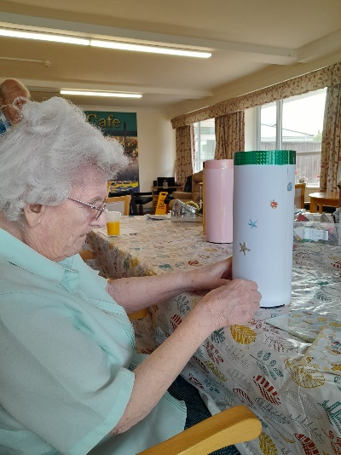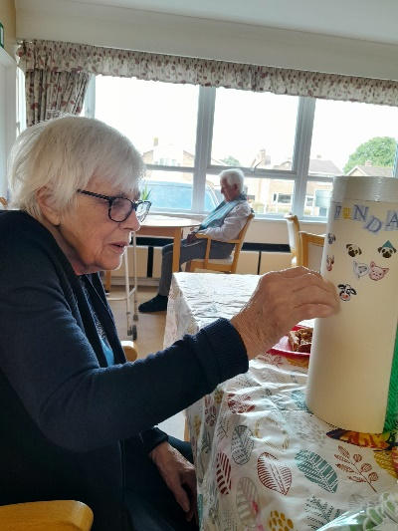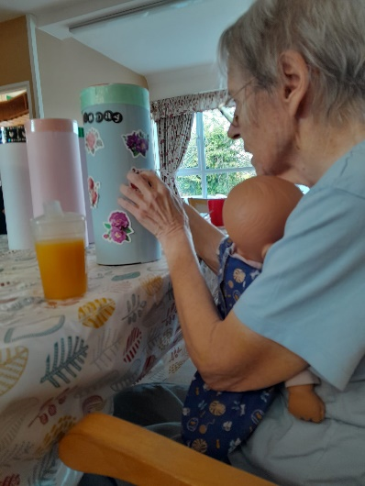
Then as we have started to see a change in the weather and we made some clouds with rainbows. It’s always fun to see the different designs that are created, Heather in particular always likes to think outside the box and her designs are always very unique.
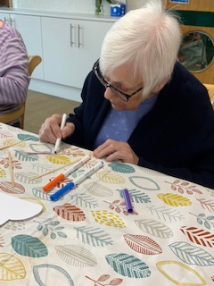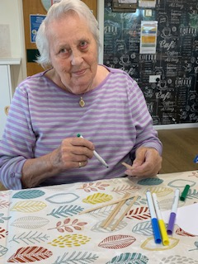
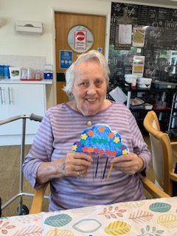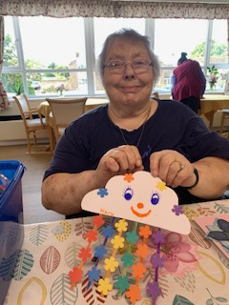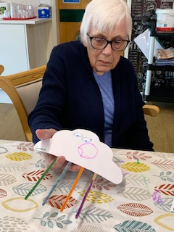

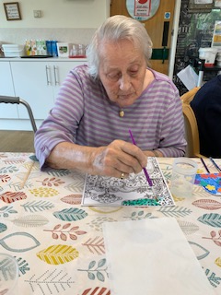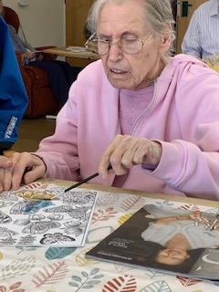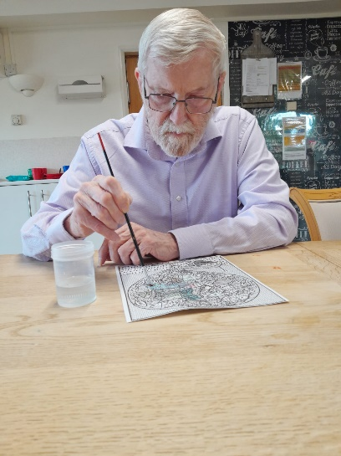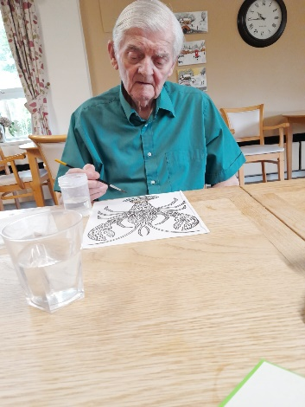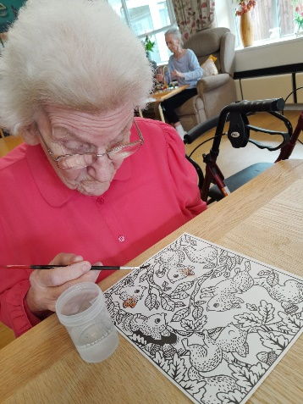
We have spent some time water colouring. This is a nice quiet activity that allows lots of creative licence and for images to be whatever colour we want.
Creative activities are always great for individual interpretation and peronal creativity.
Mini Concerts Came to visit!!!...
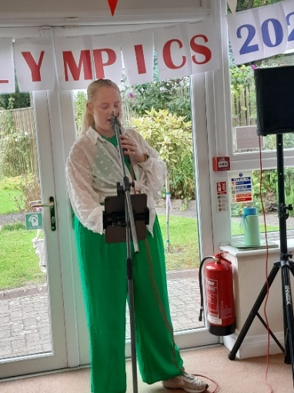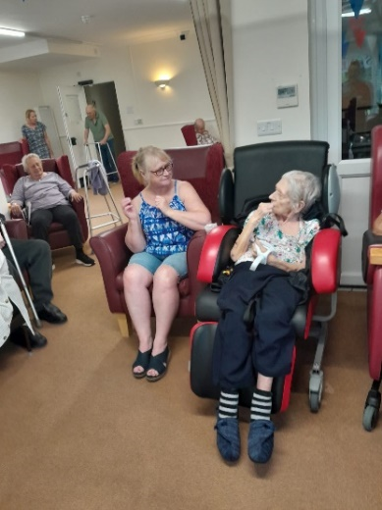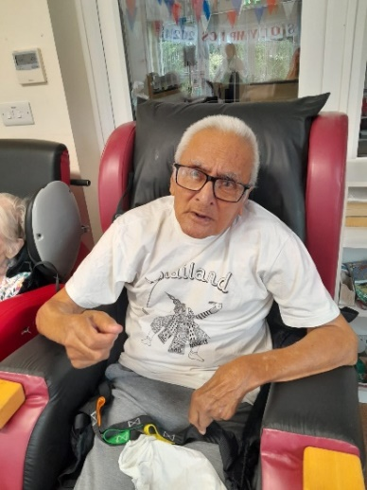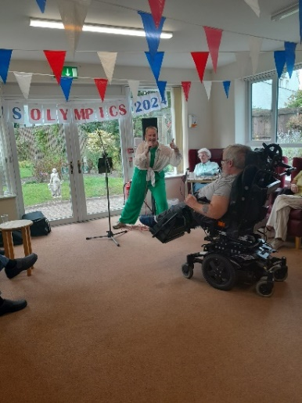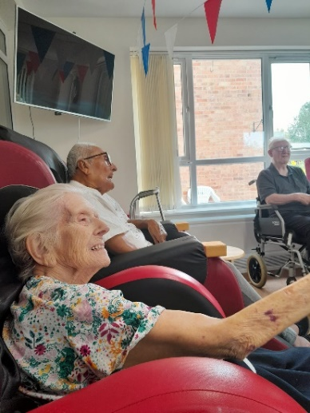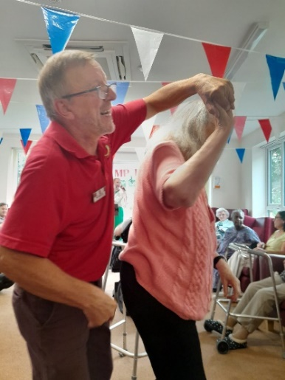
We have had Zoe and Nick entertaining us with mini concerts during August. It was great to see everyone enjoying the songs and singing along a lot of the time.
It’s even nicer when we see the engagement of some of our residents getting up and dancing, or even moving about in their seats.
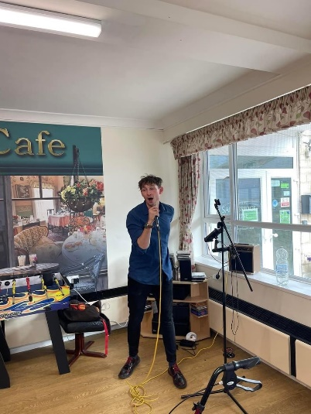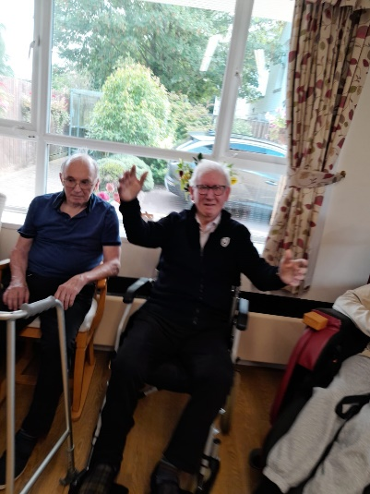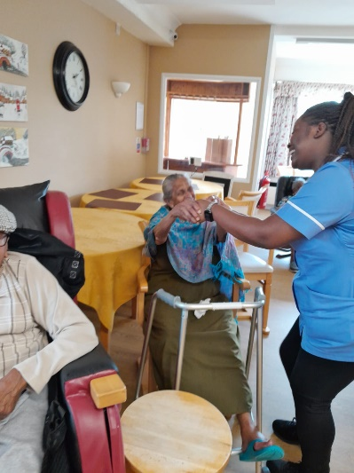
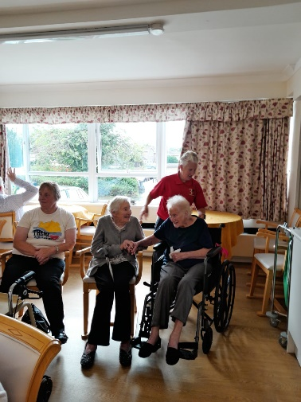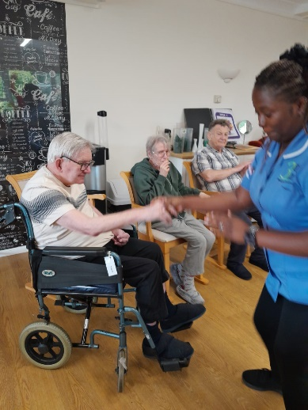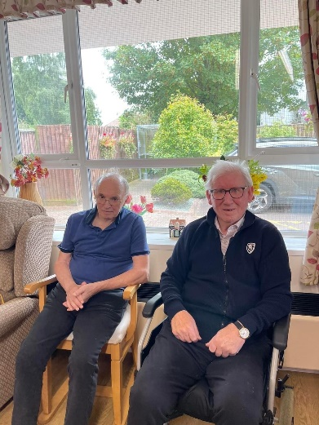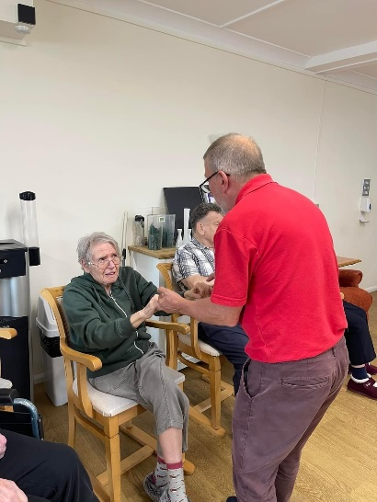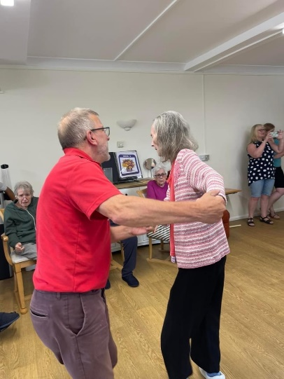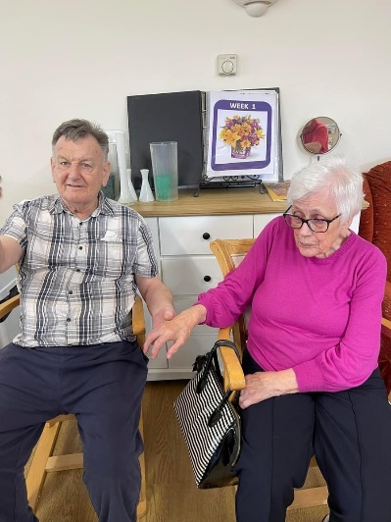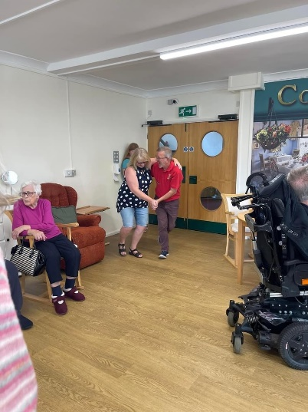

Steelpan Music
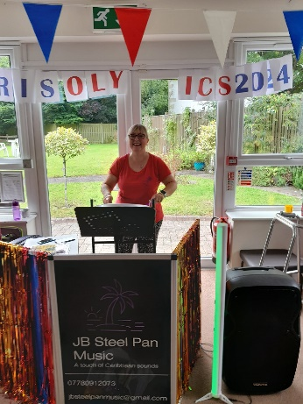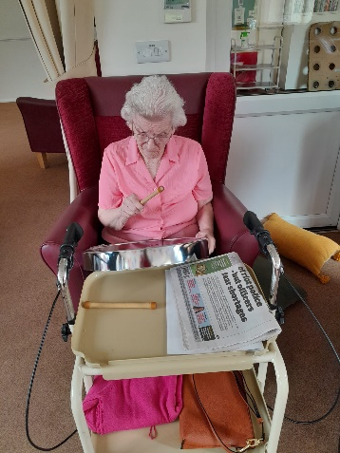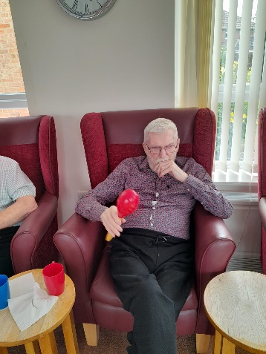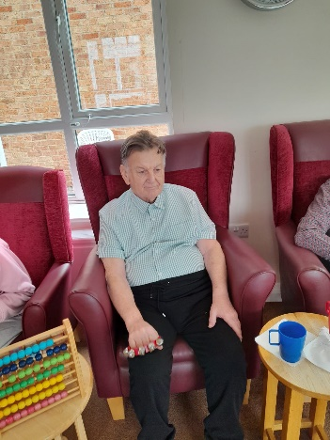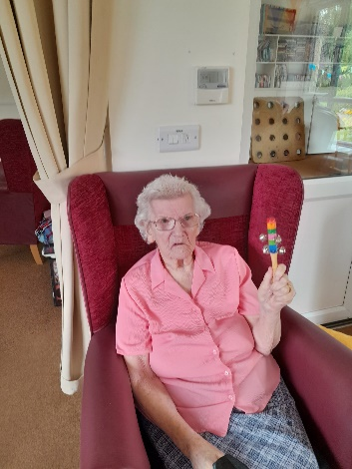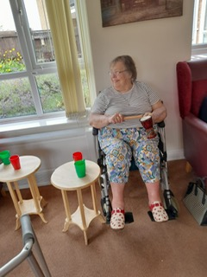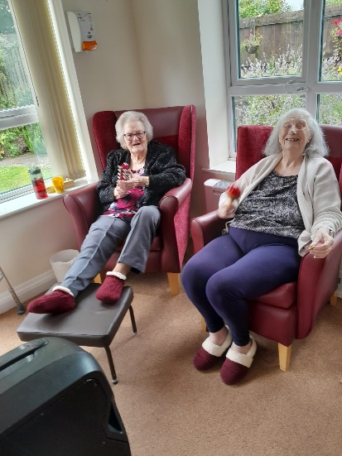
We have had Julie with her steelpans visiting us for concerts again in August. These are always really good fun, and we were hoping to have her for our Summer fun day but sadly she was already booked, maybe next year!
As usual the concerts went down very well, with instruments being played and everyone having a go on the steelpans too. Kitty has a real connection to playing these and gets very enthusiastic, to the point that Julie can’t compete!!
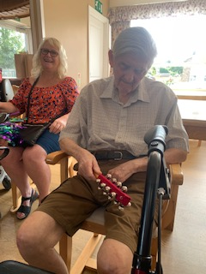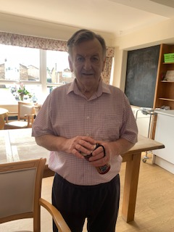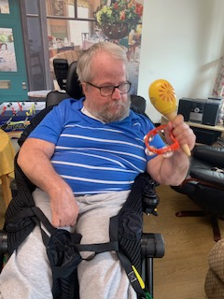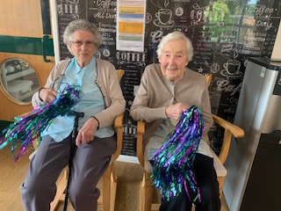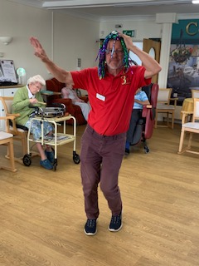
We have an additional entertainer now too, in Mark. He was enjoying the dancing and entertaining all the residents and family visiting with his great moves and unusual hair style. The hair must have been popular as Nora had a try of the same style!!
We also had our cheerleaders in this month. Mary and her friend Maureen were cheering Julie and everyone along with their moves and shaking pom poms.
Kirk always has lots of tune requests for Julie, which she can sometimes accomadate but not always, not a probloem for Kirk though as he loves the music whatever the tune.
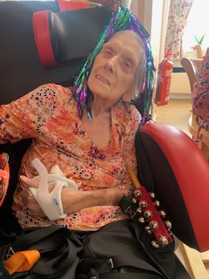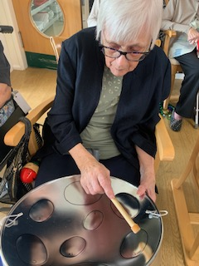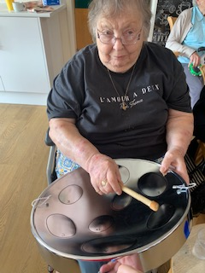
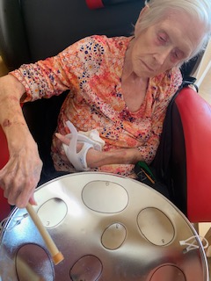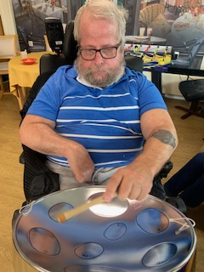

Pet Therapy
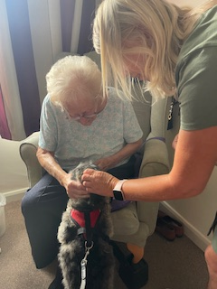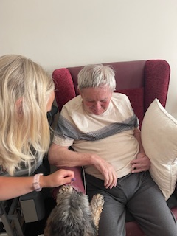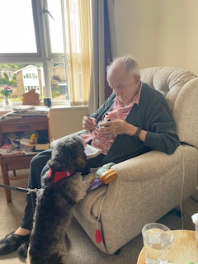
Our furry, four legged visitors have been along this month again too. As always they were very popular and put big smiles on our residents faces.
There is nothing more uplifting that seeing the effect of these dogs visiting on our residents and their mood and interaction. They become very engaged and chat away to them, and they lean over their chairs and put themselves into very strange positions to be sure to stroke and pet the dogs. Probably not positions they would want to go in otherwise.
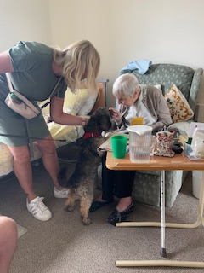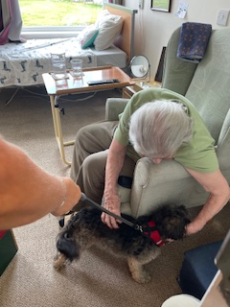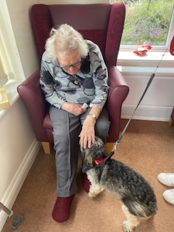
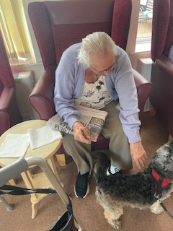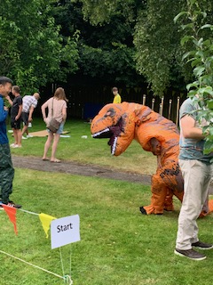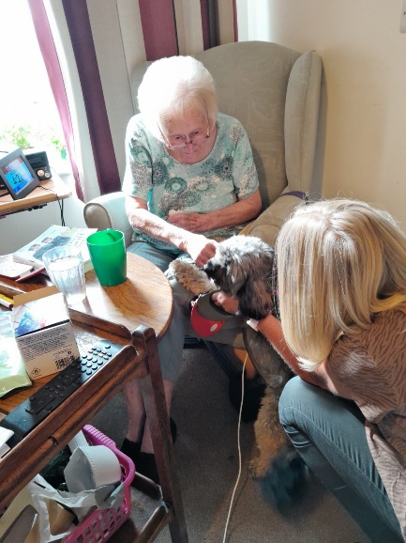
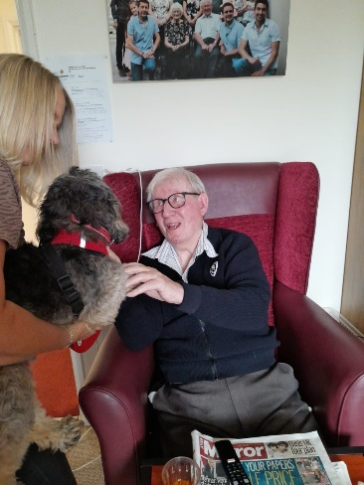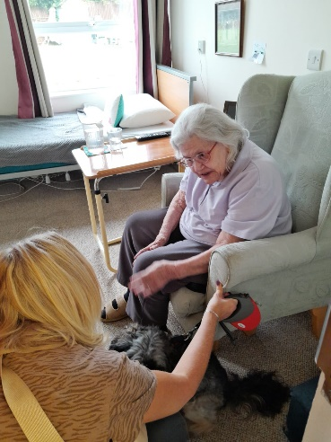
Bernard and Mary still have their little stashes of dog treats in their rooms for these much loved visits.
An additonal visitor or two this month was also spotted out in the garden at the Summer fun day…as far as we are aware they behaved themselves…up to a point!!!! Did you manage to see them on our fun day?

Summer Fun Day

This was an amazing day as we spent the time with family and friends and staff at our Summer Fun Day. We had lots of visitors supporting and family and friends coming to join in.
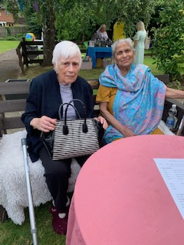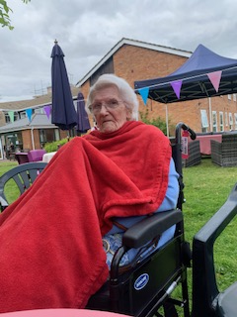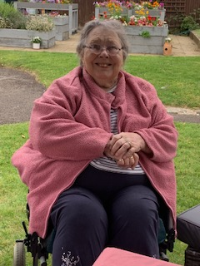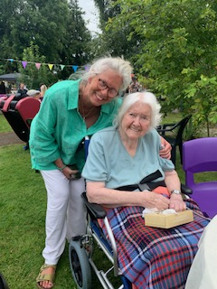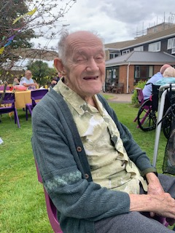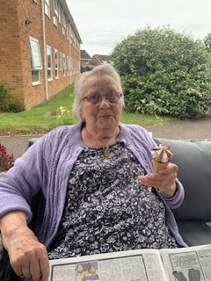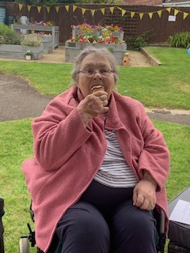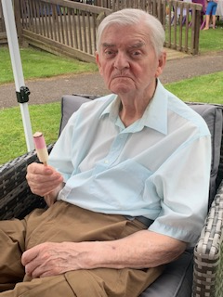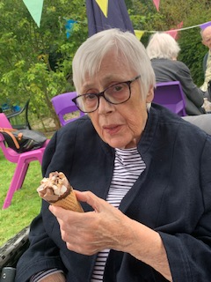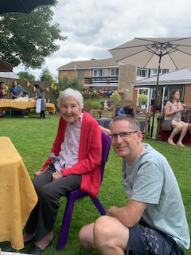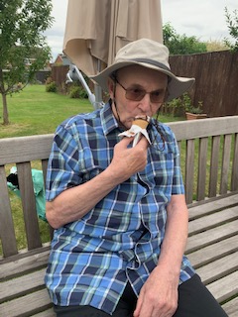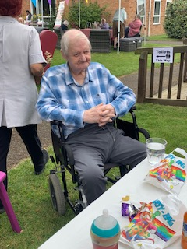
It was great to get lots of the residents outside joining us. There were even ice creams being eaten! They were able to spend some really quality, fun time with family and friends, and to watch all the antics going on all afternoon. We had lots of stall holders join us and the children had a bouncy castle and lots of fun races to take part in. We even had a visit from a couple of dinosaurs…who tried the tug-of-war but just ended up in a fight!!
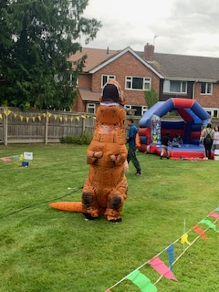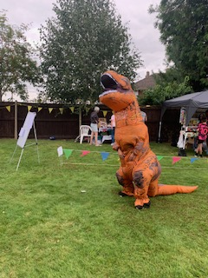
We had some great races, including sack races, egg and spoon races and donkey races!! Then we also had the children and the adults having a jelly eating competition. Everybody had a really good time and there was a great deal of laughter and enjoyment all afternoon.
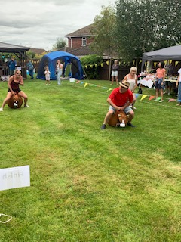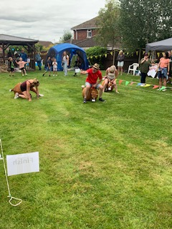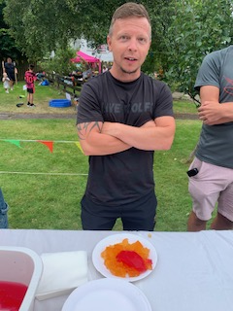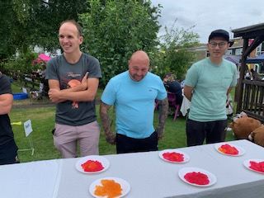
We had a bbq with lots of lovely food, and we also had Chinese snacks, hot Indian food and teas and cakes and ice creams.
The raffle was the highlight and we had so many generous donations that it took a loooong time to pick all the tickets. We had some very happy winners though, staff, residents and family and friends.
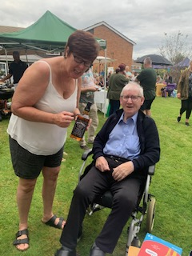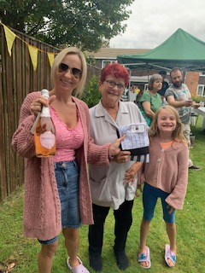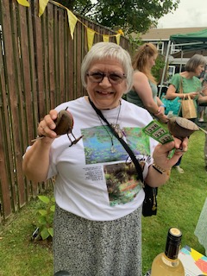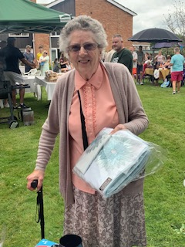
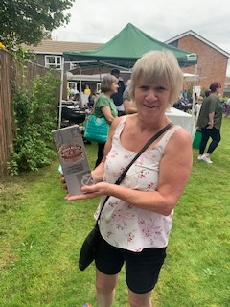
It was an amazing day and everyone had a great day, including our residents. They were full of smiles and enjoyed the engagement and socialising that the event brought.

Trips out
Croft Farm Picnic
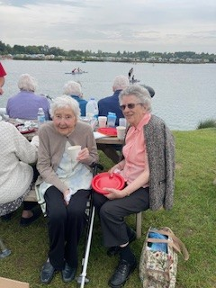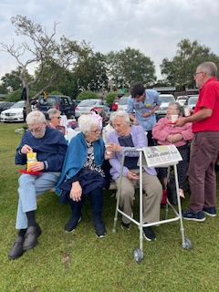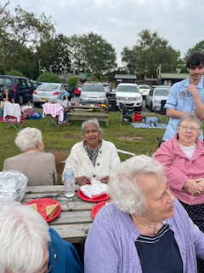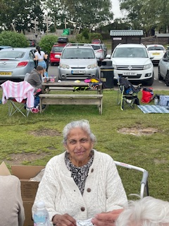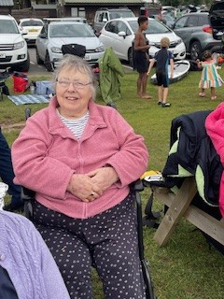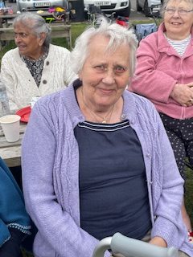
Today we have had lovely day out for a picnic lunch at Croft Farm in Tewkesbury. It was nice to take some different residents out today, such as Mary, who hasn’t done a trip out with us before. Although not briliantly sunny it was lovely and warm and was only windy for a short while. So we managed to find a table and sit and watch everything going on.
This was a great opportunity for enagaging with each other and having a very sociable time.
We were able to watch people out on the water who were paddle boarding and swimming. Mark was very tempted to join them for a dip along with Harrison our student nurse, but they chickened out in the end. This was great entertainment for the residents though and Heather amongst others was cheering them along to give it a go!!!
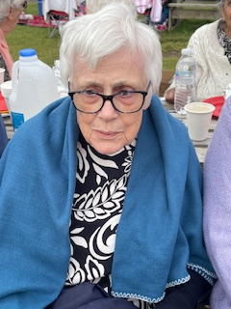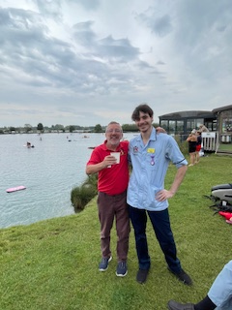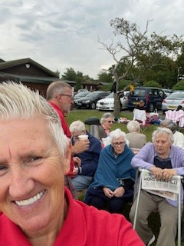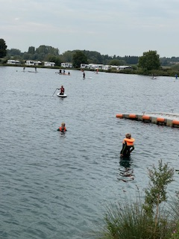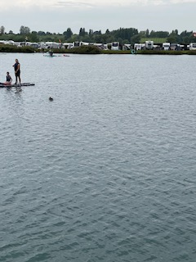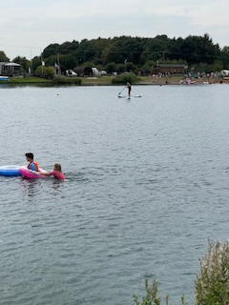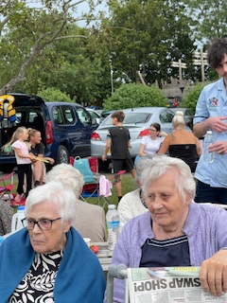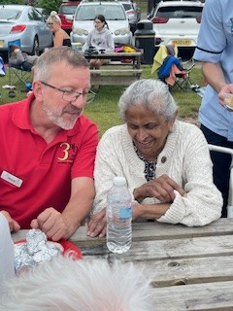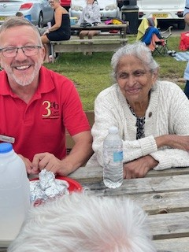
A lovely day out for everyone.

Hairdressing Salon
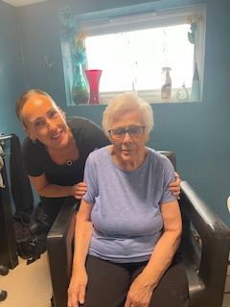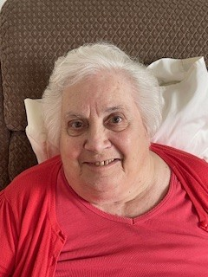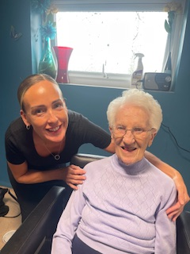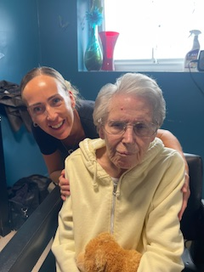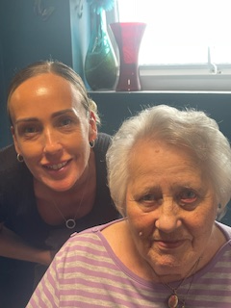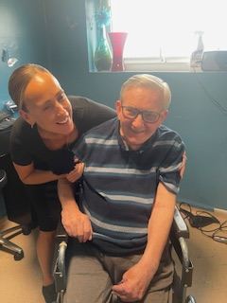
We have had a change in hairdresser during August and we want to say a lovely big welcome to Nikki.
We have had a few residents visit her and as always we can see from the picture everyone was very pleased with their hair. We look forward to seeing Nikki regularly every couple of weeks.

Exercise and Movement
Movement happens most days in some form with the residents. Whether that is dancing, playing games that involves moving about or actually doing fitness and stretching exercises. Whichever form it takes, it’s always fun and everyone appears to have a great time.
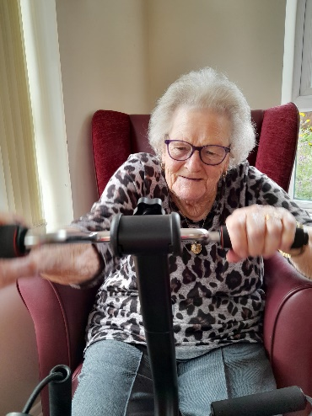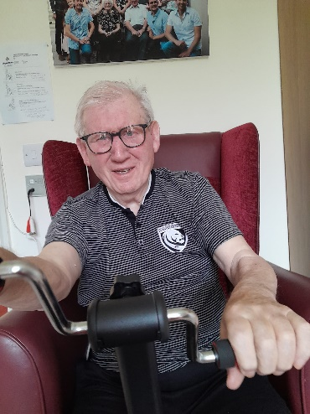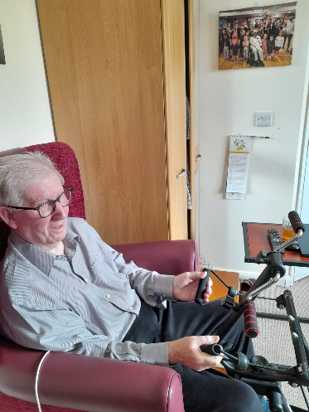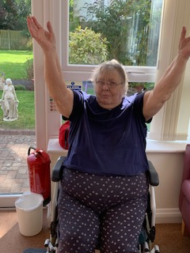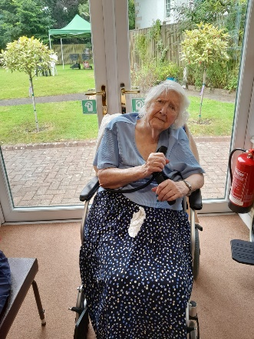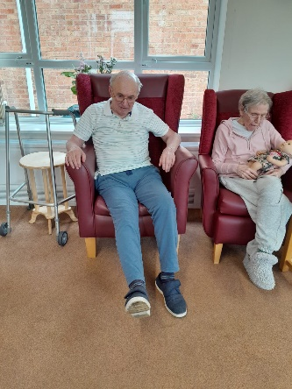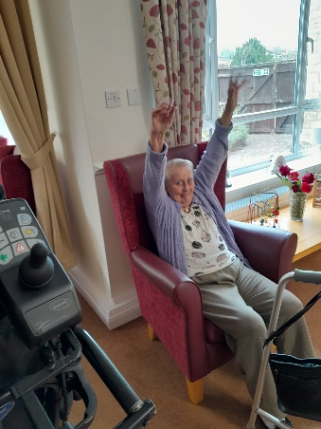
This month has involved lots of activity of movement and exercise. There have been stretches and movements to music. We have had footballs out in the lounge and these prove very popular. Everyone becomes very competitive and there are balls being kicked everywhere by everyone. Not only do they get kicked but we have also had some attempts at light headers using the light inflatable footballs.
These games and sessions are great for keeping arms and legs moving, and allowing the muscles to be used and to build them stronger, which is good for general mobility and falls prevention. But at the same time we are having great fun and not always being aware of the workout being undertaken.
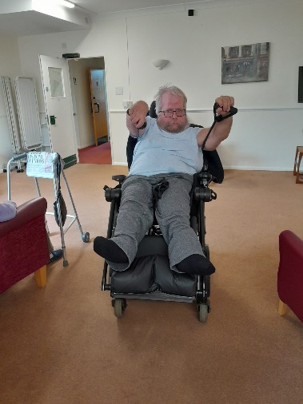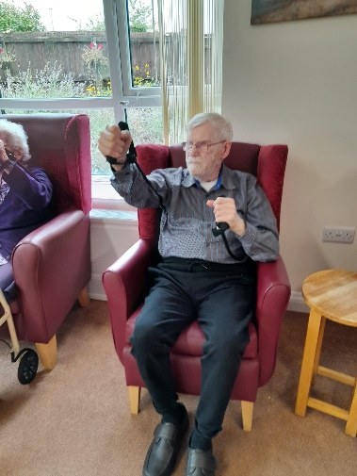
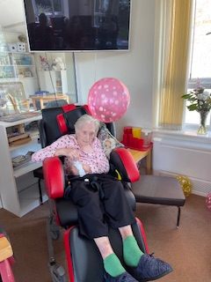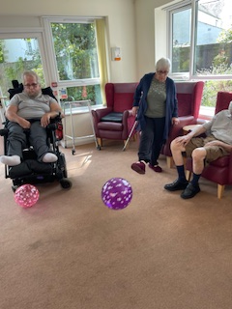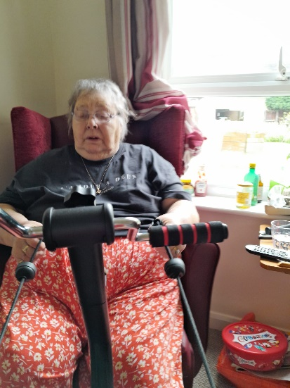
Our exercise machine continues to be used pretty much daily by some of residents, Brian in particular finds it really beneficial and feels real improvements from it, the same goes for David and Bernard, who try and use it regularly too.
Obviously it’s not just for them it’s for everybody to use and a you can see from the pictures, a lot of the ladies and gents have been giving it a go.

We could tell you about so much more!!!
- Crosswords and ABC quizes
- Gaint snakes and ladders, Big music quizes
- Indoor skittles and bingo bongo
- Giant floor dominoes and super dominoes
- Scrabble club
- Church services
- Hair and beauty

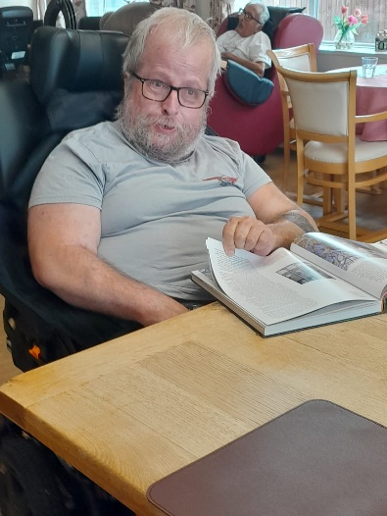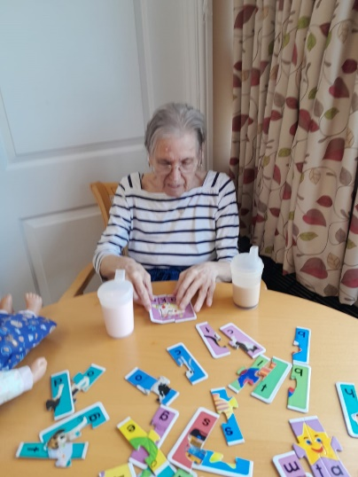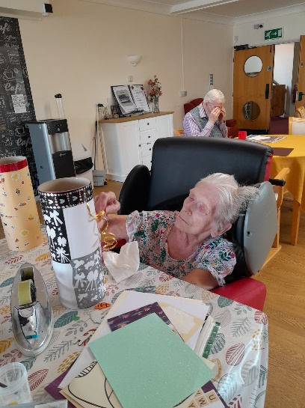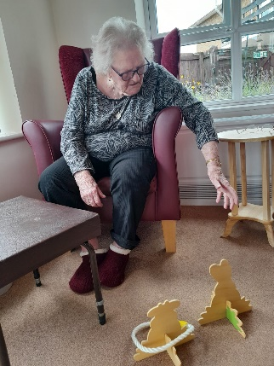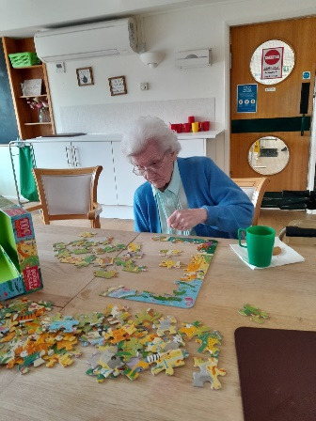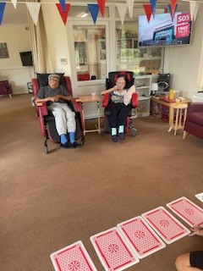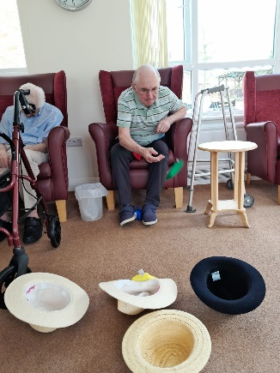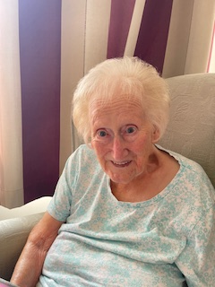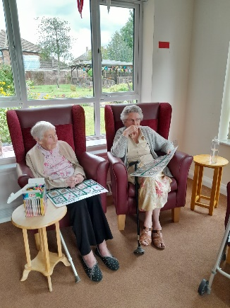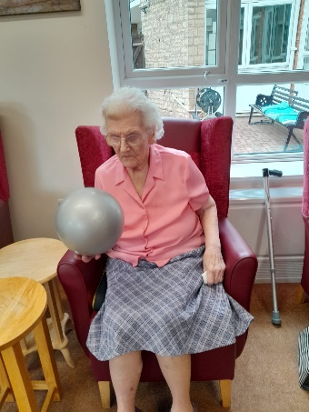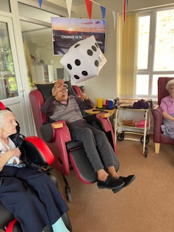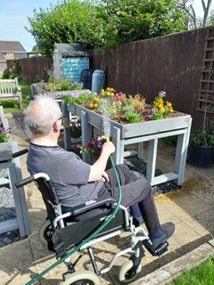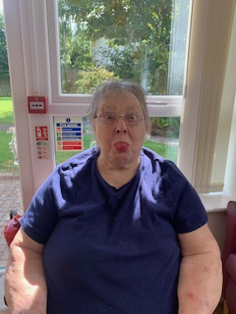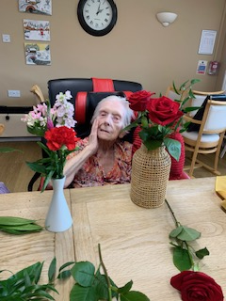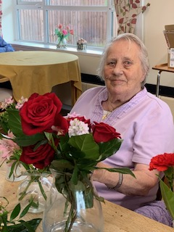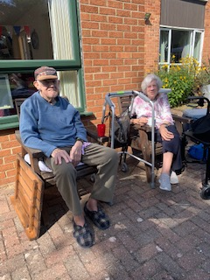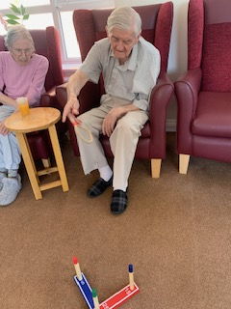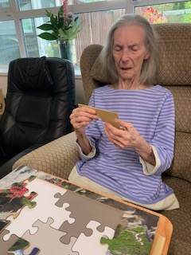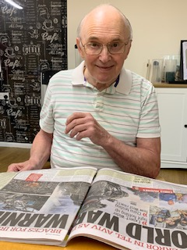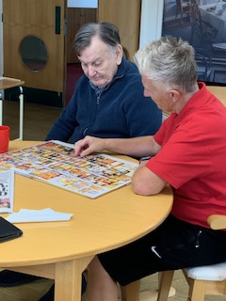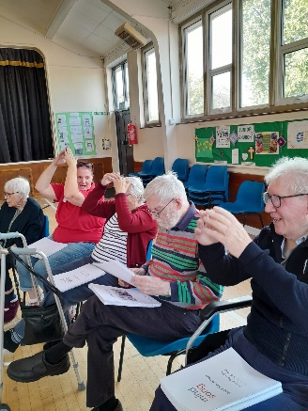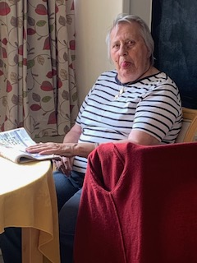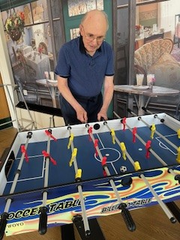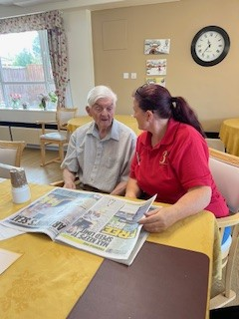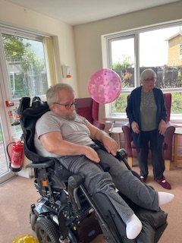
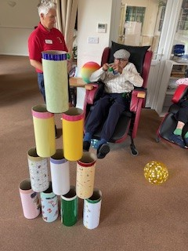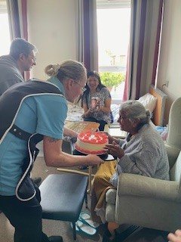

Upcoming events in September:
Mini concerts are coming to sing golden oldies on 12th and 26th September at 2pm
Julie from steelpan will be coming to play some Caribbean music on the 3rd (11am -12pm) and 18th September (3 – 4pm)
Our church service for Church of England will be 20th September (11:15 in quiet room)
Paul from the Catholic church visits on Tuesdays.
We are also in the progress of organising an elder to support our Jehovah Witness’
We always welcome family and friends to join in our activities as we always try to make them fun, so come along…you know you want…
Upcoming birthdays this month
Dave, Joseph L, Dorothy
A Happy Birthday to you all!!!!
Congratulations to our employee of the month
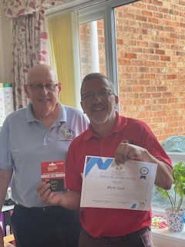 Well done Mark, well deserved.
Additional Events in September
Macmillan Coffee morning
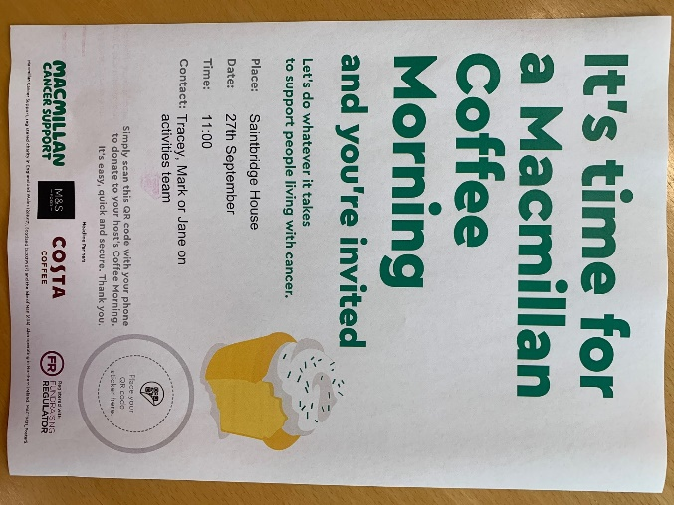
Join us for a drink and cake and support this yearly event.
Resident and Family Meeting
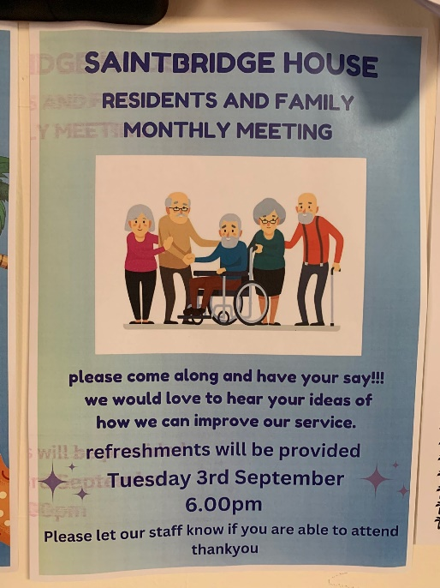
We have a resident and family meeting coming up on 3rd September. Please do try and come along and let us know if you are.
Burnham-on-sea Day Trips
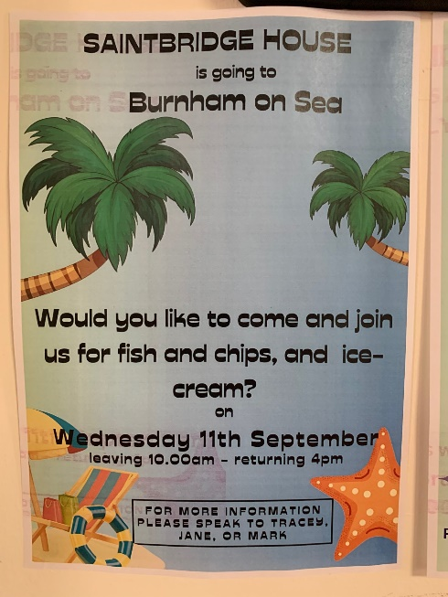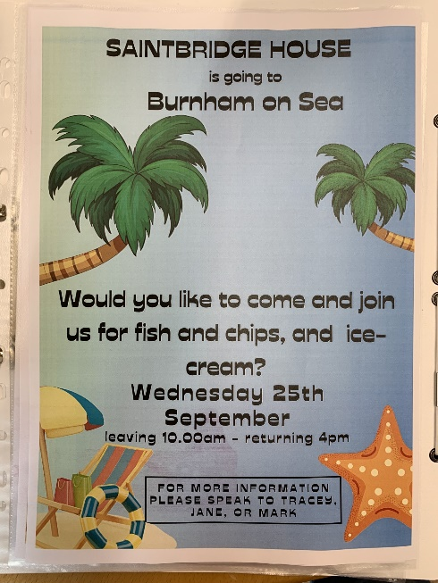
As long as the weather plays ball we are off to Burnham-on—sea for a trip again. In fact we have two dates in the diary. If you are interested in joining/assisting us, do please let us now, the more hands to help, the more residents can come along.
Date for Your Diary – Fireworks!

A date for your diary…Sunday 3rd November we are having an event with hotdogs and fireworks.

September programme of activities
Sun 1st morning prayer (Bible Reading) / creative arts / film afternoon
Mon 2nd reminiscing life stories / jigsaws / music and movement /ball games
Tues 3rd 11 – 12 steelpan concert / play your cards right / pet therapy / 6pm resident and family meeting
Wed 4th 10:30 Mind song / flower arranging / ABC quiz
Thurs 5th scrabble club / puzzles / skittles
Fri 6th creative arts / bingo bingo / music quiz with sing-a-long
Sat 7th relaxation / ball games / puzzles
Sun 8th YouTube(service) / bean bag games / film afternoon
Mon 9th reminiscence life stories / sing-a-long / music and movement / ball games
Tues 10th creative art / chair yoga /ABC quiz
Wed 11th Burnham-on-sea day trip
Thurs 12th hairdresser / scrabble club / puzzles / 2pm mini concert
Fri 13th creative arts / bean bag games / music quiz with sing-a-long
Sat 14th relaxation / skittles / ABC quiz
Sun 15th Morning prayer (Bible reading) / creative arts / film afternoon
Mon 16th reminiscence life stories / jigsaws / music and movement /ball games
Tues 17th creative arts / gardening club / pet therapy
Wed 18th Mind song Hucclecote / balloon tennis / 3 – 4pm steelpan concert
Thurs 19th Scrabble Club / puzzles / bingo bongo /ABC quiz
Fri 20th Creative arts / 11:15 church service (CofE) /giant snakes and ladders / music quiz with sing-a-long
Sat 21st relaxation / tin can alley / puzzles
Sun 22nd morning prayer (YouTube) / dominoes / film afternoon
Mon 23rd reminiscing life stories / sing-a-long / music and movement /ball games
Tues 24th creative arts / chair yoga / ball games
Wed 25th Burnham-on-sea day trip
Thurs 26th hairdresser / Scrabble club / puzzles / 2pm mini concerts
Fri 27th 11-12 Macmillan Coffee morning / bean bag games / big music quiz
Sat 28th relaxation / creative arts / crosswords
Sun 29th Bible reading / giant snakes and ladders / film afternoon
Mon 30th reminiscing life stories / jigsaws / music and movement /ball games

