Saintbridge House
Welcome to our December newsletter!
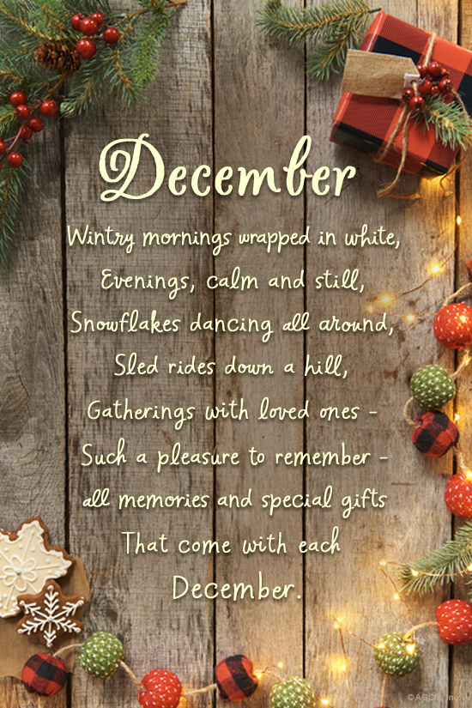
Interesting facts about December!!!
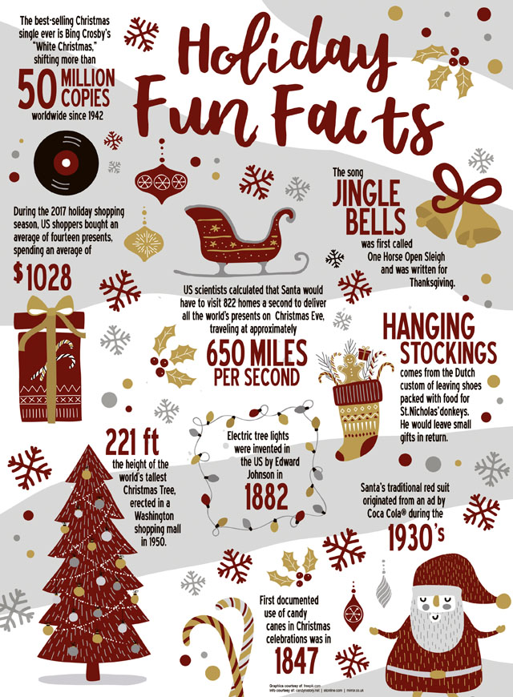
Let’s look at what we have been up to in November!!!
We wanted to start by saying a big thank you to you all for your continued support, so we thought it would be nice to put on a firework display for all the family and friends to enjoy, and of course with hotdogs and burgers!!!

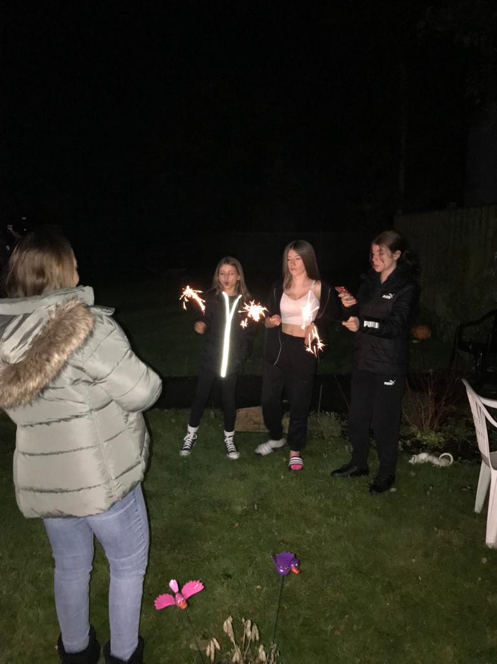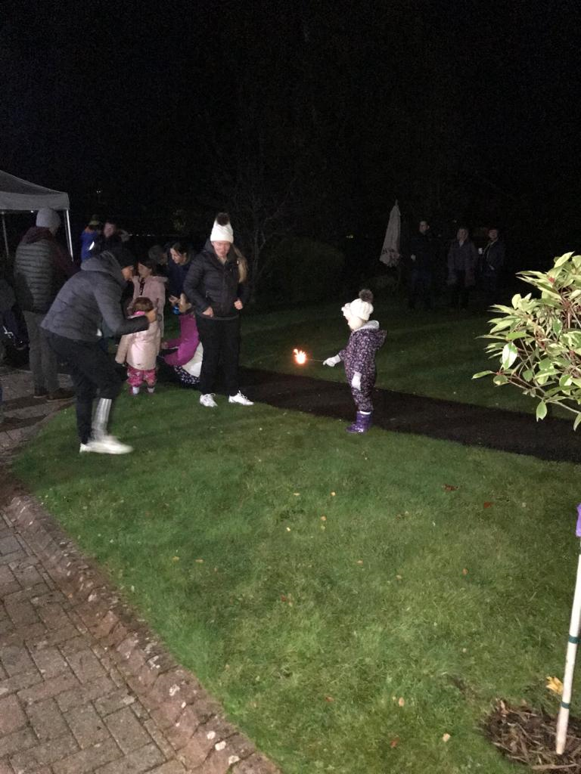
The firework display was amazing, a big thank you to Darren for lighting the fireworks, and to all the staff, family, and friends that helped to make this a fabulous evening.
Everyone had said what an amazing evening it was, and we were grateful the weather held out to.

Diwali Celebrations
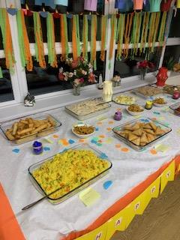
We have been celebrating the Diwali festival, tasting some amazing traditional Indian food made by our very own staff, which was delicious and enjoyed by residents, and their families, we have also been getting creative making lanterns, and bunting.

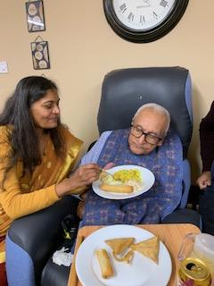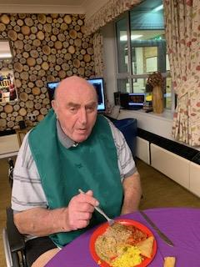
Residents gathered in the lounge to watch the service and remember those that were lost and engaged in the 2 minute silence!!!....
Heather and Diane wanted to make poppies for the staff to wear.
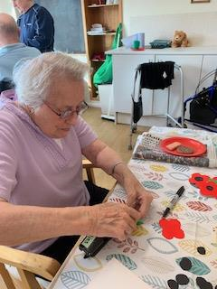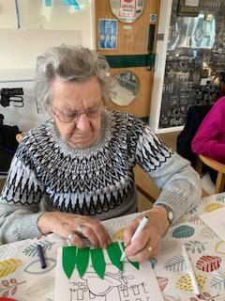
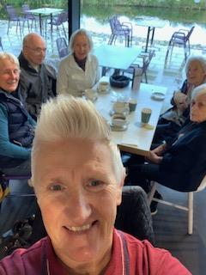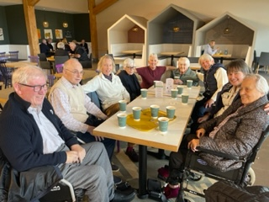
We have been out for coffee to the farm shop, which is excellent value for money, if you know the right people, thank you Carol.
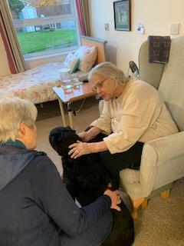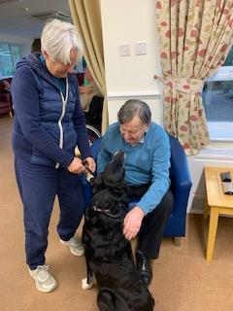
We have been very lucky this month with our pet therapy as we have had Hayley and Peggy come to visit, Carol has brought her lovely dog Skye to meet everyone, and Jean has brought in Kali, it is lovely to see the residents faces light up when the dogs come to visit.

Children in need
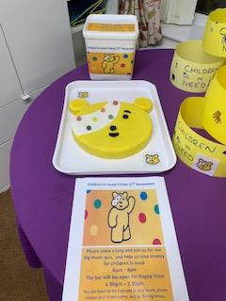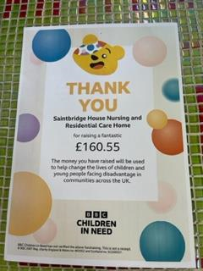
We have had a lovely day making bunting, and hats for children in need ready for our quiz evening, it was great to see some of the family members coming to join in, we even opened the bar for happy hour and some of our residents had a babycham, and gin and tonics.
Thank you to everyone that donated! we raised £160.55. amazing!!!

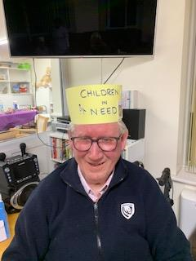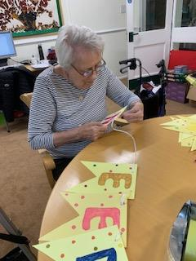
The flower arranging group seems to be a huge hit with all the residents, it’s one of those activities which needs no explanation, we placed a vase in front of David, and he sat there for a while then started to get creative and made a lovely arrangement.
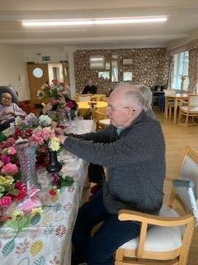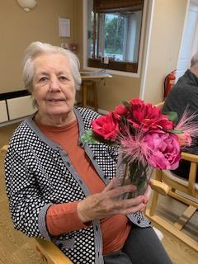
Lynne joined us for the first time today and as you can see, she has made a masterpiece, she then continued to make 2 other arrangements, Dorothy also joined in for the first time and she told us she really enjoyed it.
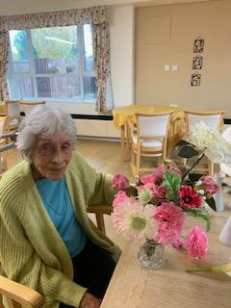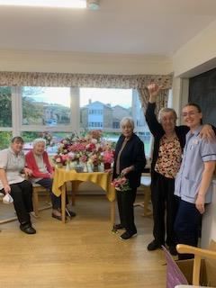

Pottery and Sculpture group
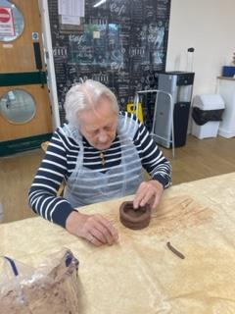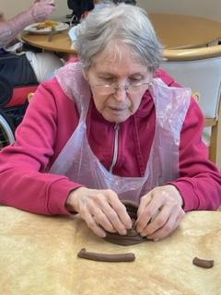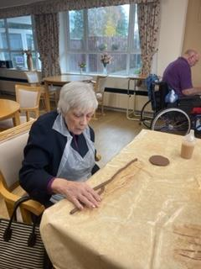
We had our very first pottery and sculpture session this week and thought we would have a go at making coil pots, the residents appeared to enjoy it although it was a bit mucky!!!

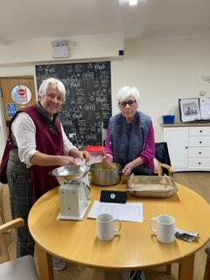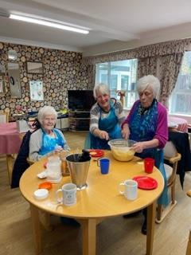
This month’s baking has been lemon drizzle cake, and a sponge cake, the ladies love the cookery group, soon we will be making Christmas cakes!!!...yummy.
Mini Concerts Came to visit us!!!...

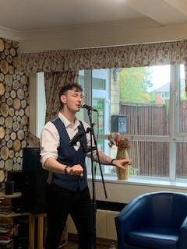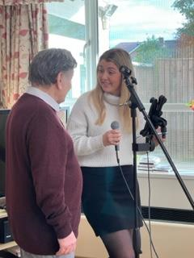
We had ‘sing – along a swing with Nick, who was amazing, and Brian stated he had an amazing voice, and he would like him to come back again.
Megan also came along and sang ‘familiar favourites and Terry loved joining in.

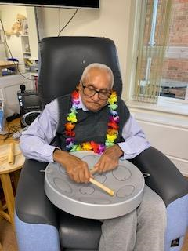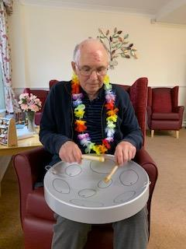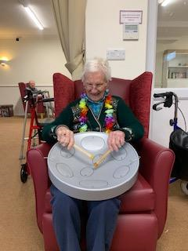
Ravji, David, and Sybil, joining in with the steelpan music.
Games Time
Just to mention a few!

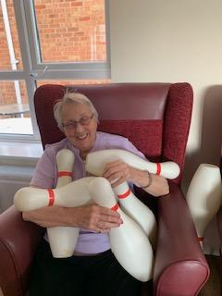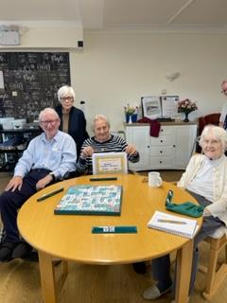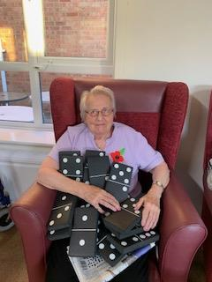
Heather has had a very lucky week, she has won the skittles, dominoes, and scrabble!!!...

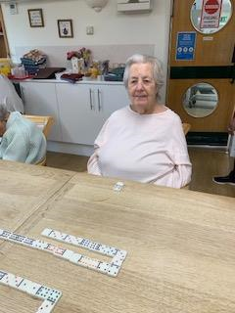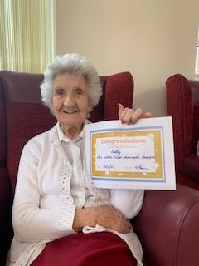
We have been playing super dominoes and this week’s winner was Betty, well done Betty!!...
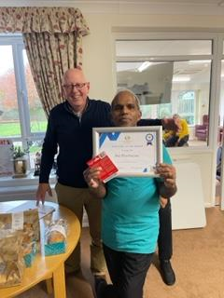
Congratulations!! to Raju, who won our employee of the month award, Well done Raju, well deserved!!!..
We could tell you about so much more!!!
- We have been doing card making, word searches, and quizzes,
- Giant snakes and ladders on a Monday followed by a general knowledge quiz, including the big music quiz on a Friday.
- Chair yoga to music
- Indoor skittles
- Bingo bongo!
- Giant floor dominoes
- Scrabble club
- Pottery
- Church service
- Hair and beauty
Upcoming Activities in December:
Keith will be performing his ‘Grumpy Gig’ on 15th December at 6.30pm all welcome, the bar will be open for happy hour!!!
We have the children coming to visit from Finlay Road infant school, hopefully to perform their Nativity dress rehearsal. (TBC)
mini concerts are coming to sing golden oldies, and countdown to Christmas, to our residents on the 7th and 2^{1st} of December.
Julie from Steelpans will be coming to play some Caribbean music and Christmas songs on the 13th of December.
Hayley and Peggy will be visiting us for more pet therapy on the 12th of December, also there will be other days that Carol and Jean will bring in Skye and Kali.
Magic lantern show on the 19th 2.230 – 3.30pm
We have a Christmas party, with a Jack and the beanstalk panto, and a special visit from Father Christmas.
Carol singers from the local church on the 23rd of December at 4.15pm.
Dave Ivle will be coming to sing some old favourites. 29th December at 6.30pm and the bar will be open for happy hour, and you are all invited.
We always welcome family, and friends to join in our activities as we always try to make them fun, so come along you know you want to!!!...
Birthdays this month!!!...
Peter, James, Colin, Ravji, Alan, Haimchand Bissu, and David .
wow lots of birthdays!!!

A big happy birthday to you all!!...
December programme of activities
Fri 1st put up the Christmas decorations/ Big quiz.
Sat 2nd film club/ story time
Sun 3rd Church service on YouTube
Mon 4th super dominoes/ Chair yoga/ Bingo bongo
Tue 5th pamper day/ creative arts/ cookery club / ABC quiz – crossword time.
Wed 6th mind song (Brock worth) / flower arranging group.
Thu 7th scrabble club/ Mini concerts
Fri 8th pottery and sculpture group/ general knowledge quiz
Sat 9th Play your cards right/film club.
Sun 10th Church service on YouTube
Mon 11th mini concerts 11am / singalong Christmas carols
Tue 12th pamper day/ creative arts/ cookery club/ skittles/ pet therapy.
Wed 13th coffee out/ Steelpan music1.30pm – 2.30pm – Christmas theme
Thu 14th scrabble club/ flower arranging group.
Fri 15th church service/ Grump gig evening (ukulele) 6.30pm start and the bar will be open
Sat 16th giant dominoes/ film club
Sun 17th church service on YouTube
Mon 18th Reminiscing / chair yoga / games
Tues 19th creative arts/ cookery club/ ABC quiz
Wed 20th Christmas party/ jack and the beanstalk panto/ Father Christmas 1pm doors open
Thu 21st memory games/ scrabble club/ mini concerts – countdown
Fri 22nd pottery and sculpture/ big music quiz
Sat 23rd bingo bongo / film club
Sun 24th Church service on YouTube / Christmas eve carols
Mon 25th Christmas Day
Tue 26th pamper day/ creative arts/ cookery club/ pet therapy.
Wed 27th trip out / flower arranging club.
Thu 28th scrabble club/ special bingo 2pm eyes down (prizes to be won)
Fri 29th play your cards right/ big quiz time/ music night with David Ivle 6.30pm – 7.30pm
Sat 30th Reminiscing/ Christmas films
Sun 31st New Years Eve

