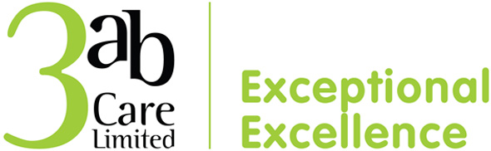***Thank You Cards 2023***

***October 23”***

***“Michelle and your fantastic team,***

***We just can’t thankyou enough for everything – you really are wonderful!***

***Thank you for all the care and TLC you gave mum.”***

***September 23”***

***“Thank You to all staff here for looking after me for 6 weeks. You are very kind. I will thank you every day.***

***Thank you Again.”***

***September 23”***

***“Thank you so much for all you’ve been doing for mum – you are wonderful!”***

***July 23”***

***“Thank you for letting me stay at Brook House during mum’s final days, and also my sister from the previous week. I want to say how grateful I and the family are for all the love and care that was lavished on mum during the last weeks of her life. I was touched to discover how many of you had a genuine affection for her – everyone had a story to tell. I know that she was in the best possible place at Brook House, and I will always remember your kindness to our family at such a difficult time.***

***With love and best wishes.”***

***April 23”***

***“Everyone at Brook House, I do not have enough words to thank you all for the love and care you showed my mum during her time with you at Brook House. Especially in the last 14 days when not only did you expertly care for my mum, but you cared for my sister and I. It helped make a truly sad time bearable. I will genuinely miss seeing you all on a daily basis, and the ducks of course. You are an incredible group of people and I have been privileged to se your work at first hand and ALL of you play an important role.***

***Take care everyone.”***