
The Willows Whisper

January 2026
How do we welcome the New Year around the world?

In this newsletter we will talk about New Year’s traditions that take place all over the world.
We are incredibly lucky to work in a multicultural environment, and have staff who can tell us about their different traditions, on bringing in the new year.

Philipino’ New Year traditions focus on attracting prosperity, good health, and luck. This involves lots of noise to scare spirits, eating round shaped foods and noodles for long life, wearing polka dots for wealth, and symbolising money with having coins in pockets. This is all done, whilst preparing for a midnight feast called Media Noche.

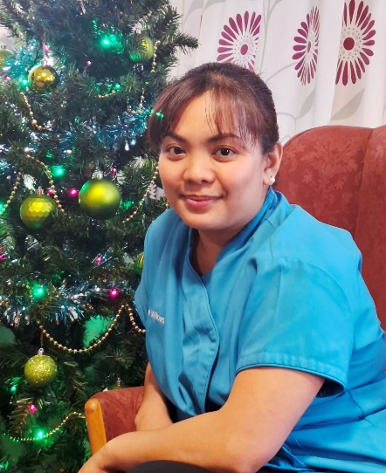
Johanne, grew up in the Philippines, always celebrating the New Year with her family. She told us that “everyone must dress up for the occasion, and all rooms in the house should have the lights on. My parents would throw coins and money around the house”. In the morning Johanne and her sister would go around the house picking up the money. Her family would then make a ‘prosperity bowl’ with rice, paper money, 12 round fruits, coins, and an egg. At midnight all doors and windows would be opened, and people make as much noise as possible, using car horns and clappers. Every neighborhood has a very big fireworks display. People will set up tables outside on the streets and the whole neighborhood would eat together..




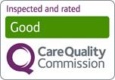

Big fireworks display
One of the most popular ways to celebrate seeing in the New Year is with big fireworks display. These take place all over the world, as different countries hit midnight.



In New Zealand, Auckland Sky Tower is usually part of an impressive fireworks display, and the same happens in Sydney Harbor in Australia. In Toronto in Canada, it's in Nathan Phillips Square, while in Rio de Janeiro in Brazil, it's the city's famous Copacabana beach where the sky is lit up by fireworks. Here is a picture of a display at Copacabana beach in Rio de Janeiro.


Smashing plates in Denmark

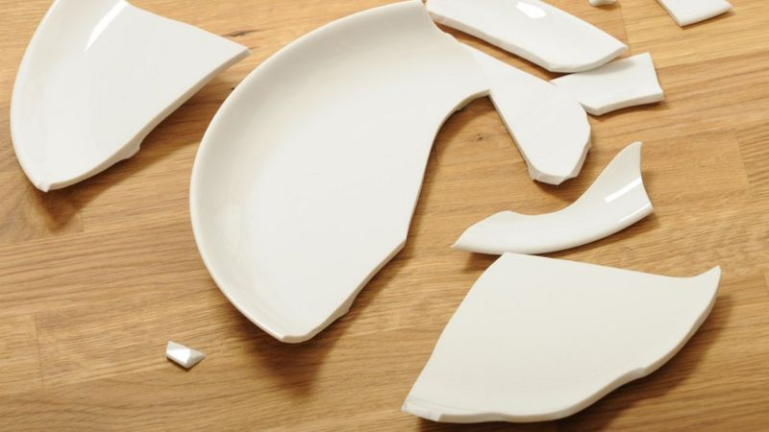

If you were celebrating New Year in Denmark, the residents hope to find smashed plates outside their door after midnight, as it is a sign of good luck. So, if you were Danish, you might go and smash a plate on a friend's doorstep to bring them good luck over the next 12 months.

Eating lentils in Brazil
In Brazil, there is a tradition to eat lentils on New Year, as these represent money - meaning good fortune for the year ahead!



Eating grapes in Spain
When the clocks hit midnight in Spain, you'll find people reaching for grapes.
This is because there is a tradition to eat one grape each time, as the clock strikes at midnight.

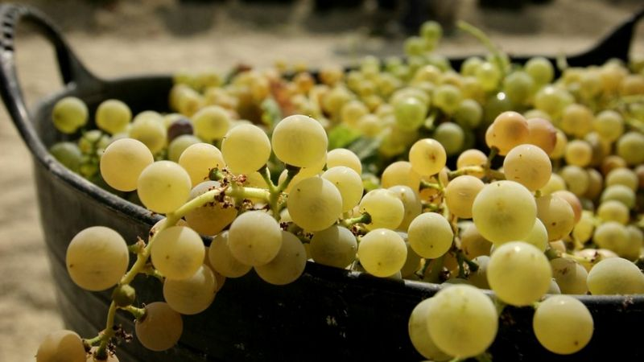

Dressing up as bears in Romania
In Romania, there's a tradition for people to dress up as dancing bears to chase away any evil spirits.



Romanian children can be seen dressing up as bears to celebrate New Year. This is because bears are special according to old Romanian stories and can protect and heal people.

Ringing bells in Japan
Some countries, like Japan and South Korea, ring bells to start the New Year.

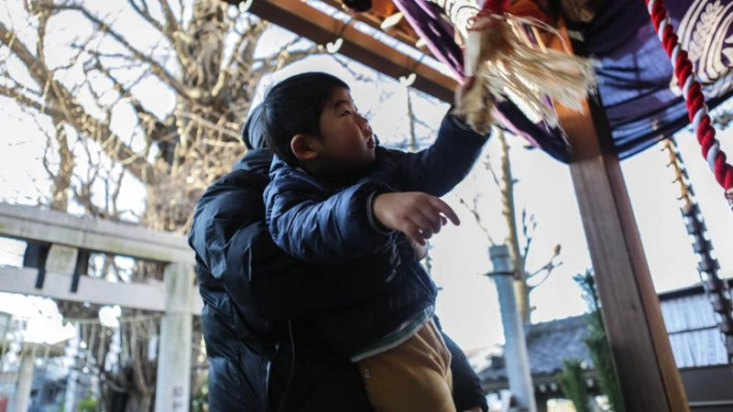

This man is helping his three-year-old son to ring a bell in Tokyo on 31 December.
In Japan, the bells are rung 108 times, so you can expect it to be quite noisy!

Walking with an empty suitcase - yes, really!
In some South American countries, you
might see some people on New Year's Eve walking around with an empty suitcase.


This is because it is believed that taking, what is called a "suitcase walk" means they will have a year full of adventures.

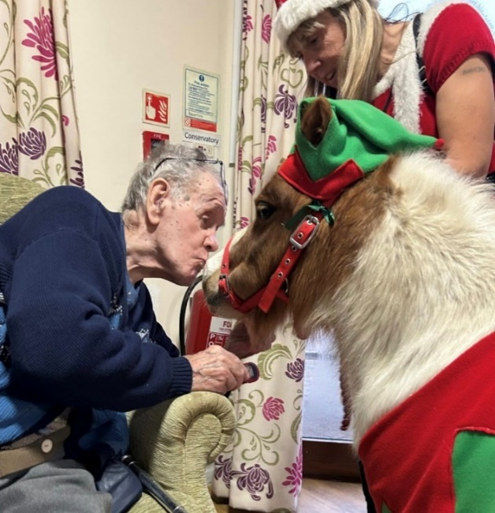

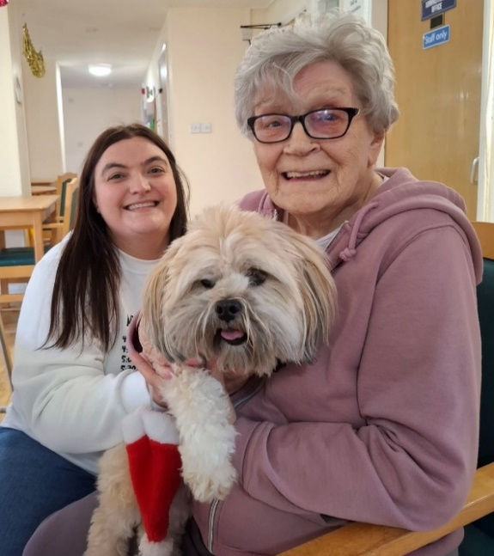
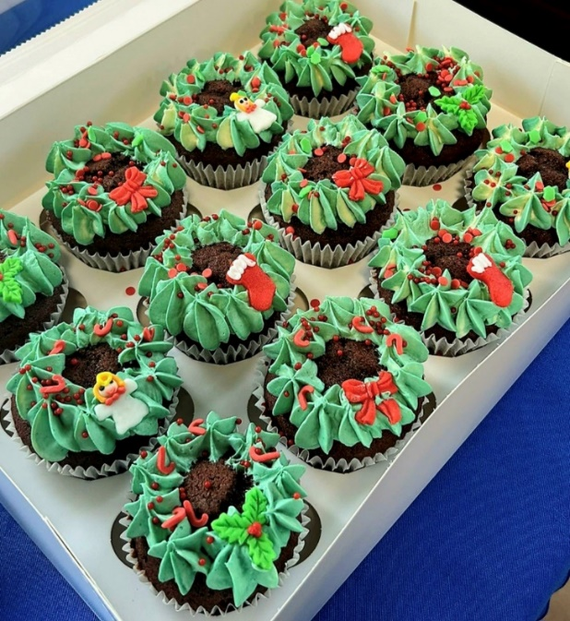
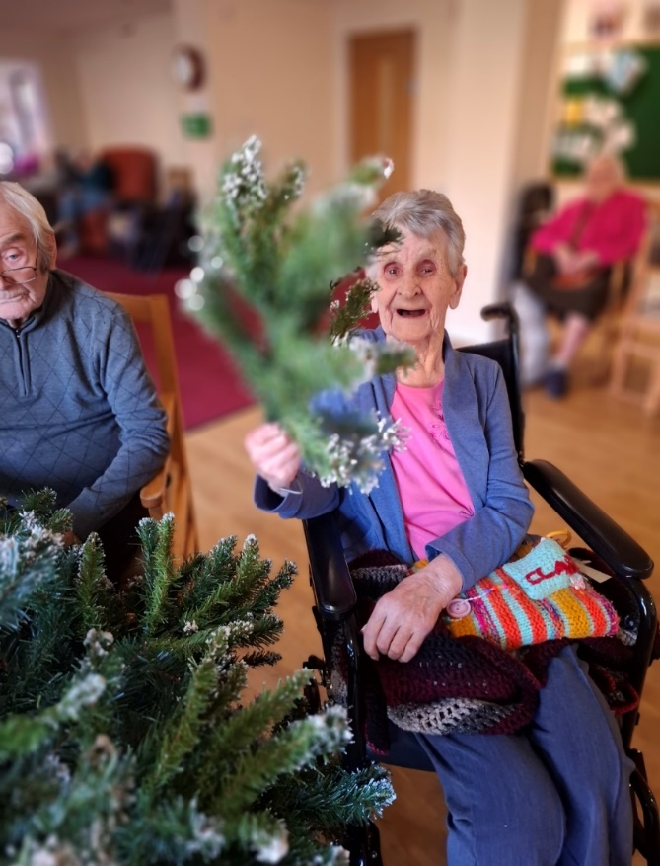
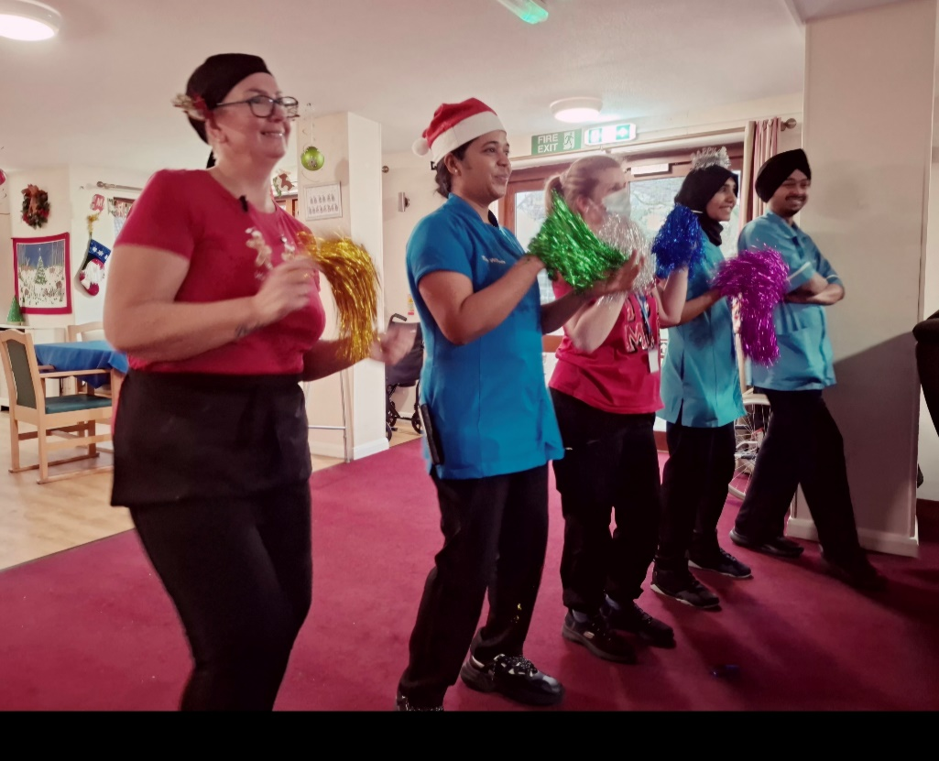
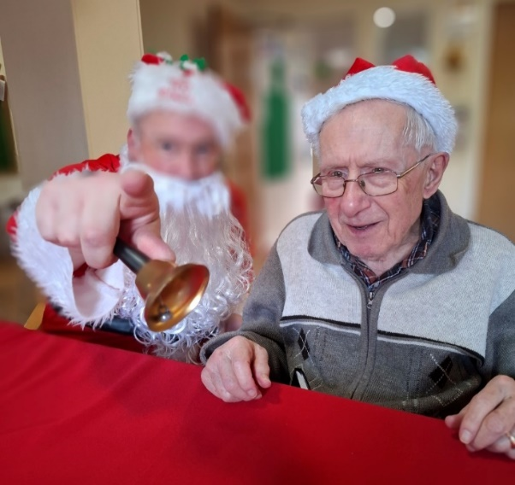

Sneak peak at our December Celebrations……




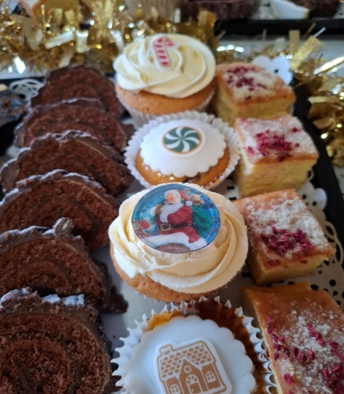
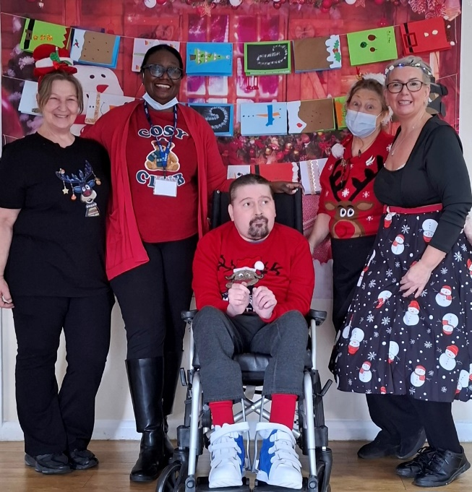
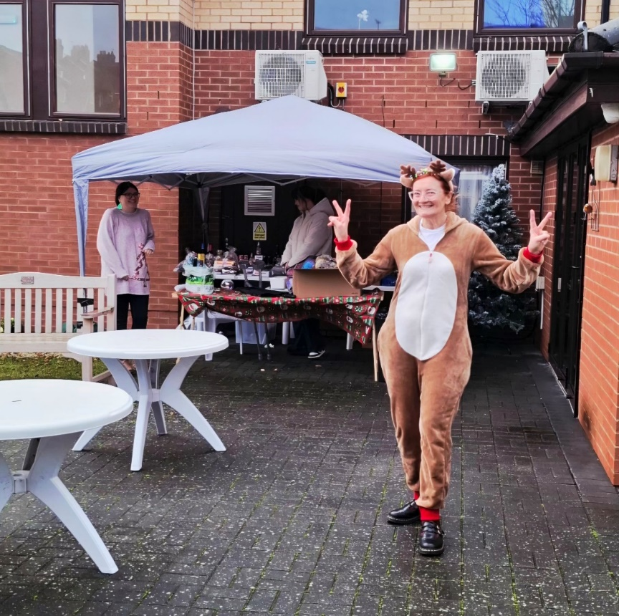
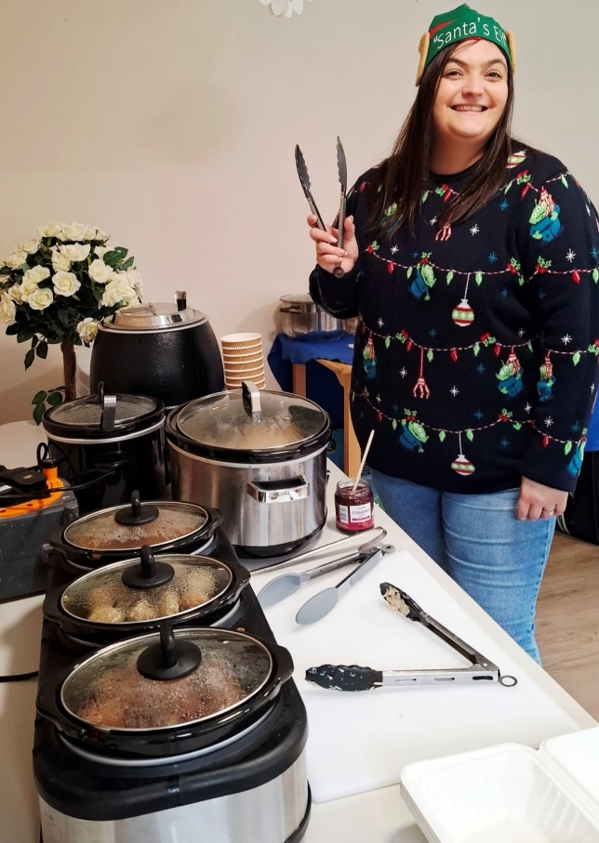
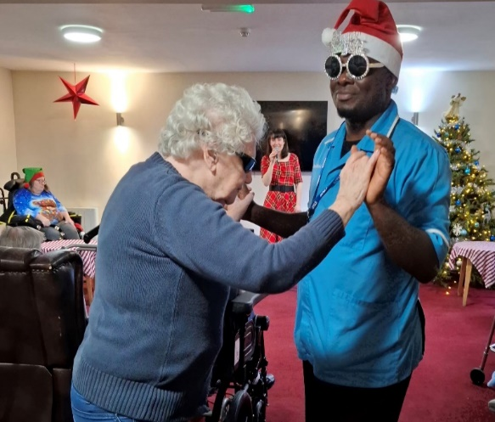
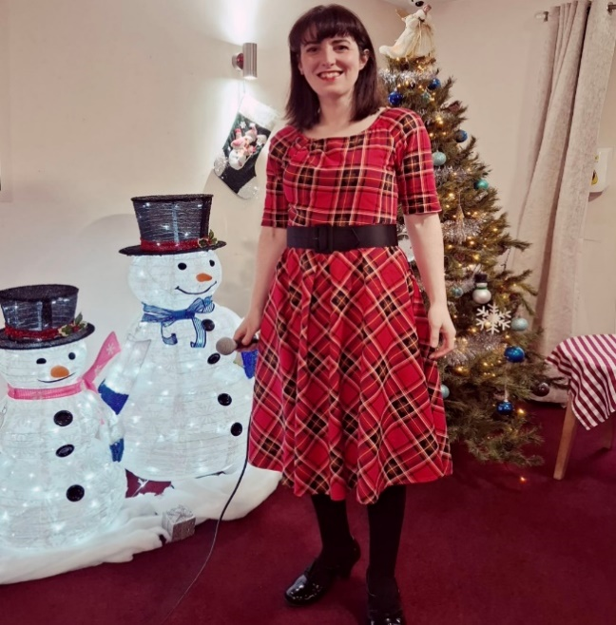
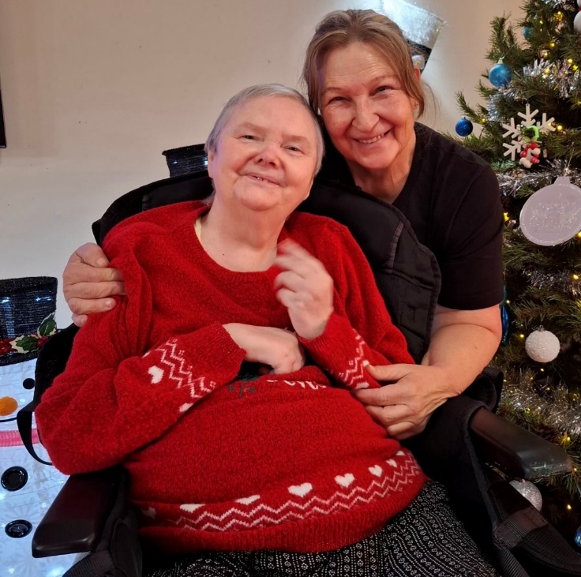
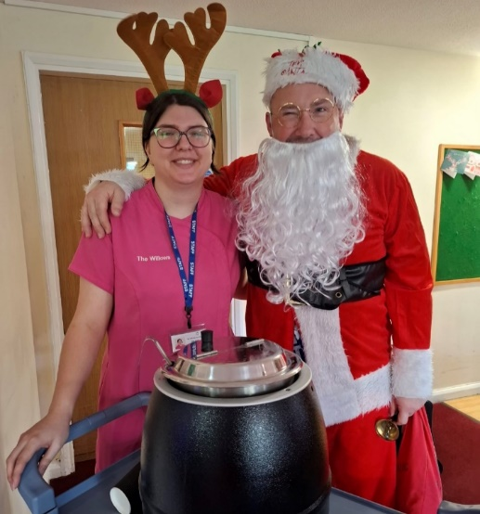
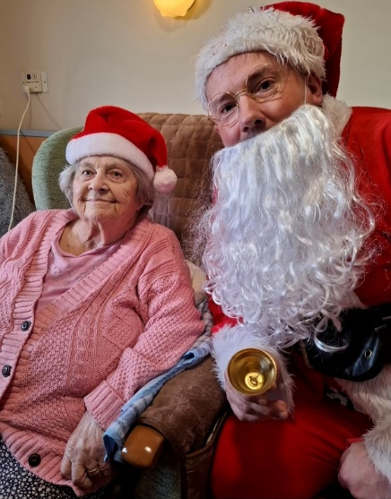
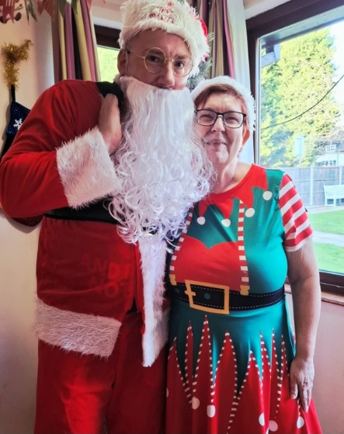
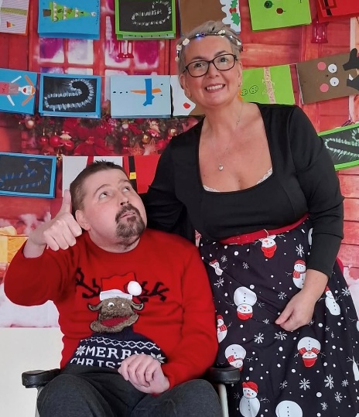
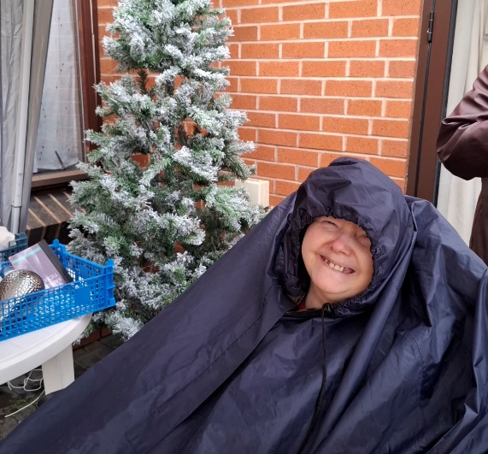



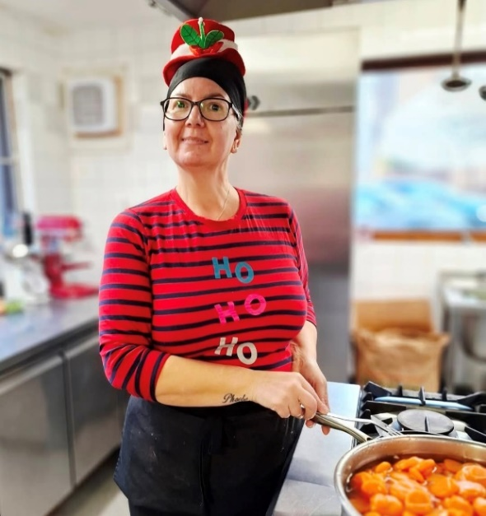
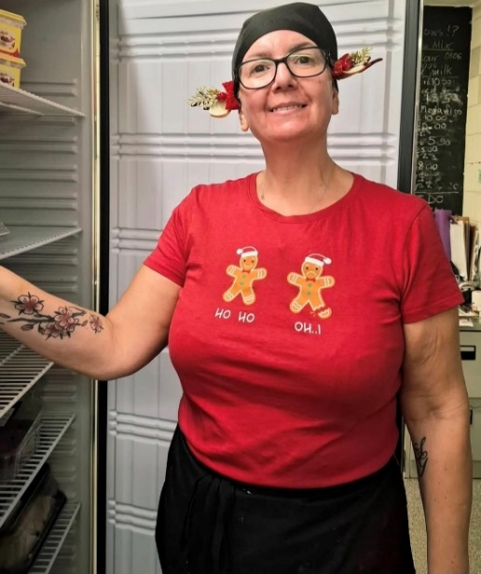
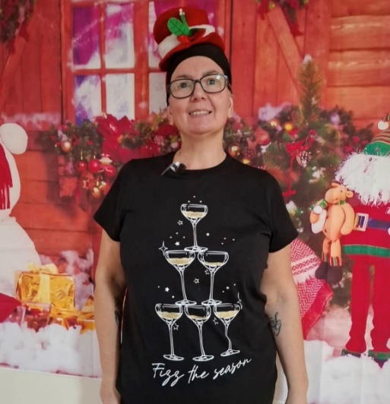
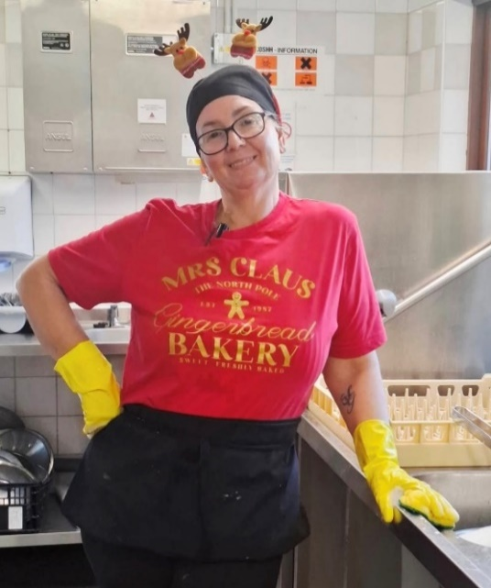
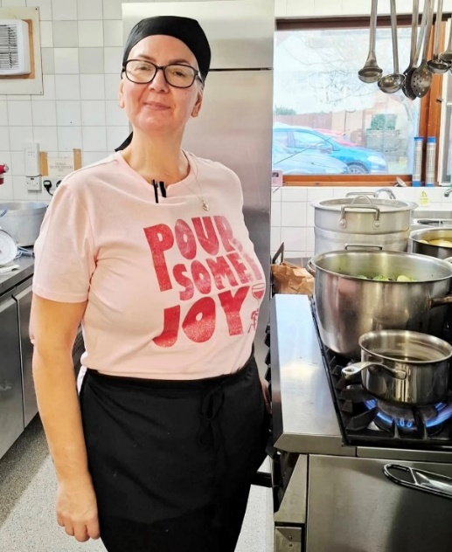

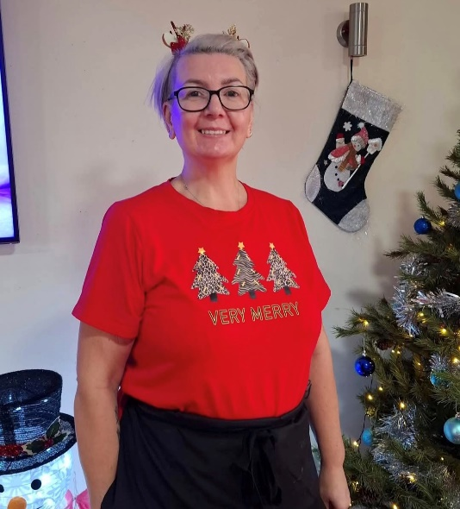
Rachael’s December was very special this year. She delighted the residents by showing up every day in a different spectacular Christmas outfit in the count down to Christmas day!
Rachael’s Ragalia…






 Recognition
We would like to take this opportunity to thank every single one of our employees, for their hard work over the last 12 months. It is the efforts and dedication of the staff that drive our success in providing excellent care to our Residents. At the end of December 2025, we recognised two staff members for going the extra mile in 2025.
Employee of the year is an award given to members of staff who have gone above and beyond in the service that they have provide to the residents and the Willows team. This year’s winner is Rachael Freer, Kitchen Assistant/Cook. We are very grateful for the dedication and support Rachel has shown in her role over the last 12 months.
The Heart Award was introduced for staff to recognise each other, when they see someone going that ‘extra mile’ in their role.
This year our annual Heart Award was won by Jennifer Boateng, Care Assistant, who has been part of the Willows family since November 2024.


Meet with the Manager

Our lovely Yvonne is available for a chat on 29th January 2026, from 2:00pm and 3:00pm.

We have some 3ab Care Calendars for all our visitors this month!

If you would like to book a specific
time slot, please call the Home on 01509 650559.

The 3ab Care Referral Program

Do you know someone seeking a Care Home for a loved one?

If you refer to resident, who comes to live at The Willows, you can receive a reward!

We are offering:

£250 vouchers if the resident comes to stay with us
on a respite stay
Or
£500 vouchers if the resident you refer comes
to our Home permanently.
If you would like more information, please speak
to Priya Patel or Yvonne Manton.
Contact us on 01509 650 559


Our Birthday Wishes for January
Stephen W - 7th
Janet K - 12th
Donald B - 13th
Ian M - 14th

Gladys - M 26th

The New Year is already here, and we are gearing up to make new promises and new beginnings for 2026.
It’s time to make New Year’s resolutions that will help us all achieve our goals.
We are wishing you all a Happy New Year!
Old out, new in! We send you our best wishes for better days in 2026!

Until we meet again……
As we leave behind 2025, sadly we also had to say our farewells to two of our longest serving and beloved residents, Grace (102), and Sheila (94).
Both ladies had many many happy years at The Willows, and they will be fondly remembered by staff members and their fellow residents.
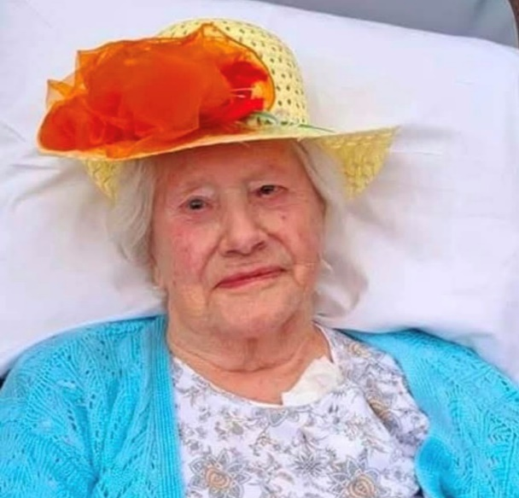


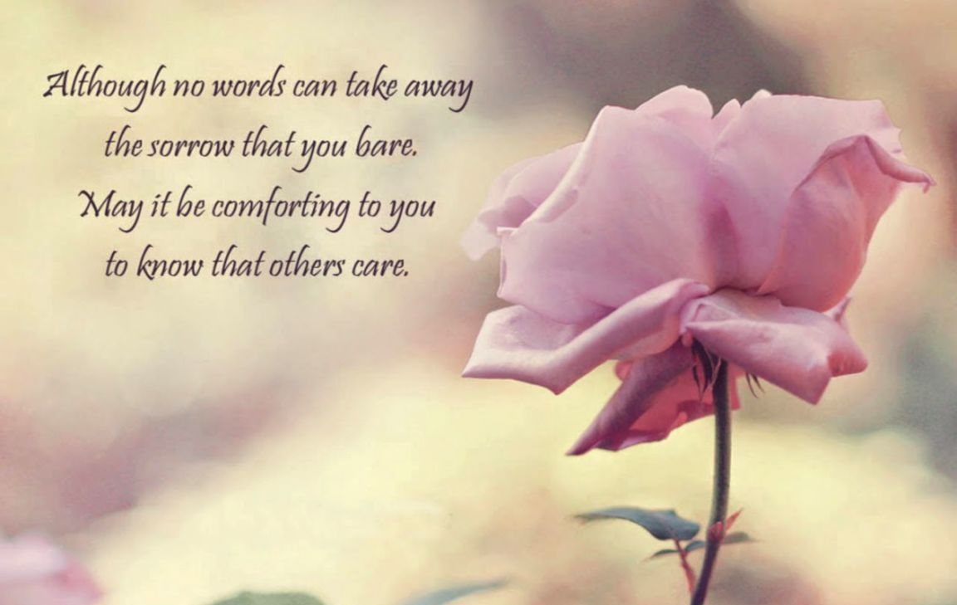

Messages for our Staff…….


“Thank you to all the staff at The Willows for
all the care, love and support you gave to our
Mum…” December 25


“Thank you all so much for the ongoing care you give to my Mum” December 25



