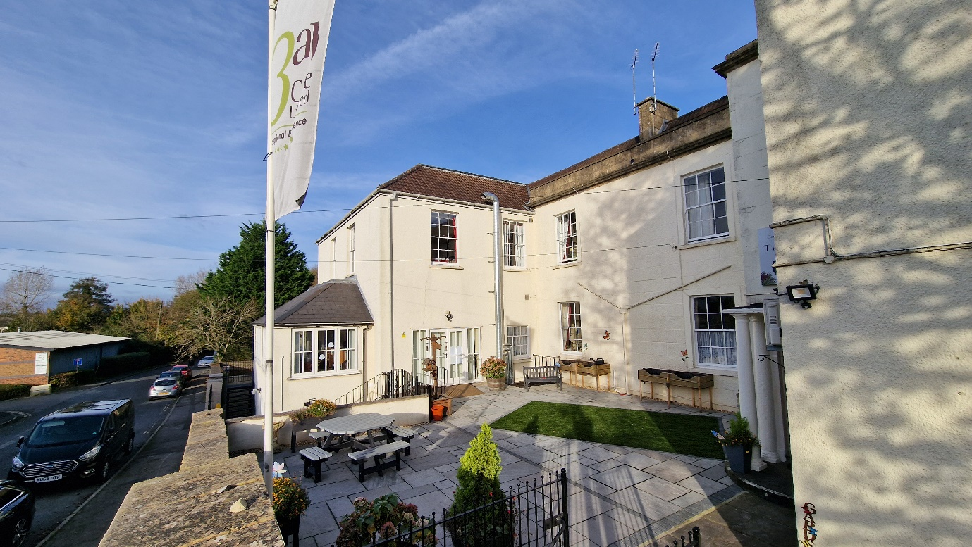

THE HEATHERS NURSING HOME

NOTE: Internal Audits are carried out quarterly throughout our group.

The last Internal Audit was completed in November 2024 by Brookhouse.

Next one is due in January 2025 by Saintbridge.

