Saintbridge House
Impact Stories
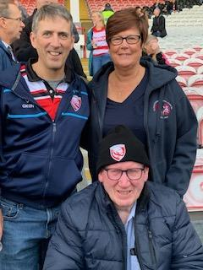
Brian has been a massive fan of rugby since the age of 14, and used to play as a scrum half for his school Widden Old boys, Brian states he used to love going to watch Gloucester play at Kingsholm on a Saturday afternoon, I asked Brian how much it cost for a ticket back then, and Brian cheekily laughs, saying he didn’t pay half the time as he and his mates used to jump the fence which is what a lot of the young lads did back then.
Brian said he used to go watch Gloucester with an old school friend however has now passed away, he said they went for over 20 years, Brian then went to some of the matches with his family who are also avid supporters.
unfortunately Brian’s mobility had started to deteriorate, and he now uses a wheelchair and requires additional support therefore has been residing at Saintbridge house for just over 2 years, Brian continues to talk about his love for rugby, and often talks about the good old days, Kingsholm rugby club hold a Rugby reminiscence group once a month at the stadium, where older Gloucester rugby fans can meet up to talk about the good old days, which includes photos, videos, talks and is attended by some of the older players, and of course tea and biscuits, Brian loves going to the group as this gives him an opportunity to socialise with others, and to talk about the game he loves, recently we arranged for Brian to go to a Rugby match where Gloucester played the Barbarians, and what a great win 35-19, they also held a wall of fame where they invited players from all over the world to celebrate, Brian found this very emotional and an honour to be a part of a momentous occasion.
Whilst we were there Brian met up with some of his family who were also watching the game, Brian sat happily watching the game with a pint of lager in his hand.
Brian had stated that he never thought he would get to watch another match, and was very grateful for the opportunity, his family were thrilled also.
We at Saintbridge House strive to enable our residents to continue to engage in their passions and hobbies wherever possible, as it is crucial to their mental health and wellbeing.

