m

**March 2023**

The Heathers Nursing Home

Monthly news letter

Welcome to The Heathers Nursing home newsletter.

The aim of the newsletter is to provide an informed and sometimes light hearted look at what is a very important job in looking after our residents.

We have had a very busy March, with celebrating St David’s Day, St Patricks Day and Mother’s day, along with lots of other fun activities.

please follow us on social media

Facebook: The heathers nursing home

Instagram: the_heathers_home

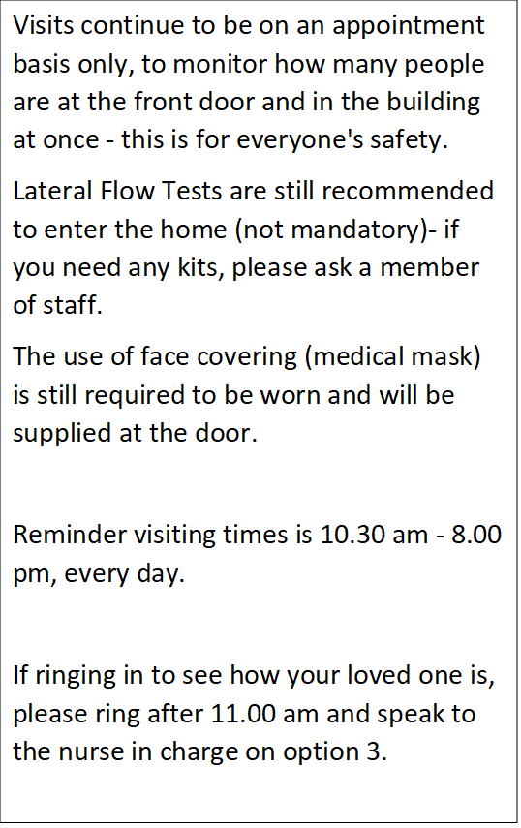

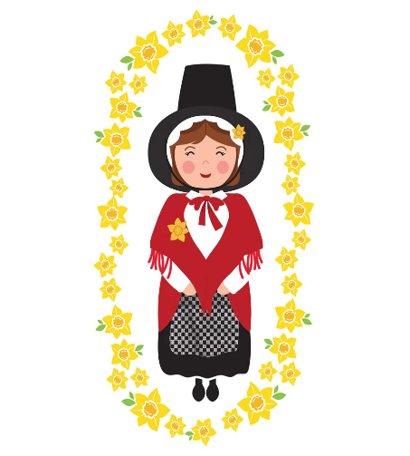

March

**St David’s Day**

We kicked off March with St David’s day, Celebrating Wales and our Welsh residents, with Themed Arts and Crafts, Welsh music and plenty of Daffodils

**World Book Day**

We celebrated World Book Day on the 2nd of march with a day themed around reading and all our favorite books from both childhood and being an adult

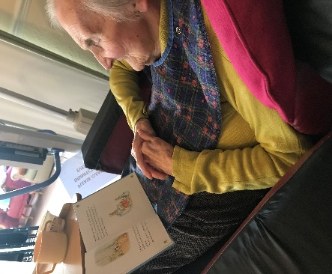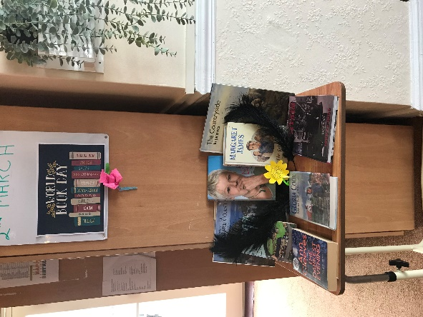

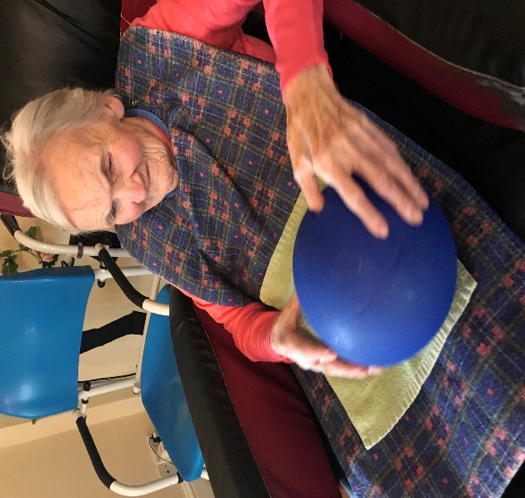

We had our bi weekly visit from Alex G, who comes to keep us all fit and active. He visits every resident who is able to move safely. We also try to keep active as much as we can.

**Keeping Active!**

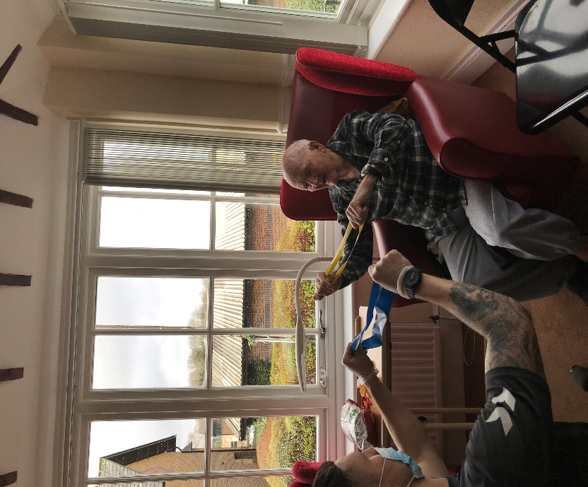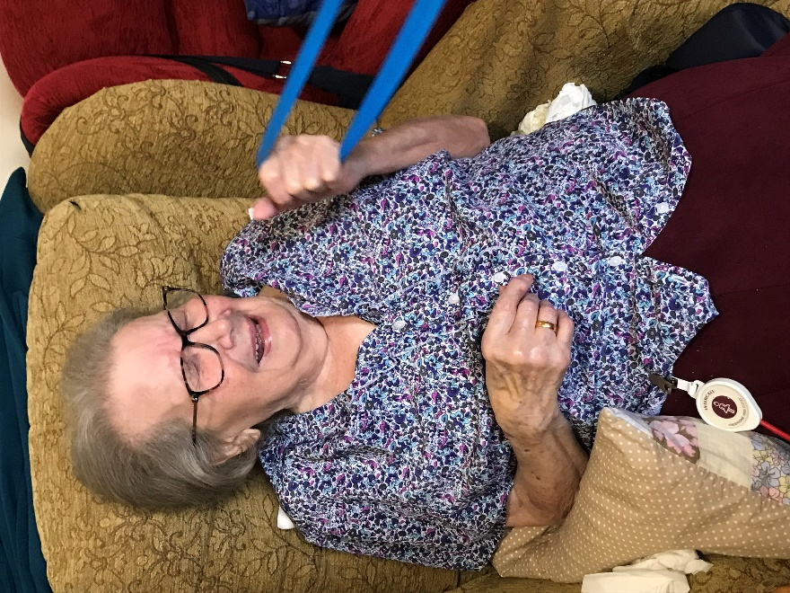

**Indoor Bowling**

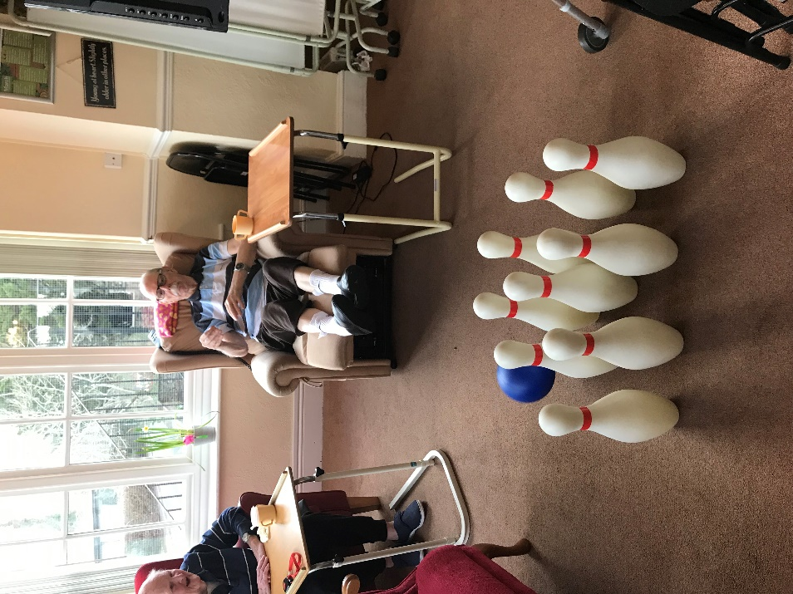

**Fun in the snow!**

We ensured all our residents had fun in the small amount of snow we had! After all we had to make the most of it whilst it lasted.

Like St David’s day we celebrated St Patrick’s day for our Irish residents, with decorations, Arts and Crafts and music throughout the day.

**St Patrick’s Day**



**Chris Auburn - Singer**

We had the lovely Chris Auburn come to sing to our residents. They love to sing along with the music.

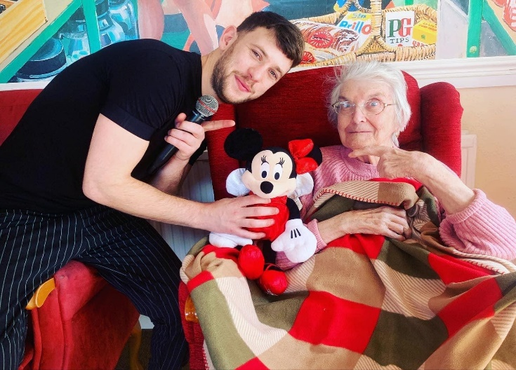





We thanked all our mothers, Nans, grandmothers, sisters and everyone in between for mother’s day. Showing them lots of love and support

**Mother’s Day**

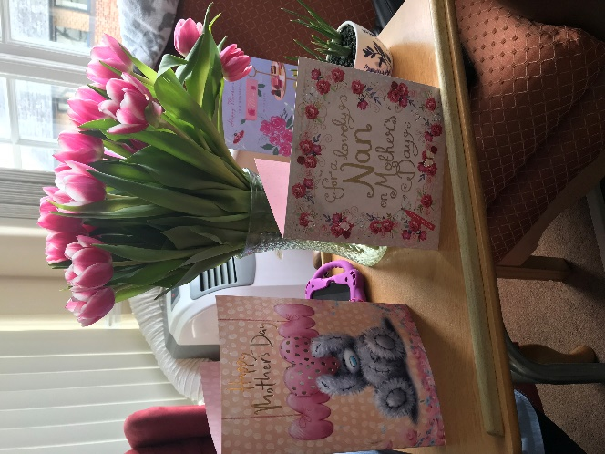

  
  
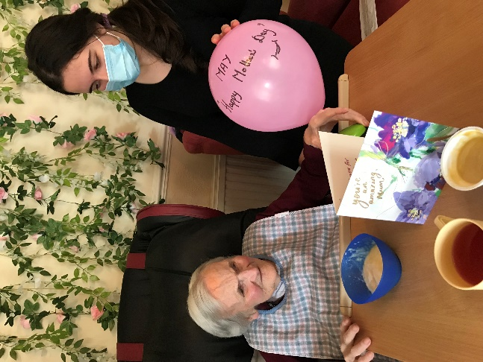

***WORLD THEATRE DAY***

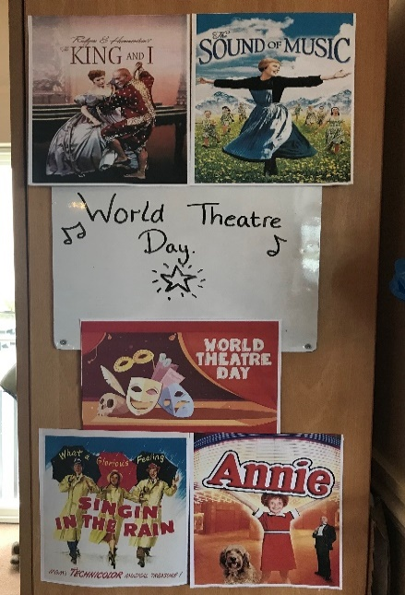  
  
  
  
  
  
  
  
  
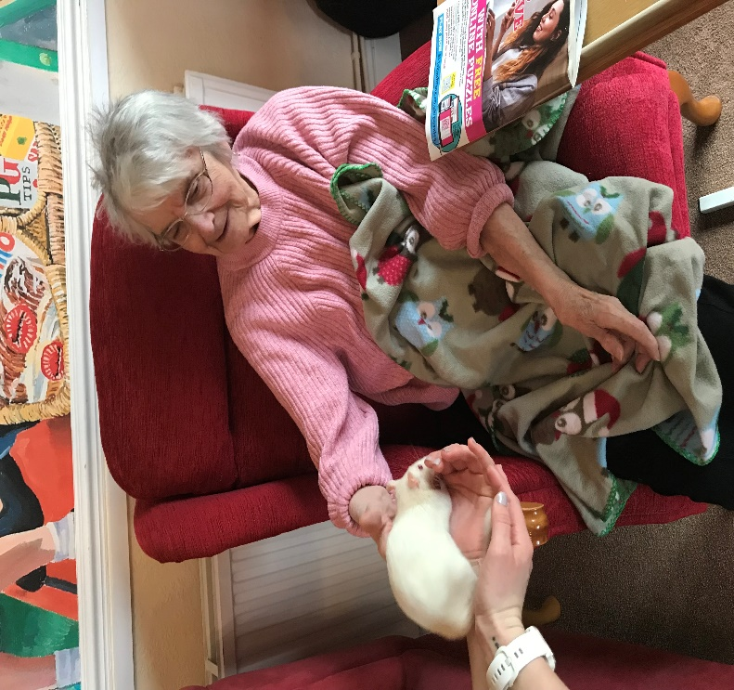

We had a theatre themed day, watching all our favorite musical songs and films from throughout the years. We all chatted about our favorite actors and actresses, The residents loved it!

**Animal Therapy – Zoo Lab**

Our lovely friends at Zoo Lab came to visit with their animals, residents got the chance to look, touch and hold all the different animals. This meant all our residents could get involved with seeing the animals.

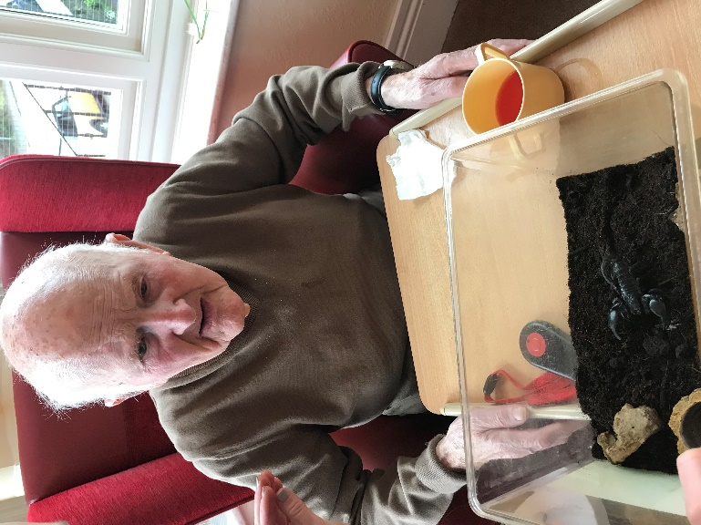



**Monday 20th - World Story Telling Day**

**Tuesday 21st - World Poetry Day**

**Wednesday 22nd -Residents Choice**

**Thursday 23rd - National puppy Day**

**Friday 24th - Games Day**

**Saturday 25th – Sensory**

**Sunday 26th - Arts and Crafts**

**Monday 27th - World Theatre Day**

**Tuesday 28th Chair Exercises**

**Wednesday 29th – Zoo Lab at 11am**

**Thursday 30th – Pamper Day**

**Friday 31st – St Johns Baptist Church service at 2pm**

**Monday 13th - Games**

**Tuesday 14th - Karaoke**

**Wednesday 15th - Sensory**

**Thursday 16th - National Panda Day**

**Friday 17th ST PATRICKS DAY / Church service at 11am**

**Saturday 18th – Arts and Crafts**

**Sunday 19th – Mother’s Day**

**Monday 6th - Arts and Crafts**

**Tuesday 7th - Bingo**

**Wednesday 8th – Chris Auburn Singer at 11am**

**Thursday 9th - Quiz**

**Friday 10th - Indoor Bowling**

**Saturday 11th – Movie Day**

**Sunday 12th – Tell me a Story Day**

**Wednesday 1st - St David’s Day / Alex G Fitness at 11am   
Thursday 2nd - World Book Day**

**Friday 3rd - World Wildlife Day**

**Saturday 4th - Games**

**Sunday 5th – Pamper Day**

**March**