Friday 10th May 2024
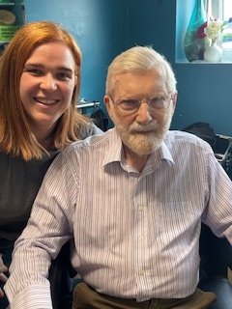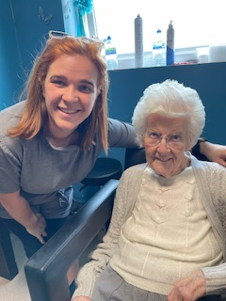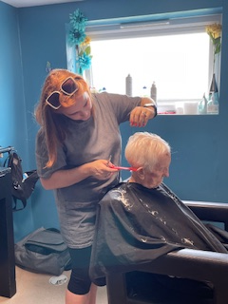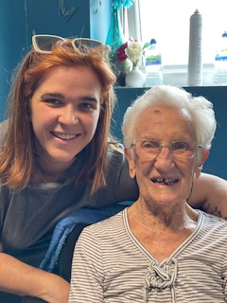
This morning we have had a visit from Emily our resident hairdresser, it was Denis first visit to the salon and he was keen to have his hair and beard trimmed and was very happy with the result, Sybil really enjoyed her hair pamper experience today as she has not had her hair done by the hairdresser for a while, she stated she felt really relaxed and it made her feel very sleepy.

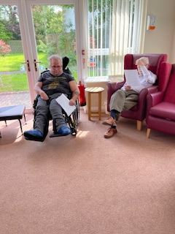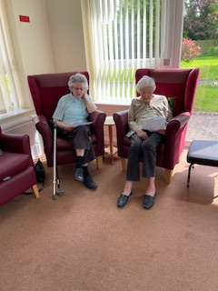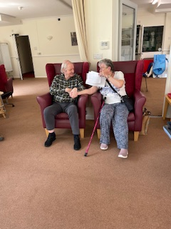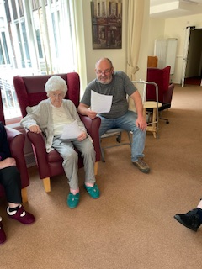

This afternoon we had our very popular “Big music quiz” we chose 60’s and 70’s this time to see how good our memories were, some of the questions were quite difficult so we had the help of Alexa who was able to play the tunes to jog everyone’s memories, playing the songs is a great as the tunes all came flooding back and the residents were able to sing along to the tunes they were familiar with, next week we will be doing hits from the 50’s, can’t wait!

